**Gallery Tour** **Line Master 1** (Assessment Master)

**Name:** _____________________________

|  |  |  |  |
| --- | --- | --- | --- |
| **Describe and Compare Transformations** | **Not observed** | **Sometimes** | **Consistently** |
| Identifies 2-D shapes that have symmetry |  |  |  |
| Identifies lines of symmetry |  |  |  |
| Constructs and completes  2-D symmetrical designs |  |  |  |
| Describes and performs transformations (slides, flips, turns) |  |  |  |
| **Identify, Describe, and Compare  2-D Shapes** |  |  |  |
| Names 2-D shapes within an image |  |  |  |
| Describes and compares properties of 2-D shapes (number of sides and angles) |  |  |  |
| Identifies and compares lines and angles |  |  |  |

**Strengths:**

**Next Steps:**

**Connecting Home and School Line Master 2–1**

**NOTE TO THE TEACHER**

You may wish to send families a ***Gallery Tour*** letter outlining a familiar activity or two they can do at home with their children.

Create a letter using this template and select one or two activities from the suggestions on the next page. Simply **delete these instructions and cut and paste the activities you have selected**, adapting them to fit your needs.

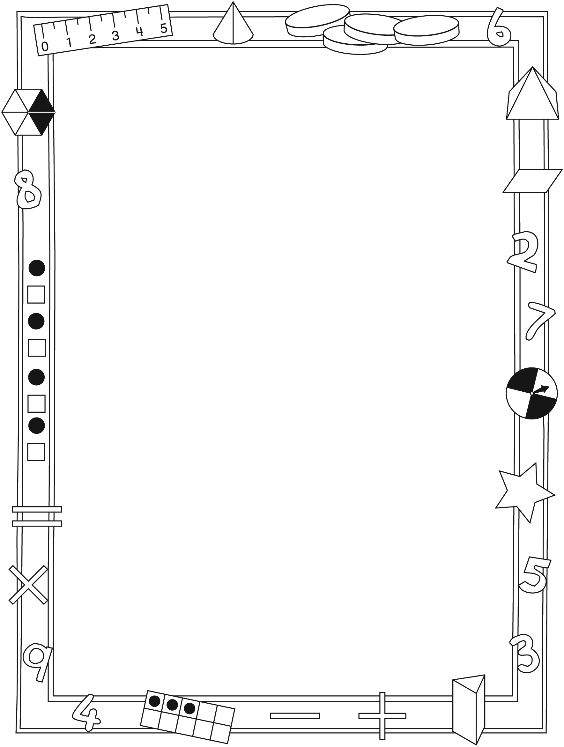

**Connecting Home and School Line Master 2–2**

Dear Family:

We have been working on ***Gallery Tour***, which engages children in conversations, investigations, and activities that help to develop their understanding of the big math idea that “Shapes and solids can be transformed in many ways.” Particular focus is placed on identifying, describing, and comparing 2-D shapes. Try this activity at home with your child.

✂ – – – – – – – – – – – – – – – – – – – – – – – – – – – – – – – – – – – – – – – – – –

**Reading the Story:** Ask your child to share what he/she finds to be the most interesting painting in each gallery. Discuss whether you agree with the curator’s choices. Refer to pages 22–23 and talk about how you would arrange the art. Ask: **How would you group the art into different rooms?** Then, consider where the painting on page 24 belongs.

✂ – – – – – – – – – – – – – – – – – – – – – – – – – – – – – – – – – – – – – – – – – –

**Symmetry Search:** We are looking for symmetry and creating a class gallery. Encourage your child to search your home for examples of symmetry. Have your child draw, photograph, and/or list what he/she finds, and bring these findings to add to our exhibit by (date).

✂ – – – – – – – – – – – – – – – – – – – – – – – – – – – – – – – – – – – – – – – – – –

**Toothpick Puzzles:** Enjoy solving these 2-D shape puzzles with your child. Talk about the number of sides, angles, and shapes in the puzzle before moving or removing any toothpicks. Then, talk about what changed when you reach a solution. Together, create your own toothpick puzzle. We look forward to solving it!

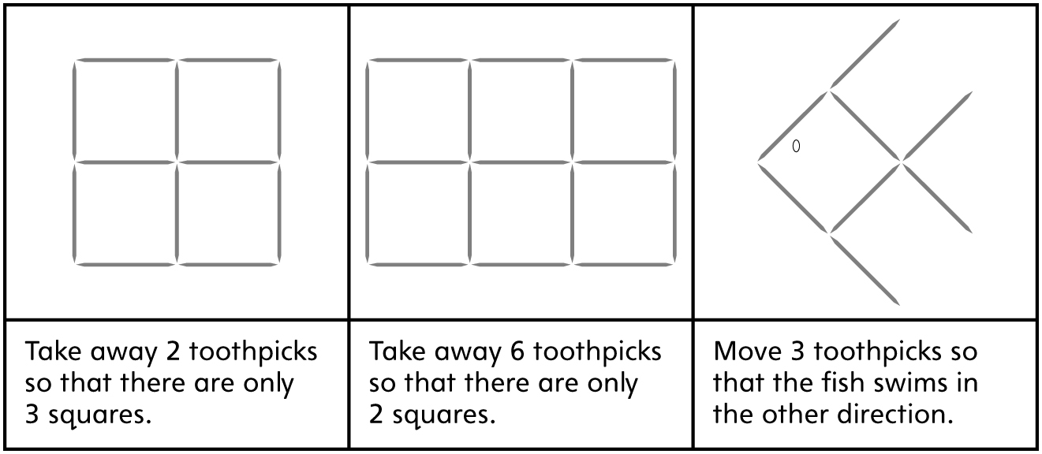

✂ – – – – – – – – – – – – – – – – – – – – – – – – – – – – – – – – – – – – – – – – – –

Sincerely,

___________________________

***Gallery Tour* Math Mat Line Master 3**

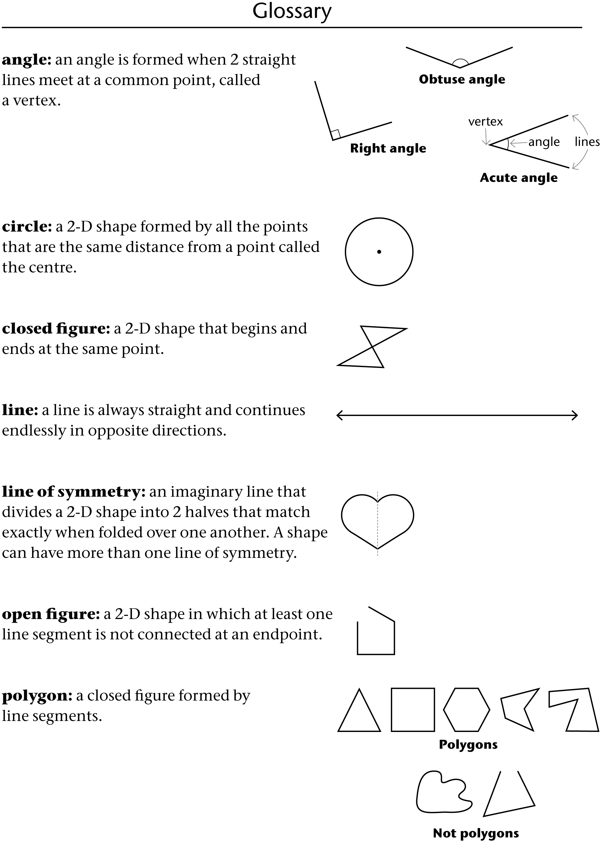

**Symmetry Surrounds Line Master 4**



**Geoboard Shapes Line Master 5**

**Name:** _____________________________

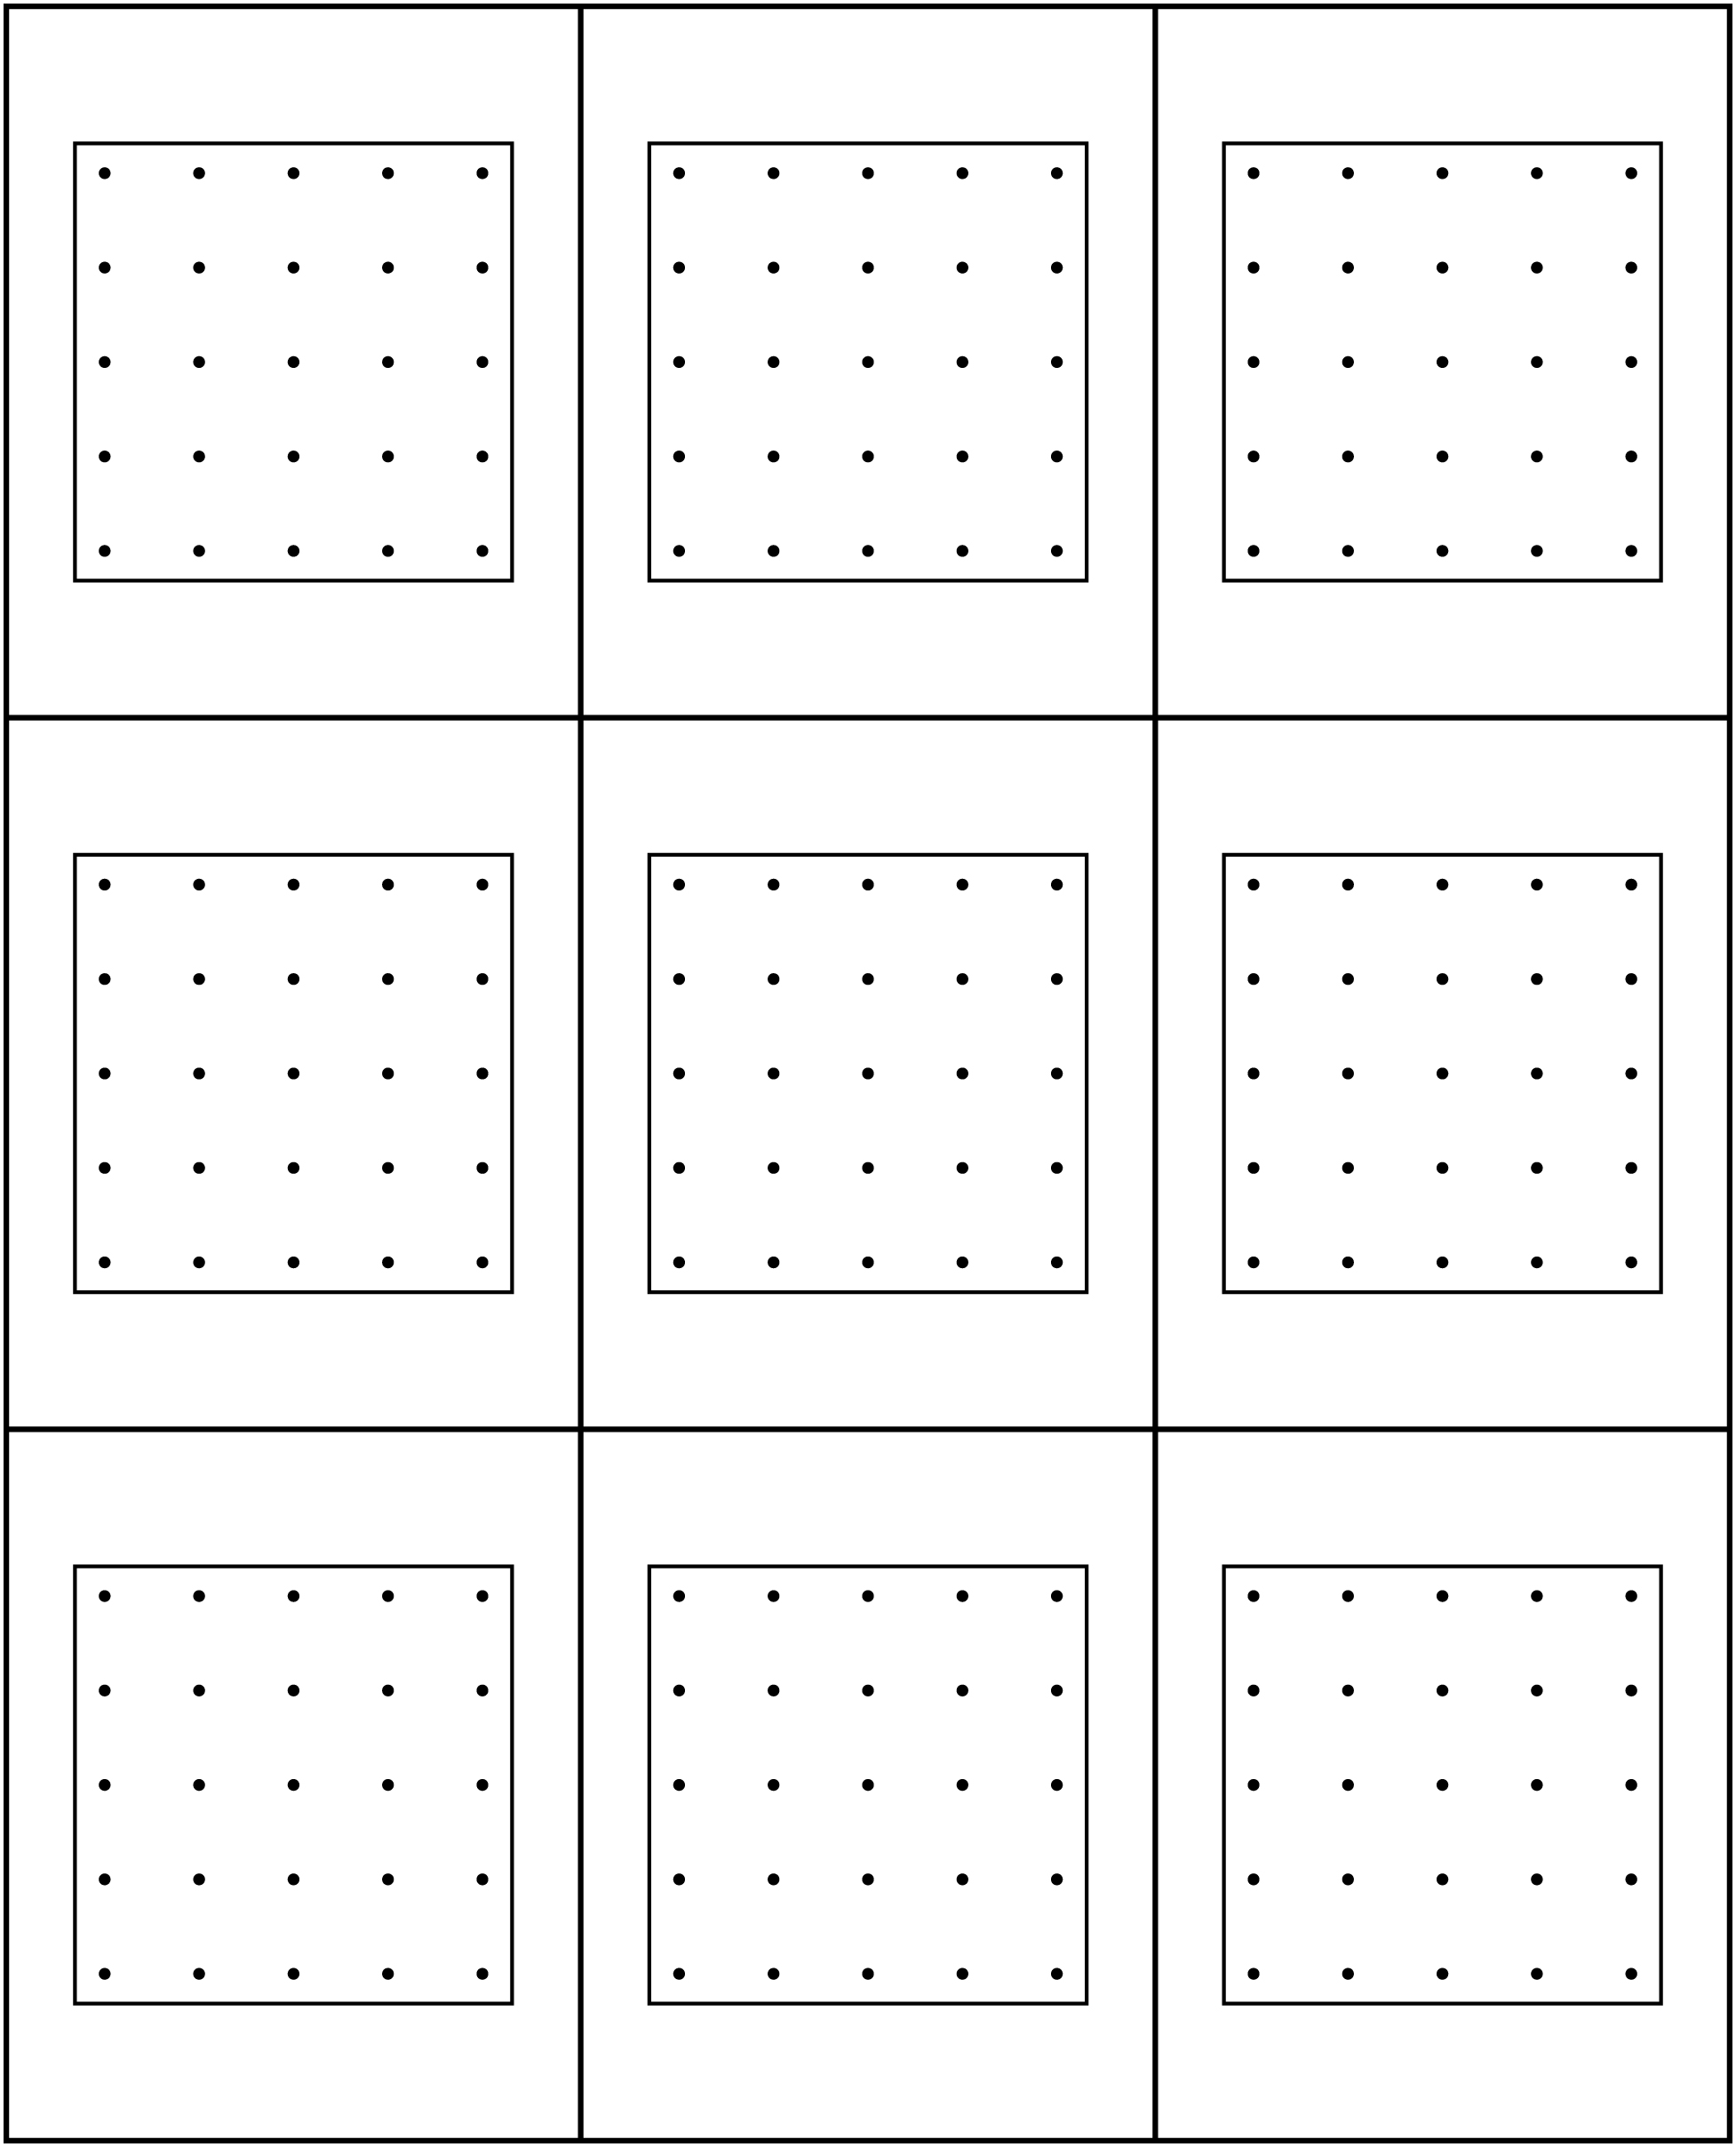

**Geometric Shapes Line Master 6–1**

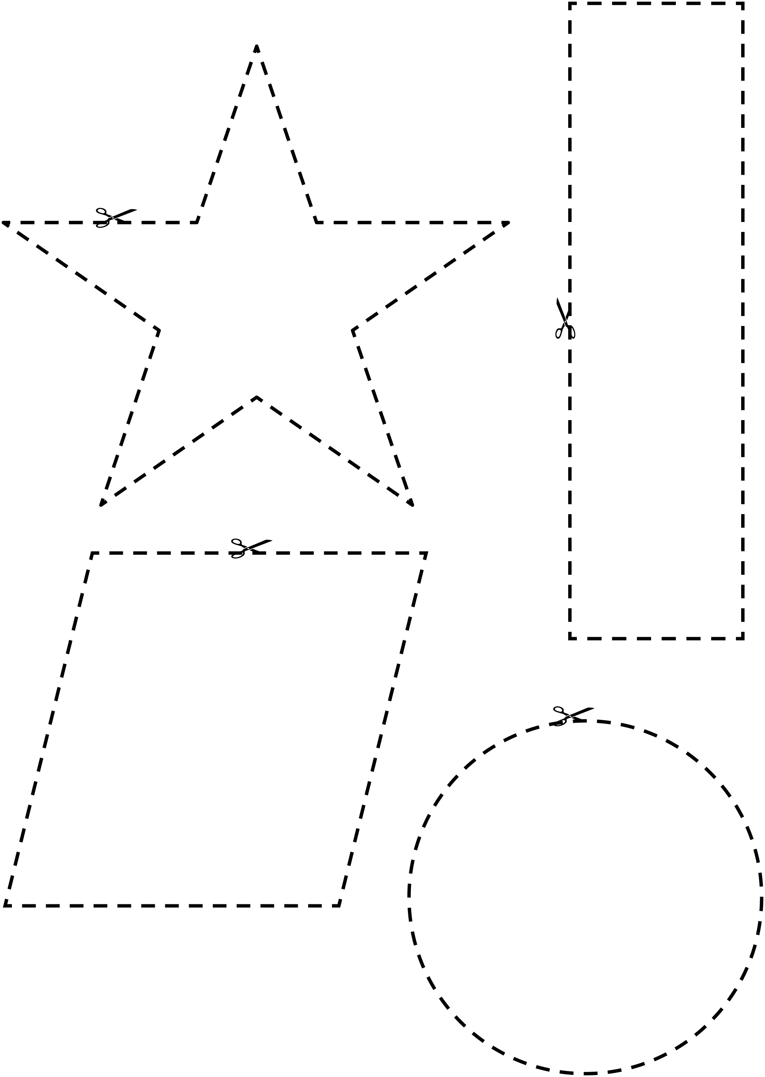

**Geometric Shapes Line Master 6–2**

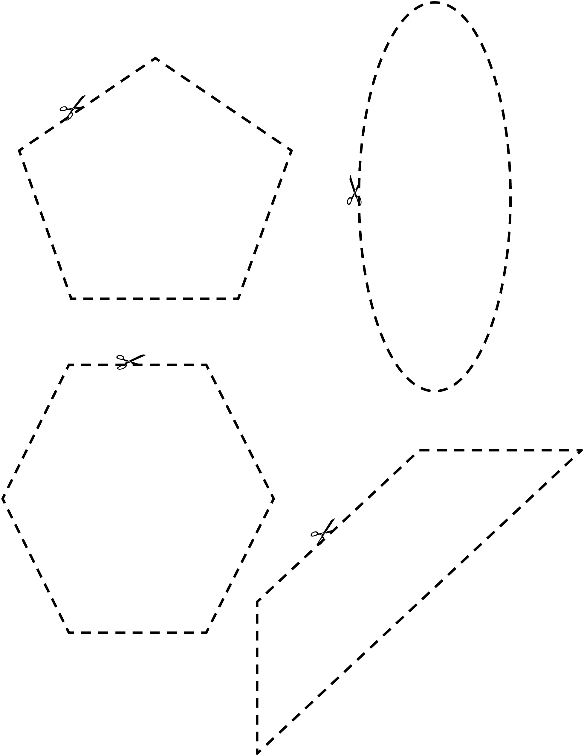

**Geometric Shapes Line Master 6–3**

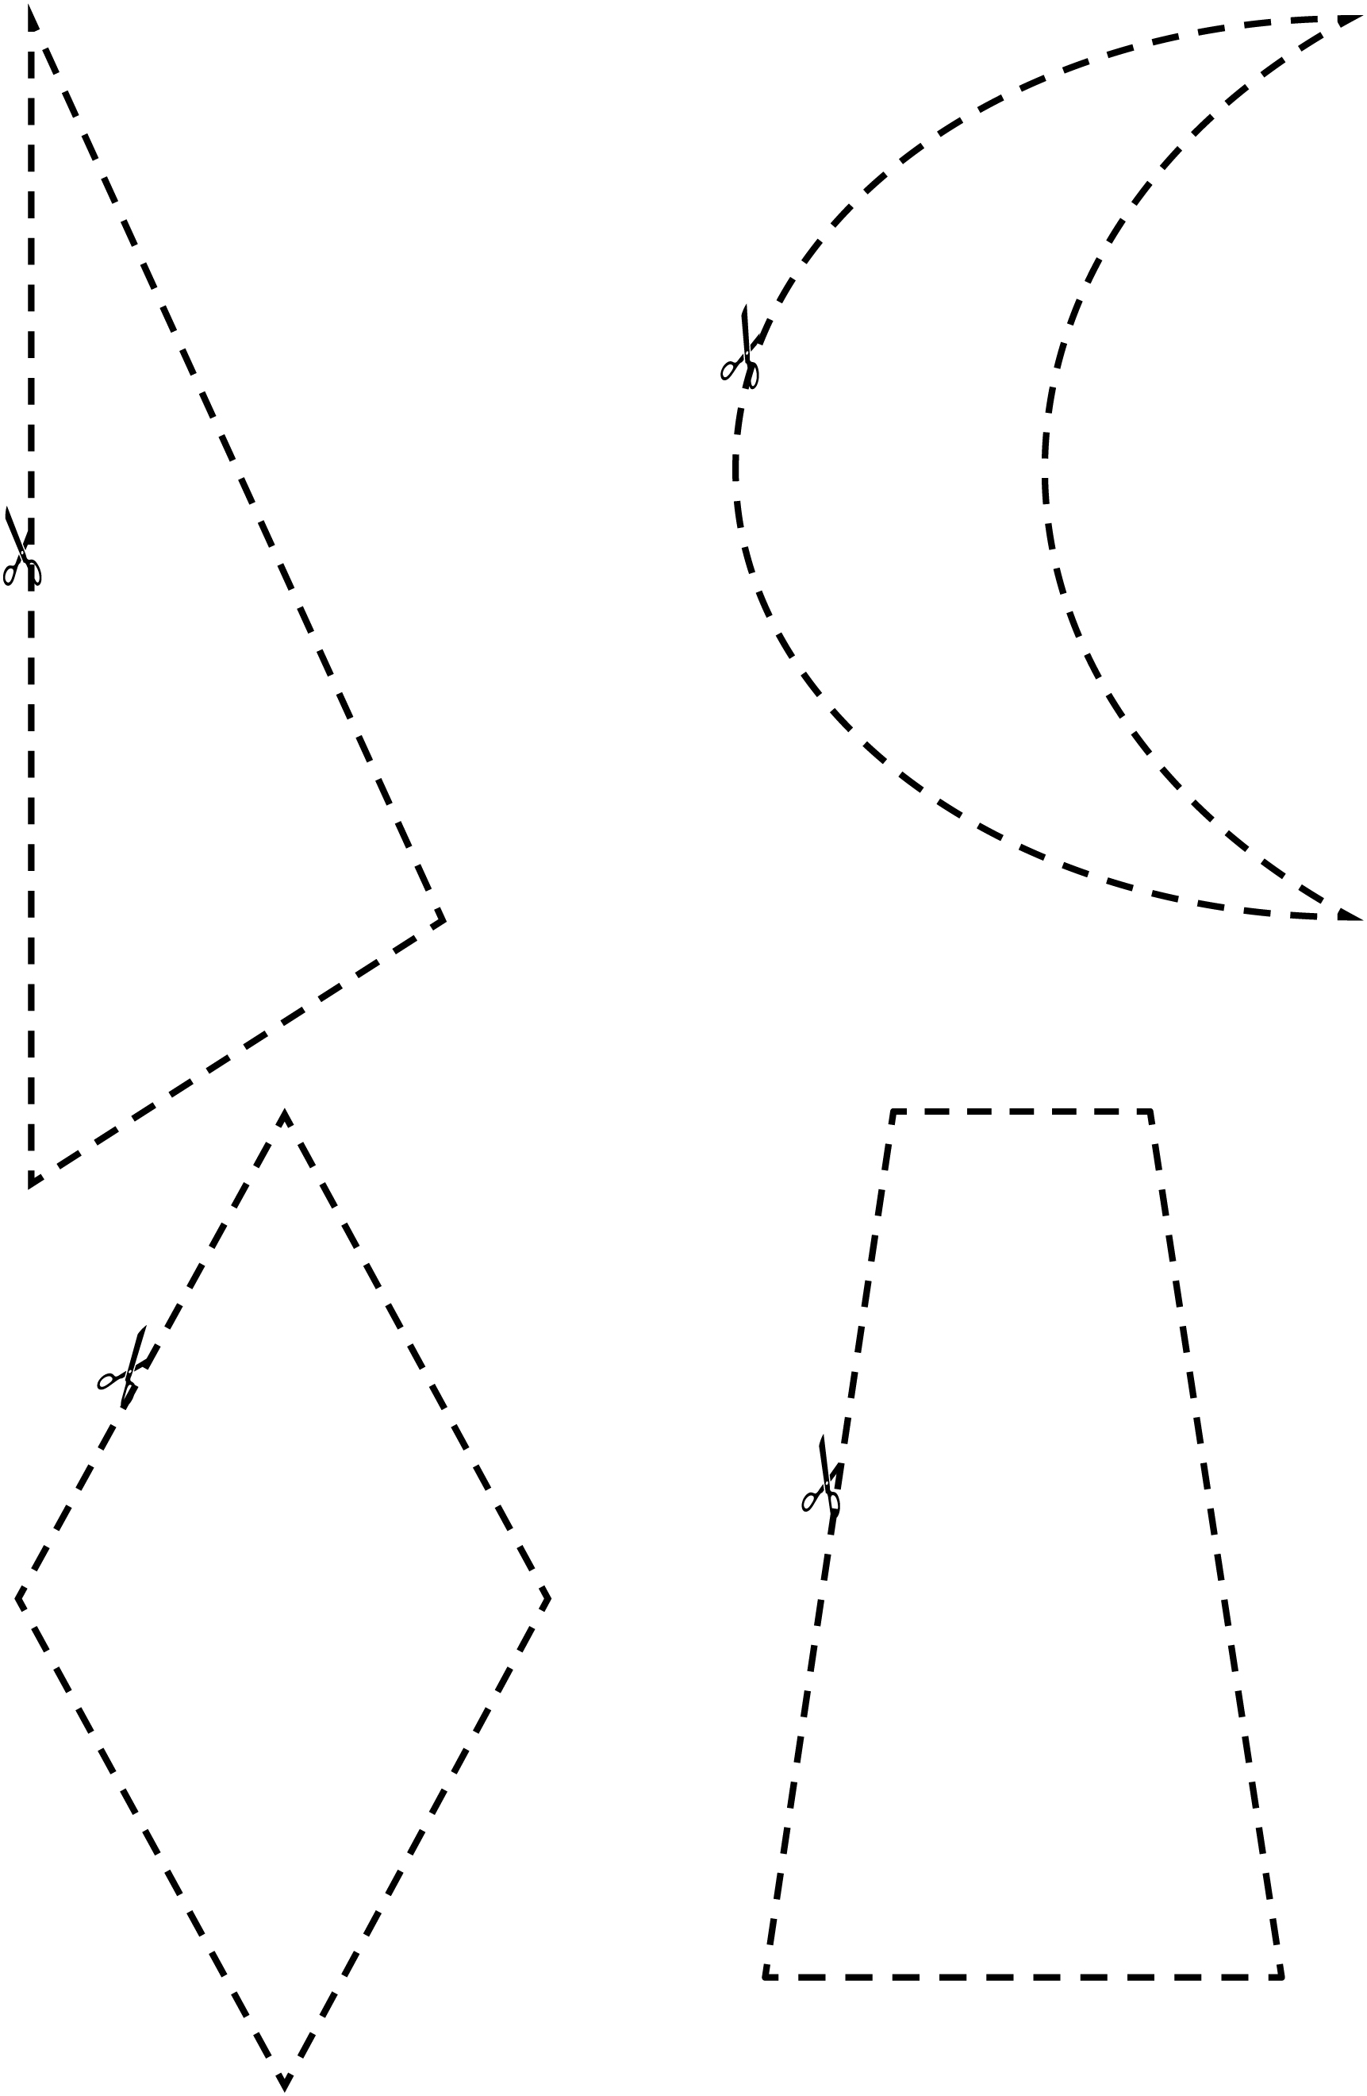

**Spinner Line Master 7–1**

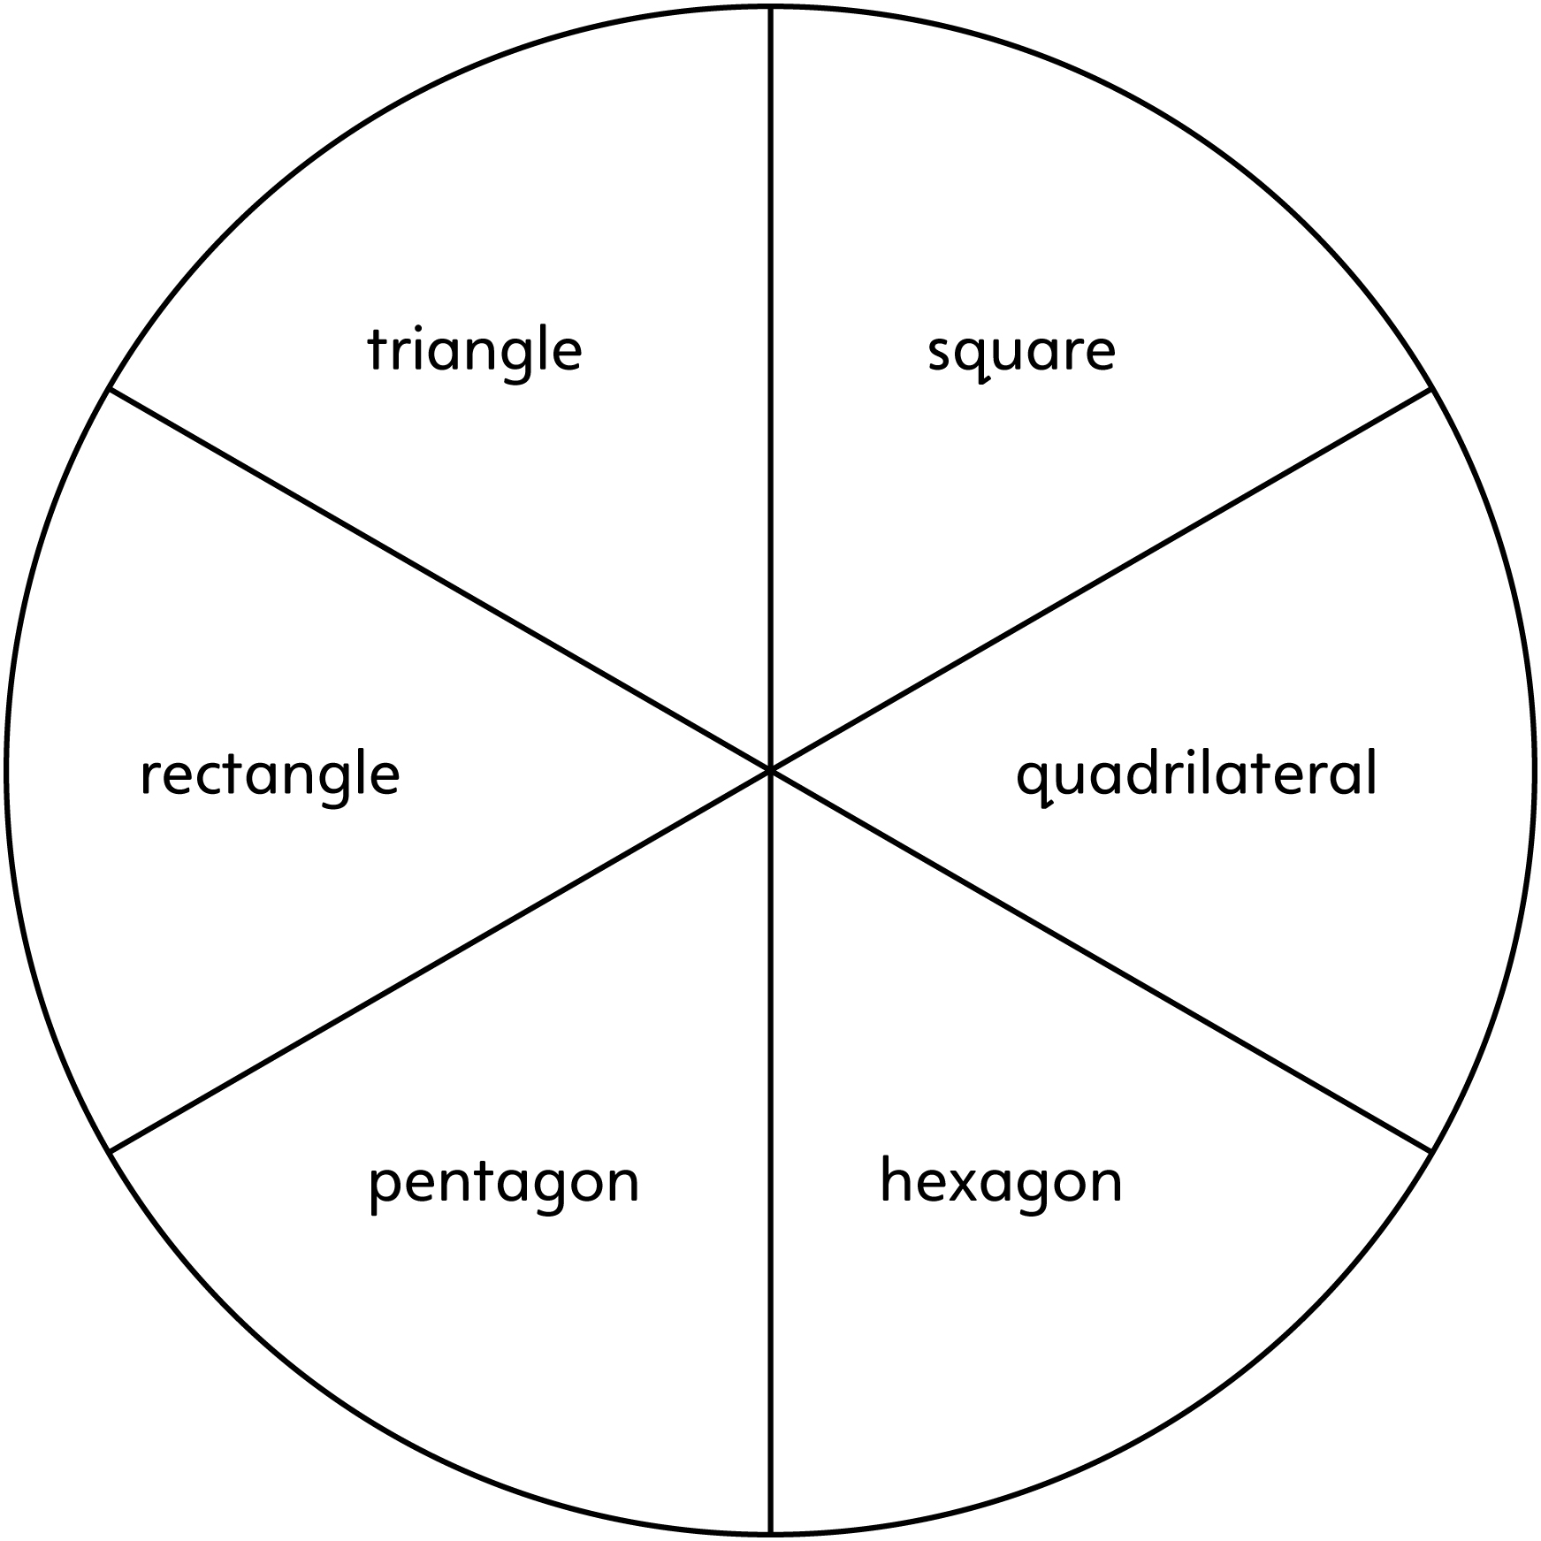

**Spinner Line Master 7–2**

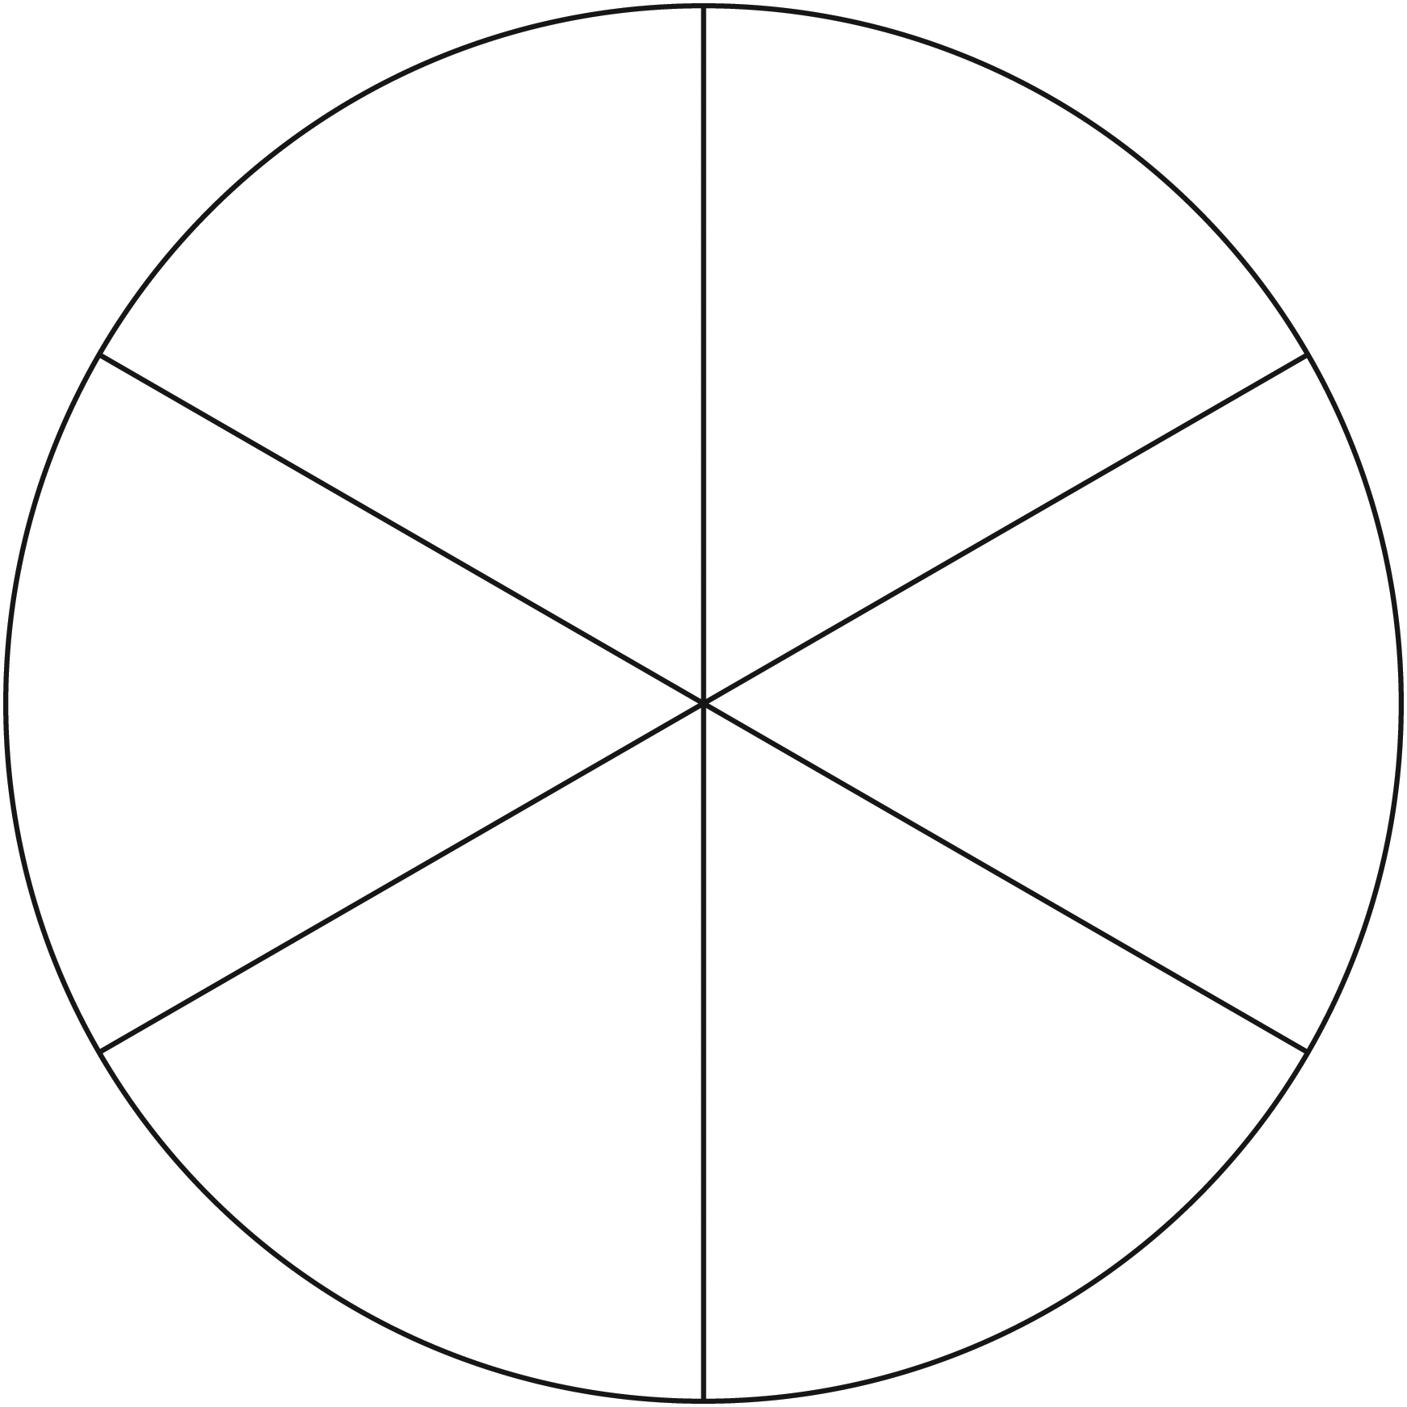

**Shape Solutions Line Master 8–1**

✂ – – – – – – – – – – – – – – – – – – – – – – – – – – – – – – – – – – – – – – – – – –

What shape can you make that has

5 sides and 2 right angles?

✂ – – – – – – – – – – – – – – – – – – – – – – – – – – – – – – – – – – – – – – – – – –

What shape can you make that has

4 sides and 0 right angles?

✂ – – – – – – – – – – – – – – – – – – – – – – – – – – – – – – – – – – – – – – – – – –

What shape can you make that has

3 sides and 0 right angles?

✂ – – – – – – – – – – – – – – – – – – – – – – – – – – – – – – – – – – – – – – – – – –

What shape can you make that has

6 sides with 2 sides that are the same length?

✂ – – – – – – – – – – – – – – – – – – – – – – – – – – – – – – – – – – – – – – – – – –

What shape can you make that has

6 sides with 1 right angle?

✂ – – – – – – – – – – – – – – – – – – – – – – – – – – – – – – – – – – – – – – – – – –

**Shape Solutions Line Master 8–2**



|  |  |
| --- | --- |
| Flip and draw this arrow. | Add lines of symmetry to this H. |
| There is a line of symmetry. Use it to make a symmetrical image. Include at least 2 squares and 2 triangles. | Draw as many lines of symmetry as you can on each shape. |