Goat Island Line Master 1
(Assessment Master)
Name: _____________________________

Measure Time, Temperature, and Length | Not observed | Sometimes | Consistently
Estimates, measures, and describes the passage of time
Uses standard and non-standard units of length
Relates temperatures to experiences of the seasons
Identifies benchmarks for temperature
Explore Units of Measure and Their Relationships
Relates number of days to a week, and number of months to a year in a problem-solving context
Compares non-standard units of length to standard units
Uses the measurement of familiar objects as benchmarks to estimate another measure in standard units
Strengths:

Next Steps:

Connecting Home and School Line Master 2–1

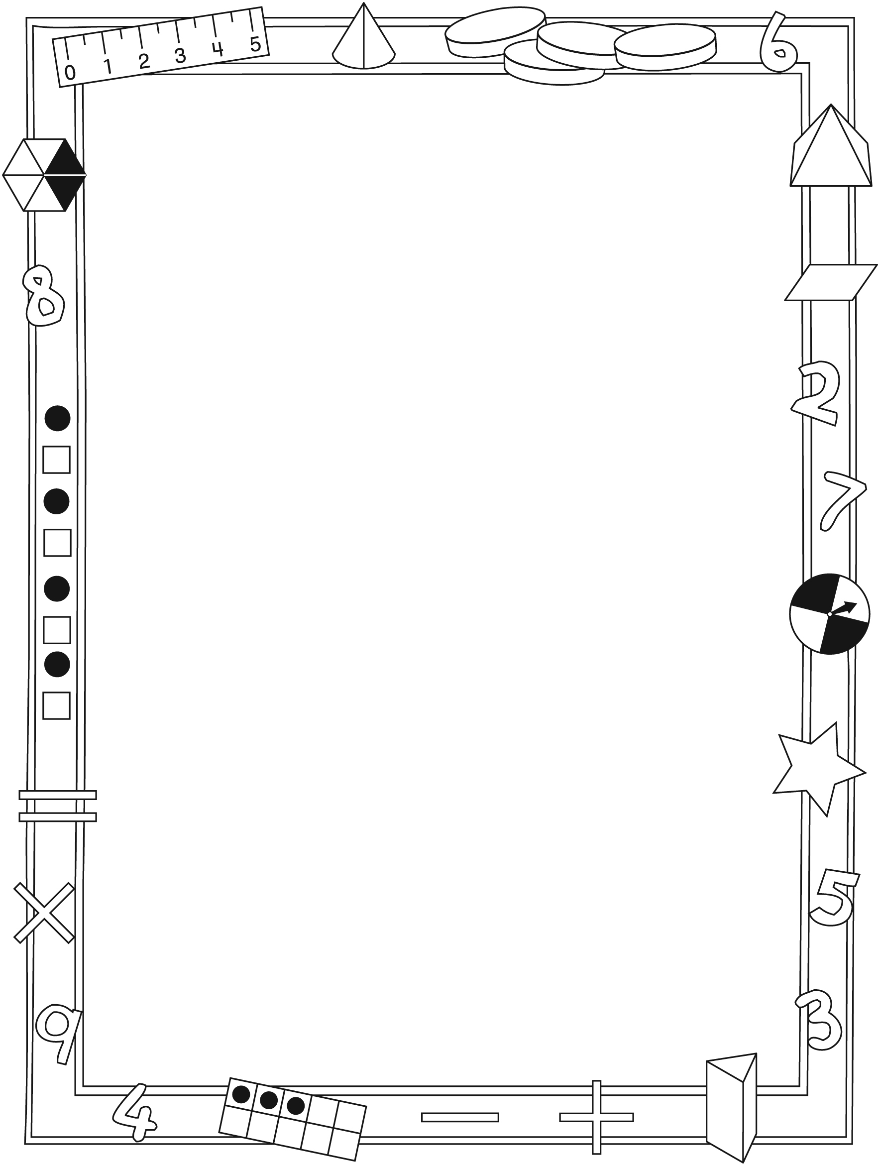

NOTE TO THE TEACHER

You may wish to send families a Goat Island letter outlining a familiar activity or two they can do at home with their children.

Create a letter using this template and select one or two activities from the suggestions on the next page. Simply delete these instructions and cut and paste the activities you have selected, adapting them to fit your needs.

Connecting Home and School Line Master 2–2

Dear Family:

We have been working on Goat Island, which engages children in conversations, investigations, and activities that help to develop their understanding of the big math idea that “Units can be used to measure and compare attributes.” Particular focus is placed on measuring time, temperature, and length, as well as understanding the relationship between units of measure. Try this activity at home with your child.
– – – – – – – – – – – – – – – – – – – – – – – – – – – – – – – – – – – – – – – – – –
Reading the Story: As you read the story, encourage your child to identify the changes in nature over time. Invite your child to estimate different measurements and make connections to her/his own life. Encourage your child to compare temperatures and predict what will happen each season.
– – – – – – – – – – – – – – – – – – – – – – – – – – – – – – – – – – – – – – – – – –
How Much Time?: Encourage your child to figure out how long parts of her/his daily routine take and/or how long different activities last. For example, how many songs can he/she listen to on the way to school? Which takes longer, eating dinner or watching an episode of a favourite television show?
Challenge your child to develop personal benchmarks for measuring time.
– – – – – – – – – – – – – – – – – – – – – – – – – – – – – – – – – – – – – – – – – –
Measuring Temperature: Review the weather forecast with your child. Encourage your child to keep a daily record of the temperature in the morning and evening. Challenge your child to use the information to predict upcoming temperatures and weather conditions.
– – – – – – – – – – – – – – – – – – – – – – – – – – – – – – – – – – – – – – – – – –
Finding Similar Lengths: Invite your child to choose a household object to estimate the length of and then measure. Challenge your child to find other objects with similar lengths and compare them.
– – – – – – – – – – – – – – – – – – – – – – – – – – – – – – – – – – – – – – – – – –
Sincerely,

___________________________

Goat Island Math Mat Line Master 3

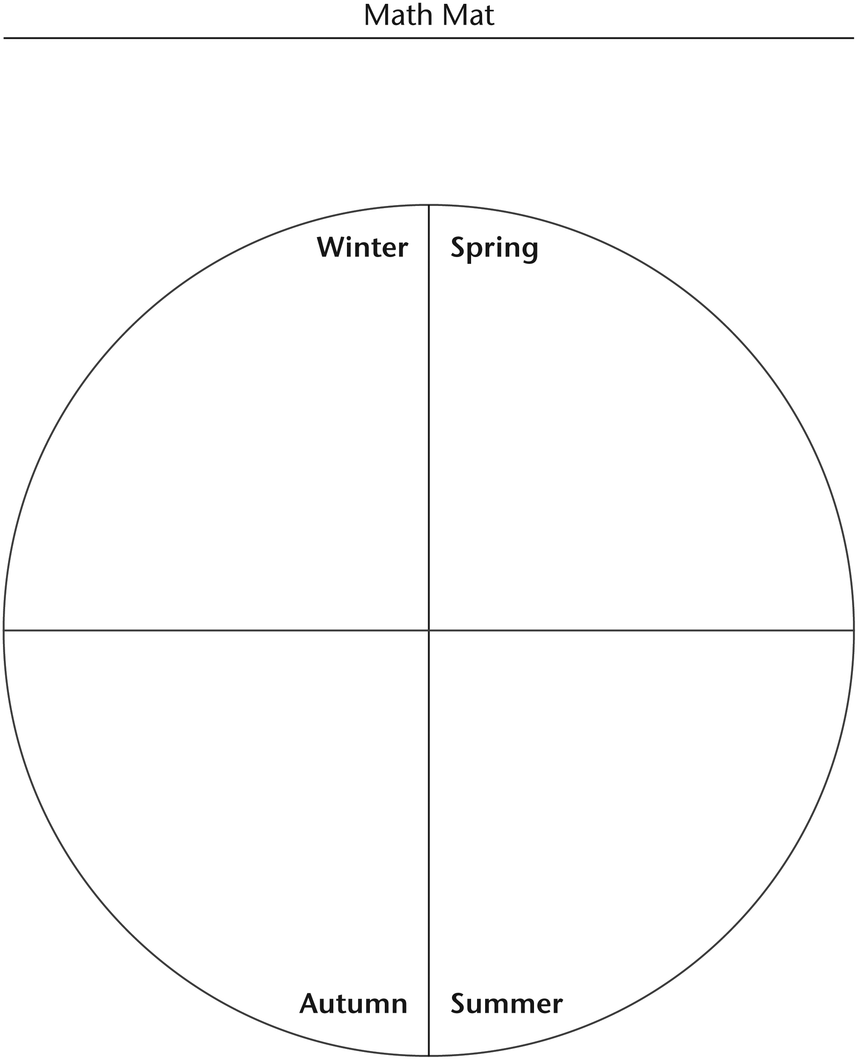

What’s the Temperature? Line Master 4
Name: _____________________________
City: _____________________________

Date | Temperature and Weather Conditions
Date | Morning | Afternoon | Evening
Today:
Tomorrow:

Suggested clothing: _______________________________________________

____________________________________________________________________

____________________________________________________________________

Notes: _____________________________________________________________

____________________________________________________________________

____________________________________________________________________

My Calendar Line Master 5–1
Name: _____________________________

January | February | March

April | May | June

July | August | September

October | November | December

My Calendar Line Master 5–2
Name: _____________________________

September | October | November

December | January | February

March | April | May

June | July | August

Measuring Shadows Line Master 6
– – – – – – – – – – – – – – – – – – – – – – – – – – – – – – – – – – – – – – – – – –
Name: _____________________________

Date | Time of Day | Length of Shadow
– – – – – – – – – – – – – – – – – – – – – – – – – – – – – – – – – – – – – – – – – –
Name: _____________________________

Date | Time of Day | Length of Shadow
– – – – – – – – – – – – – – – – – – – – – – – – – – – – – – – – – – – – – – – – – –

Weekly Calendar Line Master 7
Name: _____________________________

 | Monday | Tuesday | Wednesday | Thursday | Friday
Temperature Inside
Temperature Outside

Measuring Snow Line Master 8
– – – – – – – – – – – – – – – – – – – – – – – – – – – – – – – – – – – – – – – – – –
Name: _____________________________

I am measuring the height of... | Estimate | Actual Height
snow up to my ankles
snow up to my knees
snow up to my waist
– – – – – – – – – – – – – – – – – – – – – – – – – – – – – – – – – – – – – – – – – –
Name: _____________________________

I am measuring the height of... | Estimate | Actual Height
snow up to my ankles
snow up to my knees
snow up to my waist
– – – – – – – – – – – – – – – – – – – – – – – – – – – – – – – – – – – – – – – – – –

Memory Cards Line Master 9–1

Temperature Set

stays  cold | Winter
getting  warmer | Spring
stays  warm | Summer
getting  cooler | Autumn

Memory Cards Line Master 9–2

Time Set

3 seconds | taking a deep breath
15 seconds | saying the alphabet
2 minutes | brushing your teeth
15 minutes | morning recess
30 minutes | eating dinner
3 hours | a game of baseball

Exploring Similar Line Master 10
Measurements
– – – – – – – – – – – – – – – – – – – – – – – – – – – – – – – – – – – – – – – – – –
Name: _____________________________
My object is _______________________________________________________________.
The unit of measure I am using is ______________________________________.
It measures _______________________________________________________________.

Object | Estimated Measurement | Actual Measurement
– – – – – – – – – – – – – – – – – – – – – – – – – – – – – – – – – – – – – – – – – –
Name: _____________________________
My object is _______________________________________________________________.
The unit of measure I am using is ______________________________________.
It measures _______________________________________________________________.

Object | Estimated Measurement | Actual Measurement
– – – – – – – – – – – – – – – – – – – – – – – – – – – – – – – – – – – – – – – – – –

Weather Report Line Master 11
Name: _____________________________

Temperature
Season
What to wear
Tomorrow’s forecast

Measurement Problems Line Master 12–1
– – – – – – – – – – – – – – – – – – – – – – – – – – – – – – – – – – – – – – – – – –
The tree’s shadow is equal to 3 of my giant steps.

That is about 3 m long.

How long is 1 of my giant steps?

Show how you know.

– – – – – – – – – – – – – – – – – – – – – – – – – – – – – – – – – – – – – – – – – –
The tree’s shadow is equal to 8 of my footsteps.

That is about 4 m long.

How long is 1 of my footsteps?

Show how you know.

– – – – – – – – – – – – – – – – – – – – – – – – – – – – – – – – – – – – – – – – – –

Measurement Problems Line Master 12–2
– – – – – – – – – – – – – – – – – – – – – – – – – – – – – – – – – – – – – – – – – –
Suppose you were to go on a trip for 2 weeks.

How many days would you be away?

Show how you know.

– – – – – – – – – – – – – – – – – – – – – – – – – – – – – – – – – – – – – – – – – –
Suppose you were to go on a trip for 2 months.

About how many days would you be away?

Show how you know.

– – – – – – – – – – – – – – – – – – – – – – – – – – – – – – – – – – – – – – – – – –

