Measurements About YOU! Line Master 1
(Assessment Master)
Name: _____________________________

Estimate, Measure, and Compare Attributes | Not observed | Sometimes | Consistently
Uses familiar referents to estimate measures
Estimates, measures, and compares length
Estimates, measures, and compares mass
Estimates, measures, and compares capacity
Estimates, measures, and compares area
Identify and Relate Measures
Selects appropriate units for measuring
Compares and relates linear measures
Relates millilitres to litres
Relates grams to kilograms
Strengths:

Next Steps:

Connecting Home and School Line Master 2–1

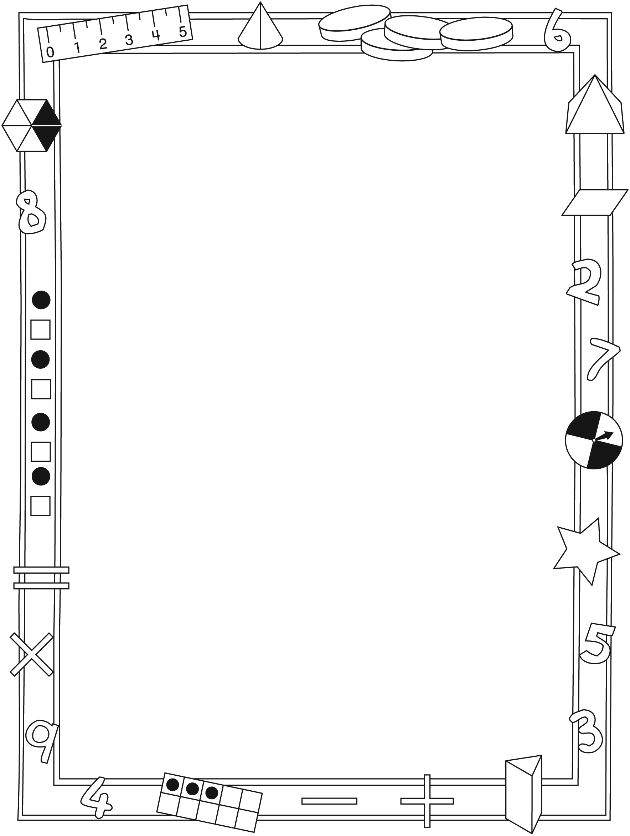

NOTE TO THE TEACHER

You may wish to send families a Measurements About YOU! letter outlining a familiar activity or two they can do at home with their children.

Create a letter using this template and select one or two activities from the suggestions on the next page. Simply delete these instructions and cut and paste the activities you have selected, adapting them to fit your needs.

Connecting Home and School Line Master 2–2

Dear Family:

We have been working on Measurements About YOU!, which engages children in conversations, investigations, and activities that help to develop their understanding of the big math idea that “Units can be used to measure and compare attributes.” Particular focus is placed on estimating, measuring, and comparing length, mass, capacity, and area. Try this activity at home.
– – – – – – – – – – – – – – – – – – – – – – – – – – – – – – – – – – – – – – – – – –
Reading the Story: As you read, ask your child to share what he/she finds to be an interesting measurement. Together, you might estimate, measure, and compare the heights of different family members. You also might pull strands of hair from willing family members and then estimate, measure, and compare hair length.
– – – – – – – – – – – – – – – – – – – – – – – – – – – – – – – – – – – – – – – – – –
Litres and Kilograms: What can you find at home with a measure of 1 litre (L) or 1 kilogram (kg)? Encourage your child to search the refrigerator and cupboards to find containers that hold 1 L, as well as for packages that have a mass of 1 kg. Have your child draw, photograph, and/or list what she/he finds and bring these findings to class by (date).
– – – – – – – – – – – – – – – – – – – – – – – – – – – – – – – – – – – – – – – – – –
Finding Benchmark Lengths: Encourage your child to search for and record items that have a length close to or exactly 1 centimetre (cm), 10 cm, and 1 m. Please ensure your child brings her/his findings to class by (date).
– – – – – – – – – – – – – – – – – – – – – – – – – – – – – – – – – – – – – – – – – –
Personal Measures: The book begins with the character sharing birth measures. If you have such records about your child, you might share them with her/him. If you have records from annual doctor checkups, your child may be interested in seeing those, as well. You can talk about growth and together make some predictions.
– – – – – – – – – – – – – – – – – – – – – – – – – – – – – – – – – – – – – – – – – –
Sincerely,

___________________________

Measurements About YOU! Line Master 3
Math Mat

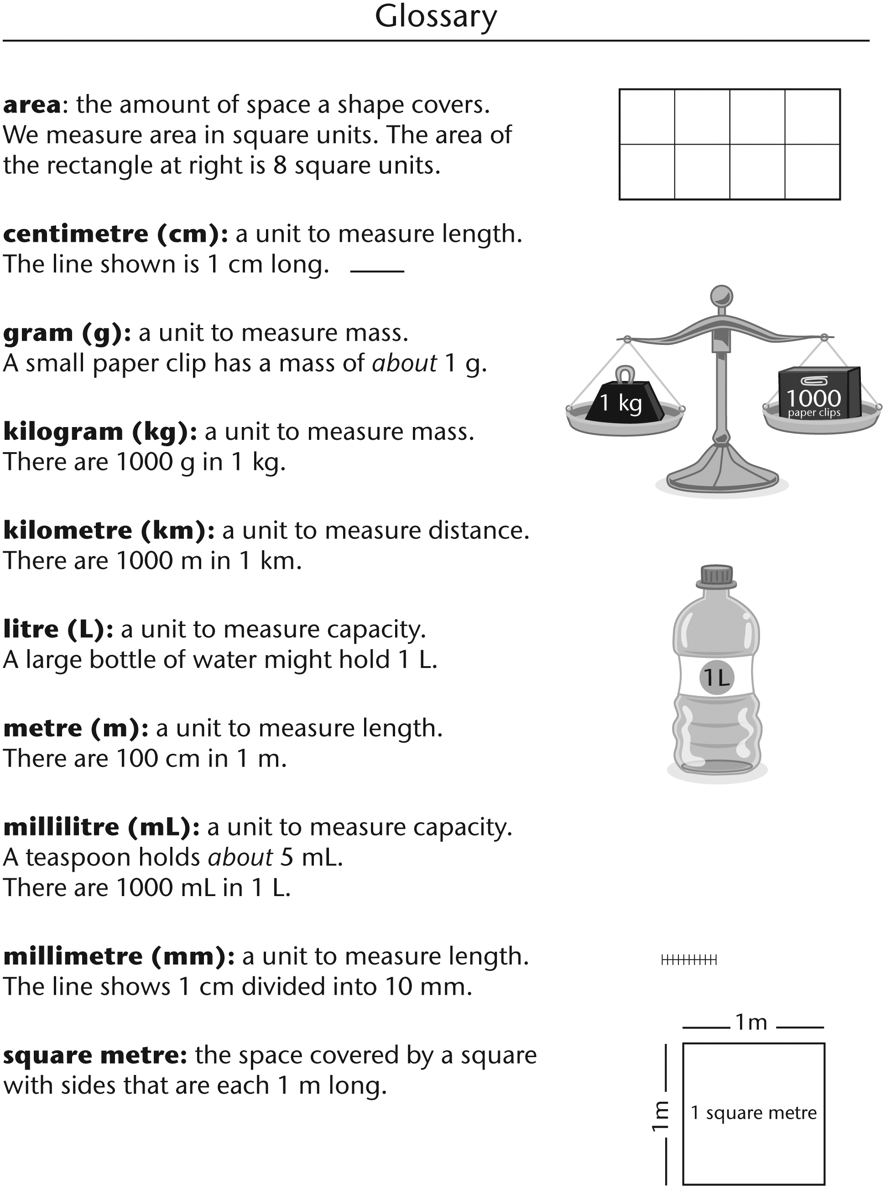

Comparing Body Lengths Line Master 4
Name: _____________________________

I am comparing | My estimate | My measure | I found out that...
leg length  to  arm length | __________  __________ | __________  __________
________________  to  ________________ | __________  __________ | __________  __________
________________  to  ________________ | __________  __________ | __________  __________
________________  to  ________________ | __________  __________ | __________  __________

Grid Paper Line Master 5–1
2 Centimetre

Grid Paper Line Master 5–2
1 Centimetre

Measuring Lengths Line Master 6
Name: _____________________________

I am measuring | My estimate | My measure

Make a Metre Line Master 7–1

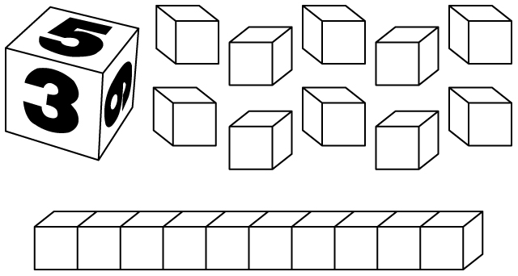

What you need:
• number cube
• Base Ten unit cubes and rods

How to Play
• Take turns rolling the number cube. Take that number of cubes or rods. For example, if you roll 5:
• You can take 5 cubes to make a length of 5 cm.
OR
• You can take 5 rods to make a length of 50 cm.
• Whenever you have 10 unit cubes, trade them for 1 rod.
• Record each turn. After 7 turns, stop and find your total length. The player closest to 1 m scores 1 point. Getting 1 m exactly scores 2 points. Here is an example of how to record:

Turn | Player Addie | Player Eric
1 | 3 cm | 20 cm
2 | 10 cm | 30 cm
3 | 20 cm | 6 cm
4 | 10 cm | 2 cm
5 | 40 cm | 10 cm
6 | 2 cm | 30 cm
7 | 6 cm | 5 cm
Total Length | 91 cm | 103 cm
How Close? | 9 cm under | 3 cm over

Make a Metre Line Master 7–2
– – – – – – – – – – – – – – – – – – – – – – – – – – – – – – – – – – – – – – – – – –
Turn | Player _____________ | Player _____________
1
2
3
4
5
6
7
Total Length
How Close?
– – – – – – – – – – – – – – – – – – – – – – – – – – – – – – – – – – – – – – – – – –
Turn | Player _____________ | Player _____________
1
2
3
4
5
6
7
Total Length
How Close?
– – – – – – – – – – – – – – – – – – – – – – – – – – – – – – – – – – – – – – – – – –

What’s the Measure? Line Master 8–1
Problems

Measuring Length and Height
– – – – – – – – – – – – – – – – – – – – – – – – – – – – – – – – – – – – – – – – – –
Here are body measurements some children made. Who ordered her/his measurements from least to greatest?

Sofia’s measures: 15 cm, 65 cm, 1 m, 90 cm
Matti’s measures: 2 m, 165 cm, 58 cm, 1 m
Raja’s measures: 10 cm, 95 cm, 130 cm, 2 m
Eden’s measures: 87 cm, 78 cm, 100 cm, 1 m
– – – – – – – – – – – – – – – – – – – – – – – – – – – – – – – – – – – – – – – – – –
Oliver measured his height and his arm span.
He is 1 m 38 cm tall. His arm span is 135 cm.
Which is longer?
Explain your thinking.
– – – – – – – – – – – – – – – – – – – – – – – – – – – – – – – – – – – – – – – – – –
The playground needs a new fence.
Circle the unit of measure they should use.
kilometres metres centimetres millimetres
Explain your thinking.
– – – – – – – – – – – – – – – – – – – – – – – – – – – – – – – – – – – – – – – – – –
Circle the best estimate for the height of the ceiling.
150 cm 2 m 2 m 50 cm 3 m
Explain your thinking.
– – – – – – – – – – – – – – – – – – – – – – – – – – – – – – – – – – – – – – – – – –

What’s the Measure? Line Master 8–2
Problems

Measuring Capacity and Mass
– – – – – – – – – – – – – – – – – – – – – – – – – – – – – – – – – – – – – – – – – –
Alexis recorded some personal measures for her Measurements About ME! book. Which unit should
she use for each measure?
height foot length
weight hair length
lung capacity skin on palm
– – – – – – – – – – – – – – – – – – – – – – – – – – – – – – – – – – – – – – – – – –
When you were born, your length and weight were measured.
What unit was used to measure your length?
What unit was used to measure your weight?
Explain your thinking.
– – – – – – – – – – – – – – – – – – – – – – – – – – – – – – – – – – – – – – – – – –
Which measure would you see on a milk carton?
1 L 1 kg 1 m
– – – – – – – – – – – – – – – – – – – – – – – – – – – – – – – – – – – – – – – – – –
Which measure would you see on a bag of flour?
2 L 2 kg 2 m
– – – – – – – – – – – – – – – – – – – – – – – – – – – – – – – – – – – – – – – – – –
Which measure would you see on a cereal box?
650 g 650 L 650 cm 650 kg
– – – – – – – – – – – – – – – – – – – – – – – – – – – – – – – – – – – – – – – – – –

What’s the Measure? Line Master 8–3
Problems

Measuring Area 1
What is the area of this shape? = 1 square unit

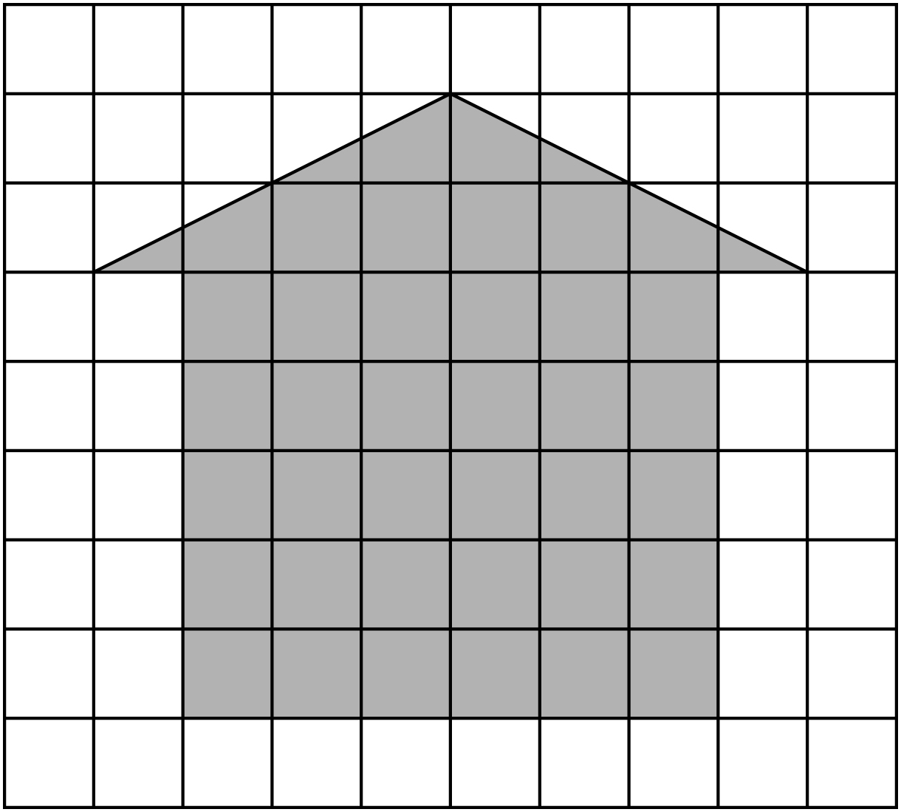

Draw a shape with the same area as the shape above.

What’s the Measure? Line Master 8–4
Problems

Measuring Area 2

Which shape has an area of 9 square units?
Which shape has the greatest area?
Which shape has the least area?

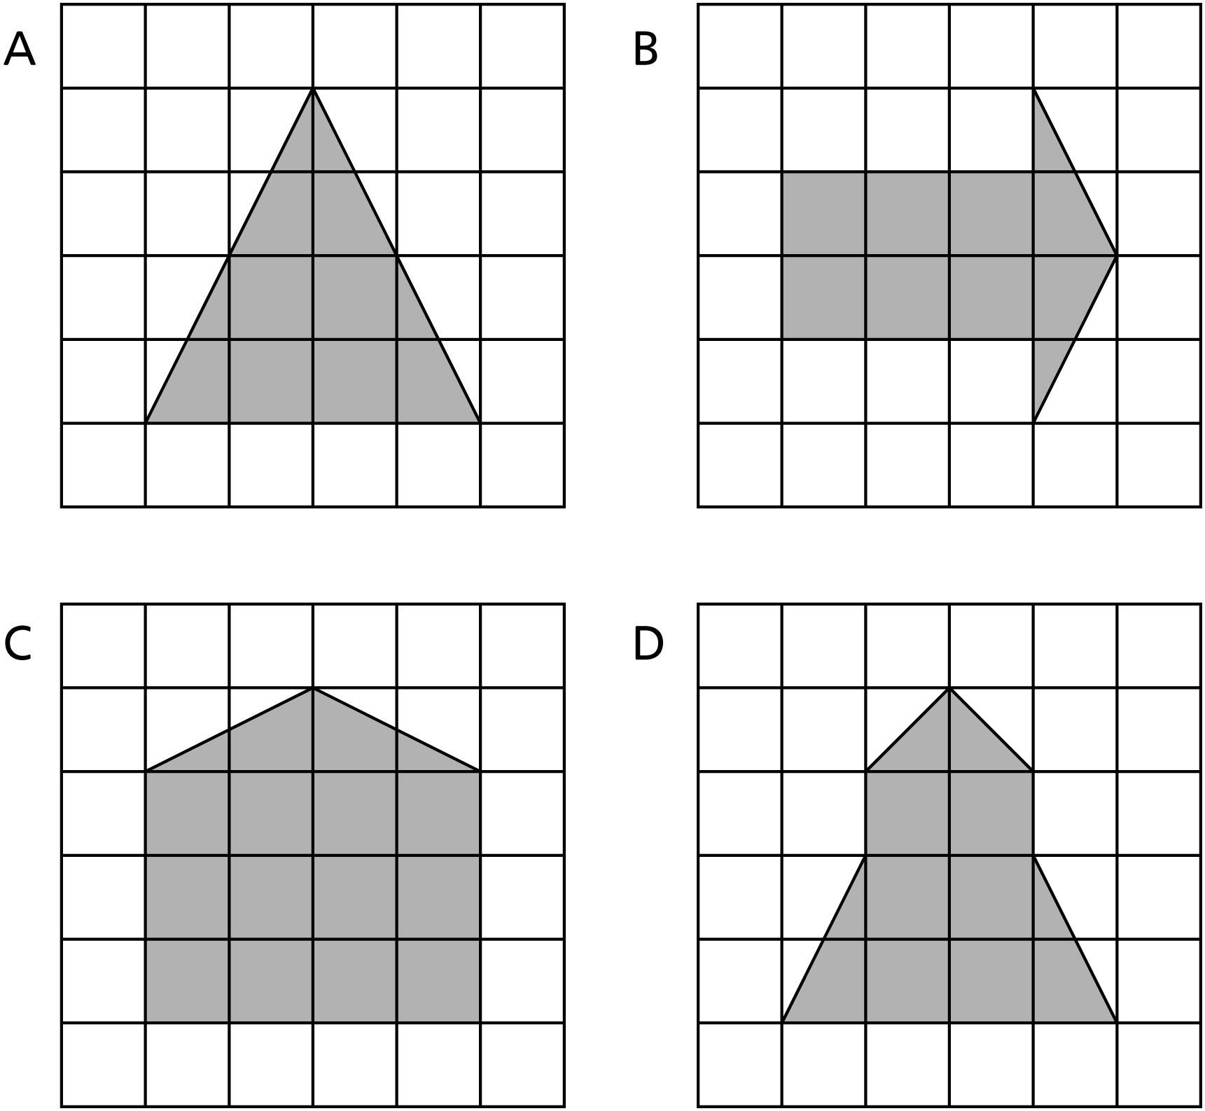

Draw a shape with an area of 16 square units.

