WONDERful Buildings Line Master 1
(Assessment Master)
Name: _____________________________

Identify, Describe, and Compare  2-D Shapes and 3-D Solids | Not observed | Sometimes | Consistently
Classifies and names 2-D shapes and 3-D solids
Constructs and compares 2-D shapes and 3-D solids with given attributes
Uses geometric properties to classify and compare 2-D shapes and
3-D solids
Compose and Decompose
2-D Shapes and 3-D Solids
Composes 2-D shapes by combining or partitioning 2-D shapes
Constructs 3-D solids from nets
Strengths:

Next Steps:

Connecting Home and School Line Master 2–1

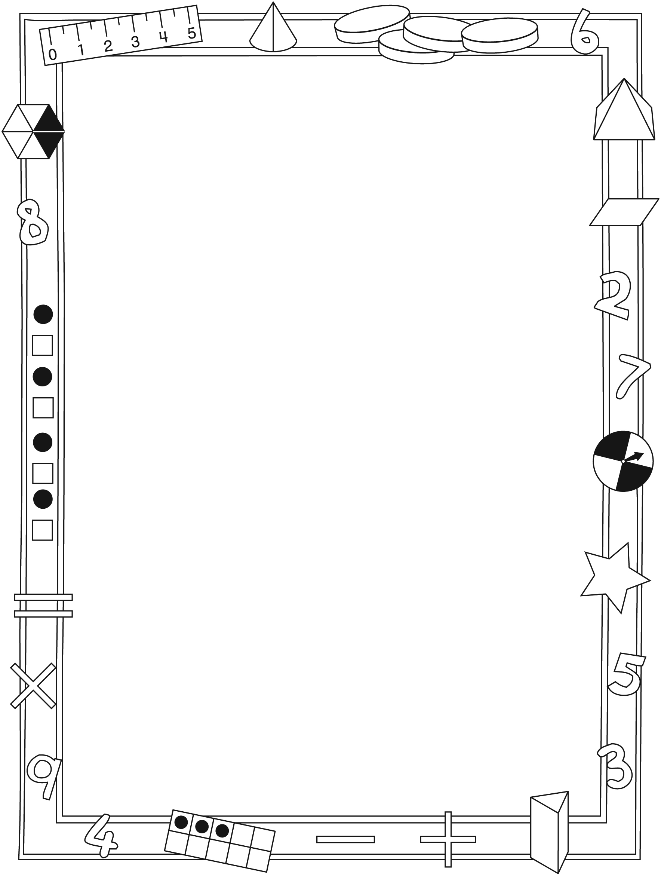

NOTE TO THE TEACHER

You may wish to send families a WONDERful Buildings letter outlining a familiar activity or two they can do at home with their children.

Create a letter using this template and select one or two activities from the suggestions on the next page. Simply delete these instructions and cut and paste the activities you have selected, adapting them to fit your needs.

Connecting Home and School Line Master 2–2

Dear Family:

We have been working on WONDERful Buildings, which engages children in conversations, investigations, and activities that help to develop their understanding of the big math idea that “Shapes and solids can be explored and compared based on attributes.” Particular focus is placed on identifying, describing, and comparing 2-D shapes and 3-D solids. Try this activity at home with your child.
– – – – – – – – – – – – – – – – – – – – – – – – – – – – – – – – – – – – – – – – – –
Reading the Story: Ask your child to share what he/she finds to be the most interesting building in the book. Discuss whether you agree with her/his choice. Page 24 prompts you to vote for a building for the new list of modern wonders. Encourage your child to survey other family members and friends to see how choices compare.
– – – – – – – – – – – – – – – – – – – – – – – – – – – – – – – – – – – – – – – – – –
New List of Modern Wonders: We are talking about other buildings that could be on the new list of modern wonders. Please search online with your child for possible entries. Search terms such as “cool buildings,” “special buildings,” and “tall buildings” will lead you to images that are interesting and worth discussing. You can email or print your entries. We look forward to discussing all the choices.
– – – – – – – – – – – – – – – – – – – – – – – – – – – – – – – – – – – – – – – – – –
Making Models: We made models of structures and buildings using straws and modelling clay. Your child has a resealable plastic bag with similar building materials to use at home. He or she will show you how to create skeletal models (pyramids, cubes, prisms, and others). Together, try to use all of the materials (and feel free to add to them) to create an interesting one-of-a-kind model. Please have your child transport this back to school by (date). It might be best to transport it in a shoebox or other similar container.
– – – – – – – – – – – – – – – – – – – – – – – – – – – – – – – – – – – – – – – – – –
Sincerely,

___________________________

WONDERful Buildings Line Master 3
Math Mat

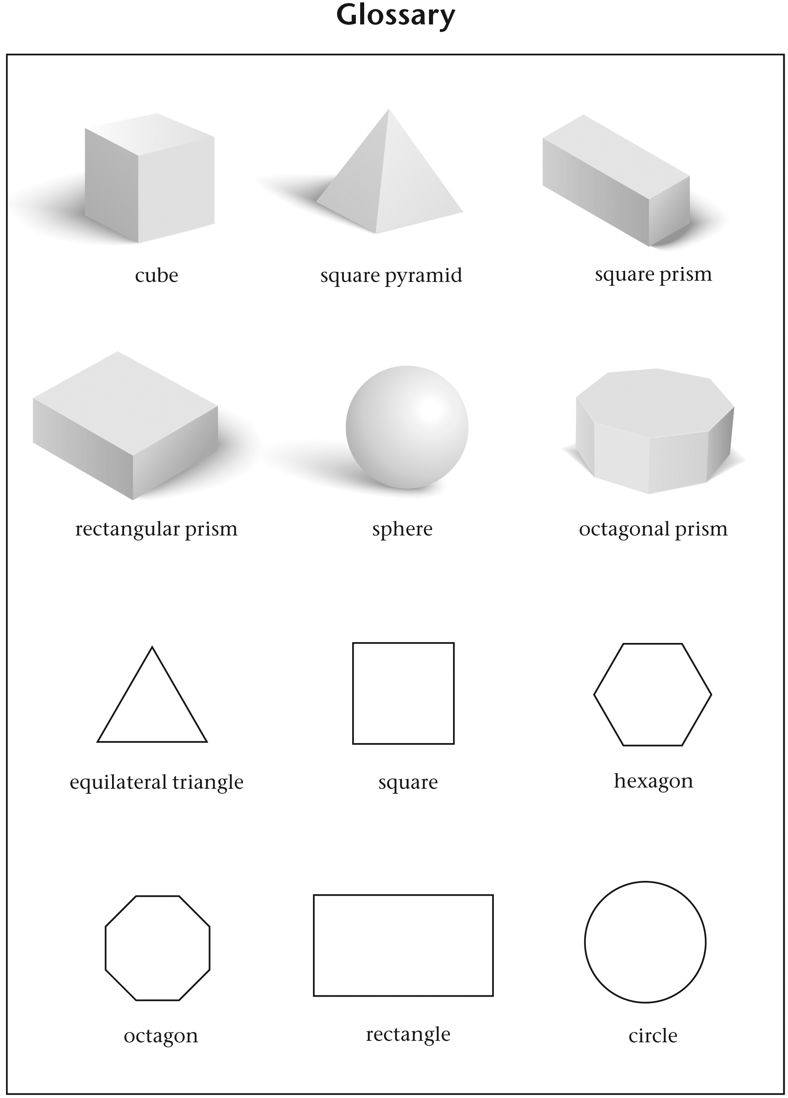

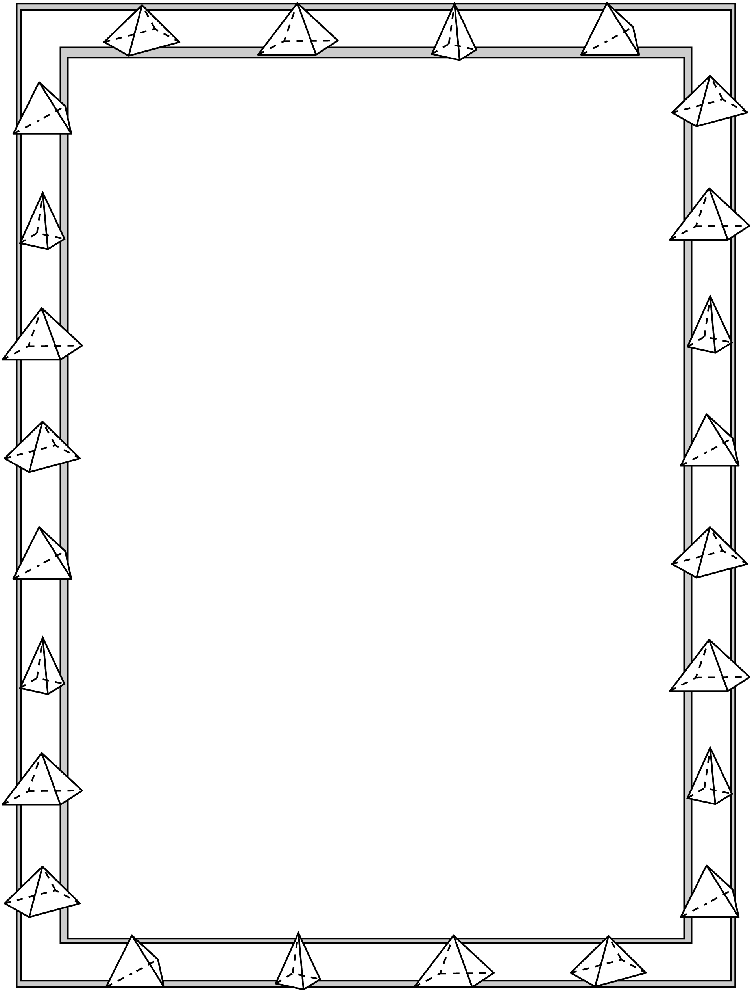
Great Pyramids Line Master 4
Name: _____________________________

I plan to make a pyramid with a base that is
______________________________________.

I will need ____________ straws and ____________ balls of clay.

Sketch a plan of the pyramid you plan to build.
Include labels for edges, faces, and vertices.

Mark the line to show how successful you were in building the pyramid you planned.

not successful very successful

Explain!

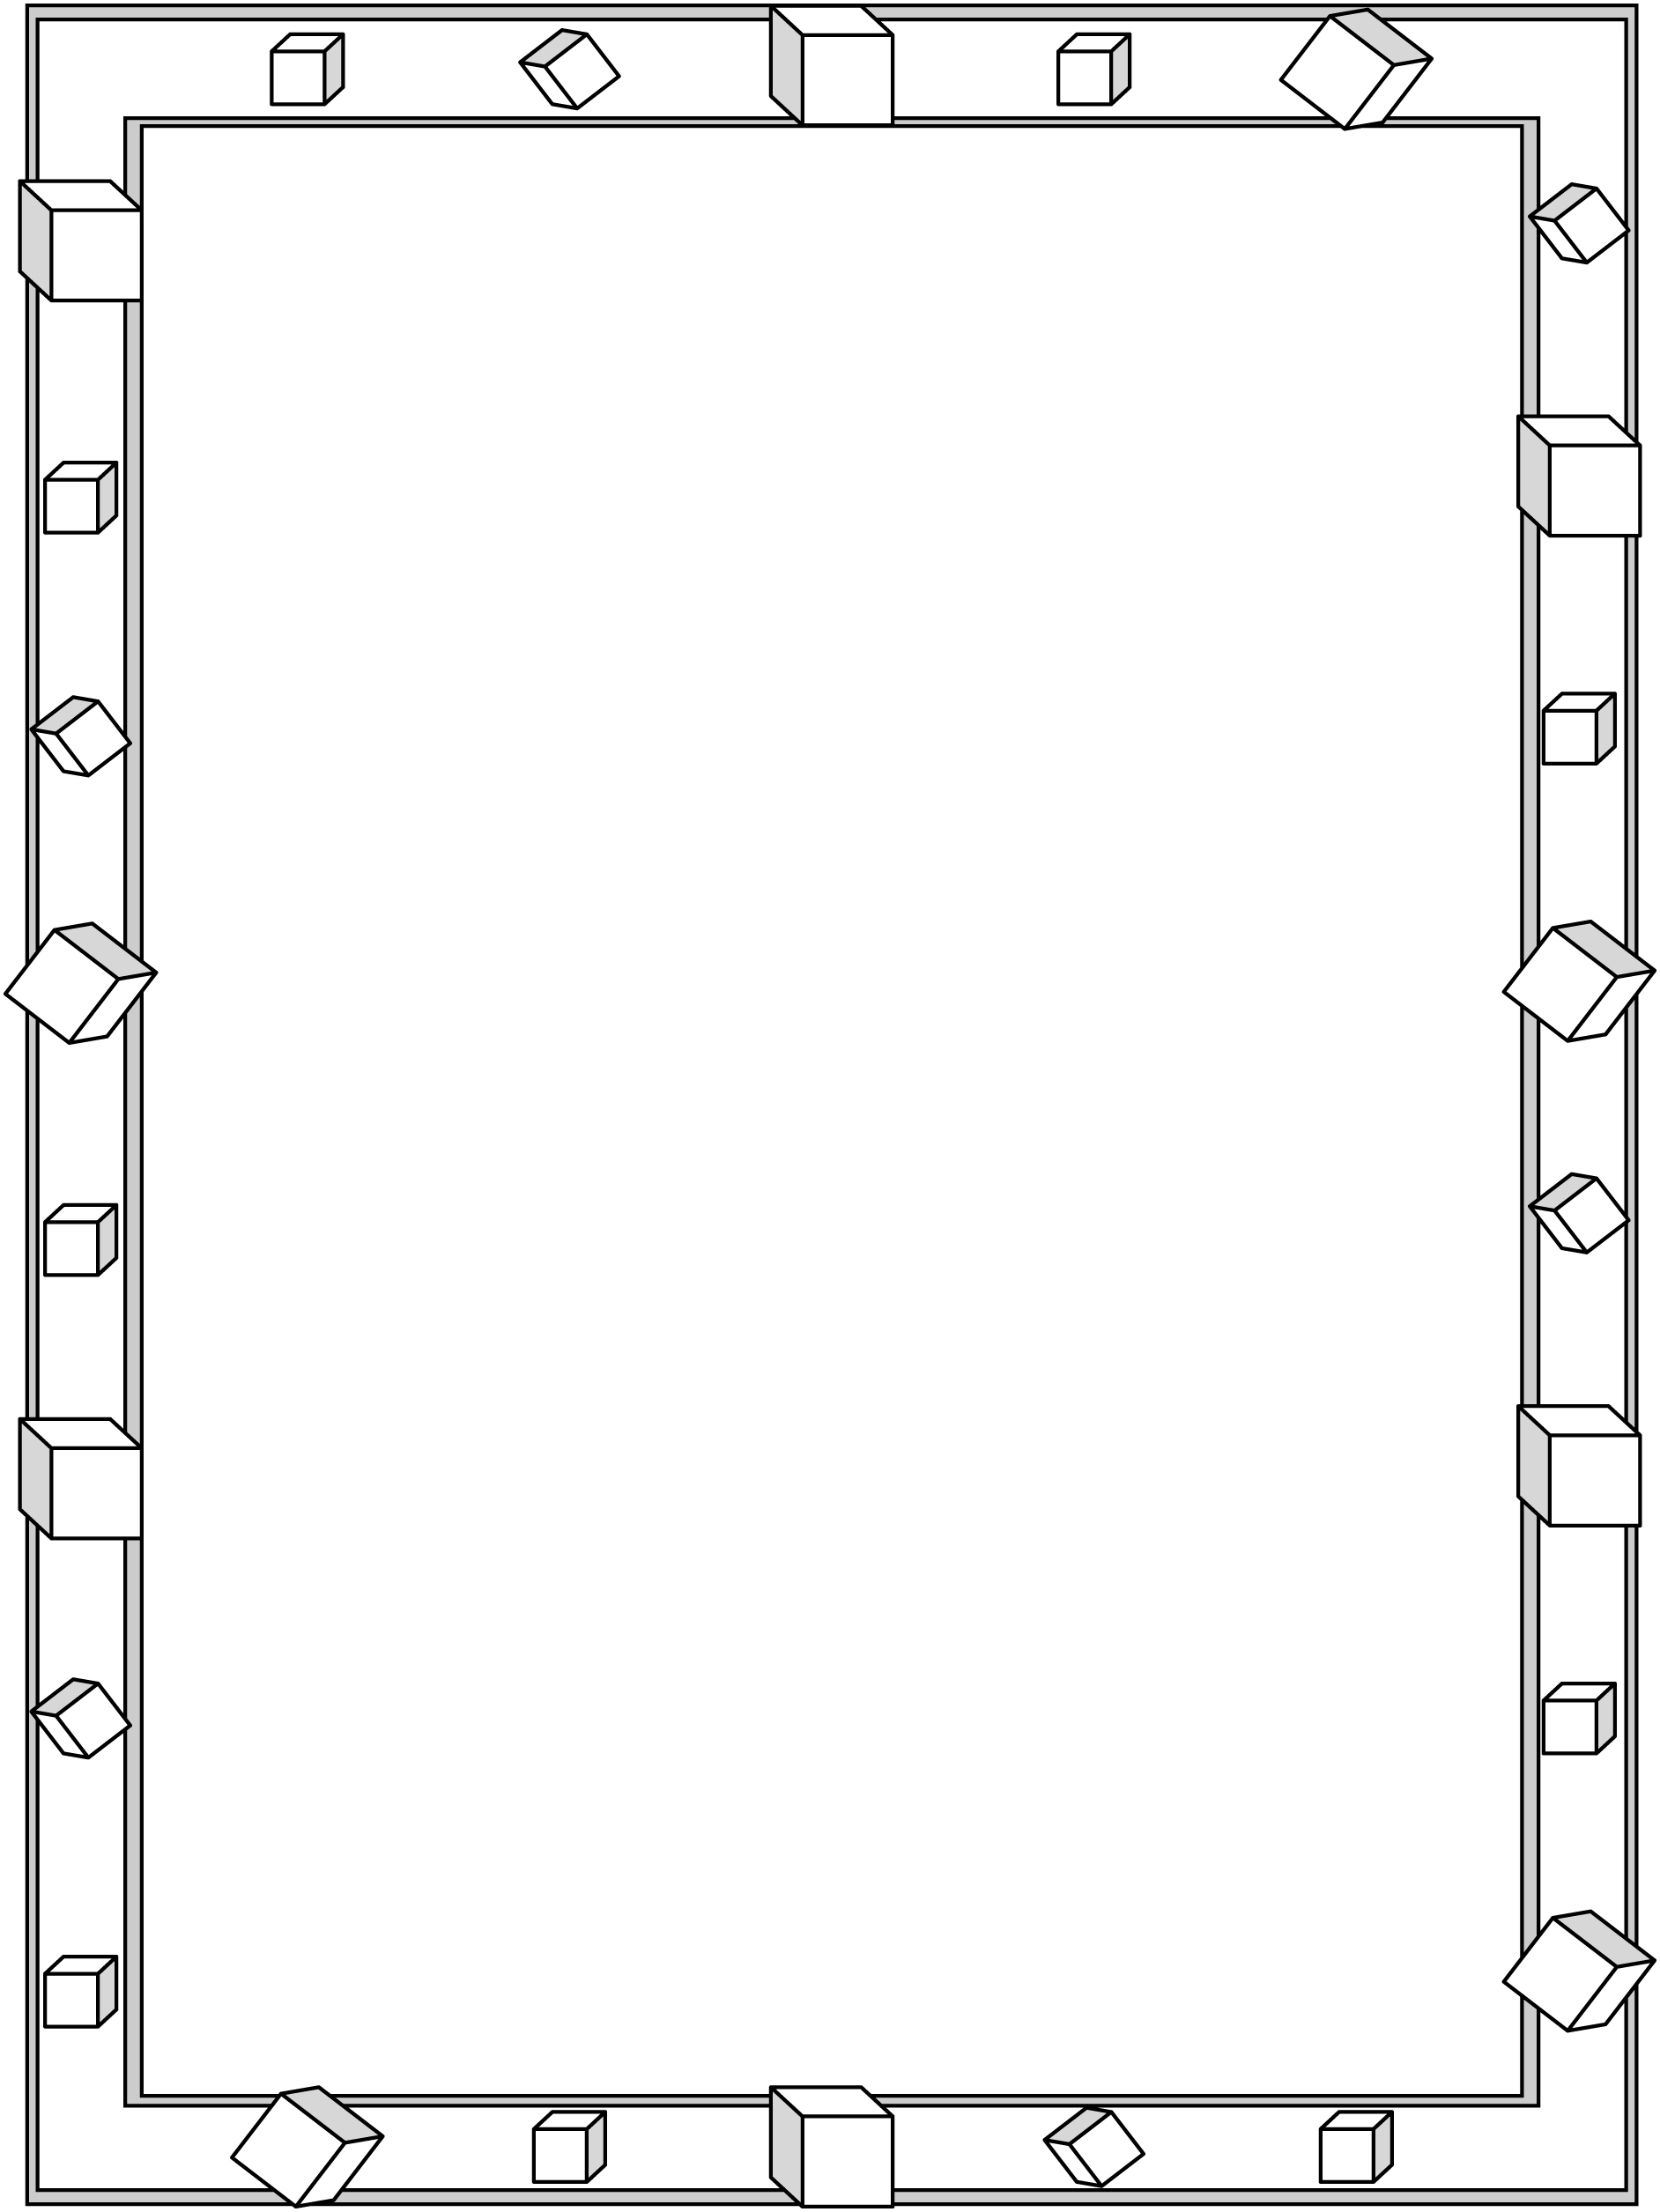
Making Models Line Master 5
Name: _____________________________

I plan to make a model of a _________________________________________.

I will need ____________ straws and ____________ balls of clay.

Sketch a plan of the model you plan to build.
Include labels for edges, faces, and vertices.

Mark the line to show how successful you were in building the model you planned.

not successful very successful

Explain!

Nets Line Master 6–1

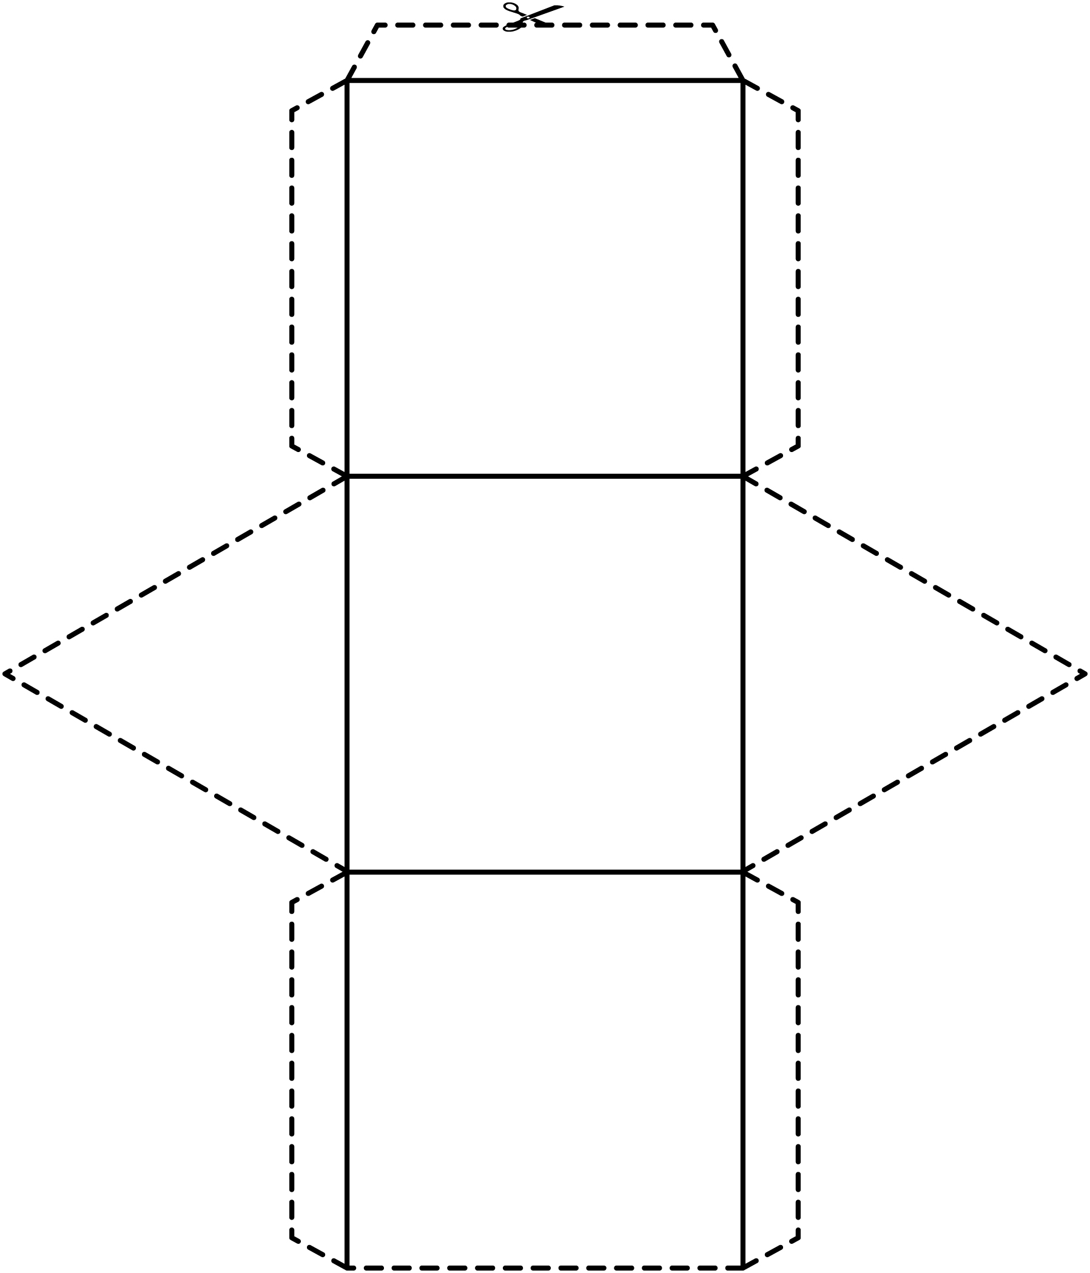

Nets Line Master 6–2

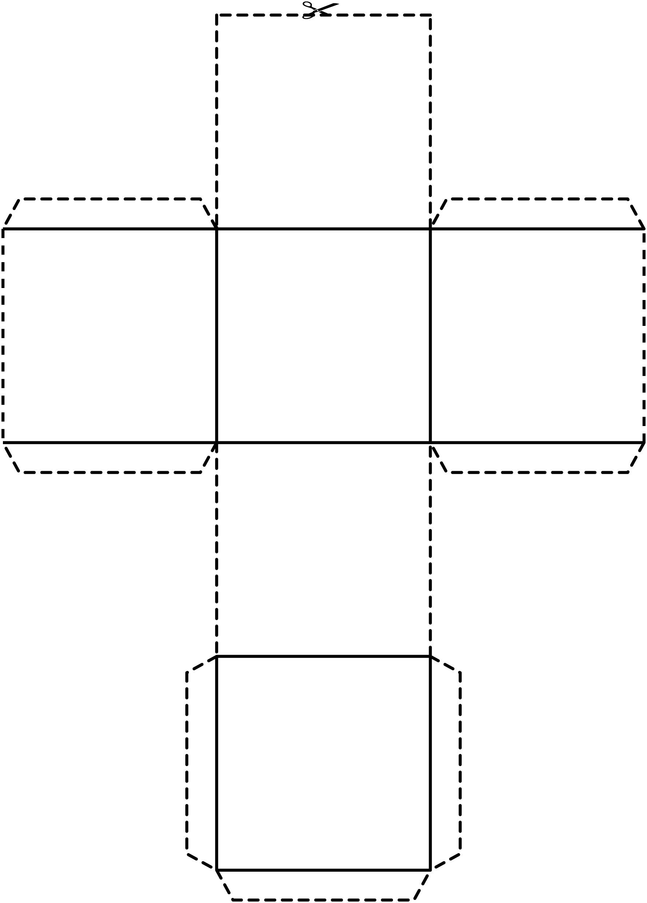

Nets Line Master 6–3
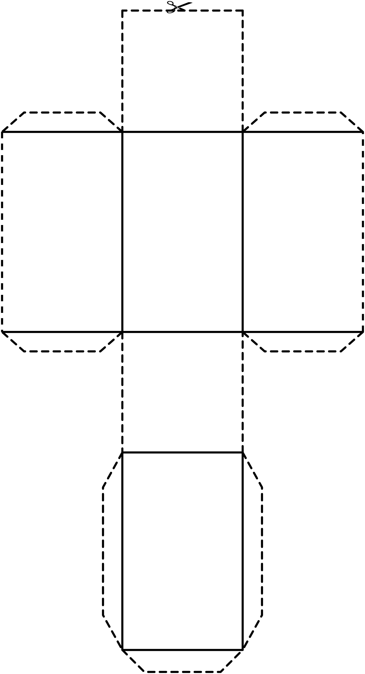

Nets Line Master 6–4

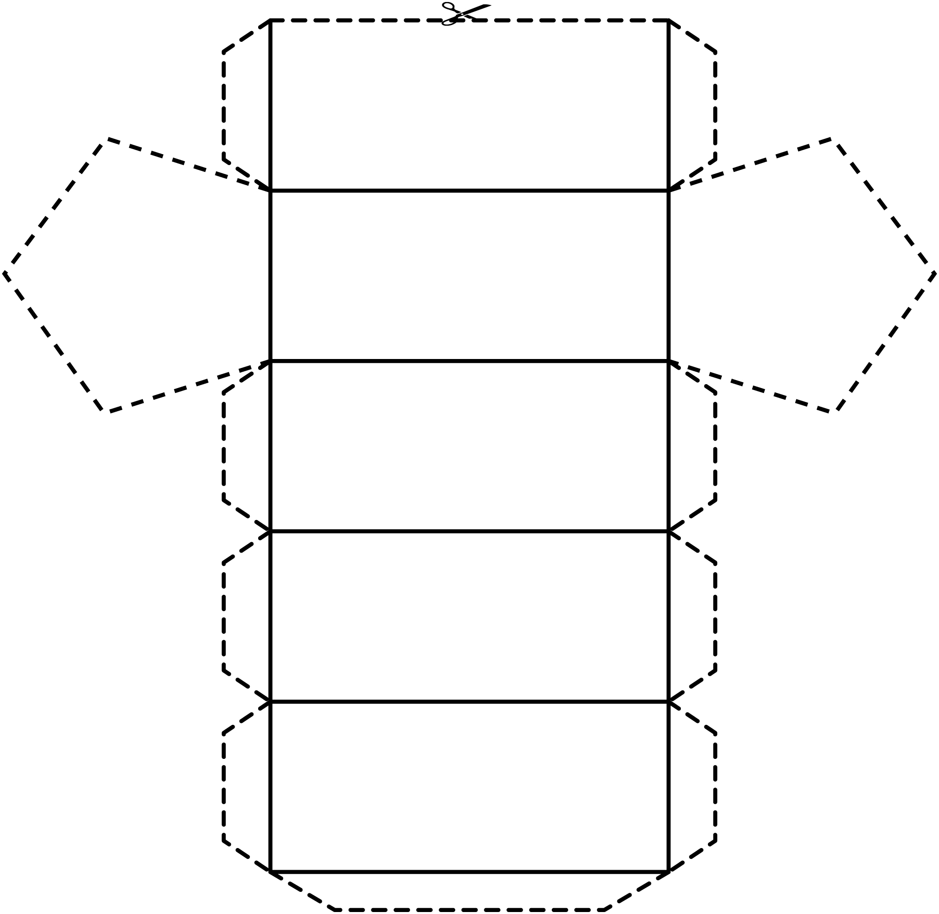

Nets Line Master 6–5

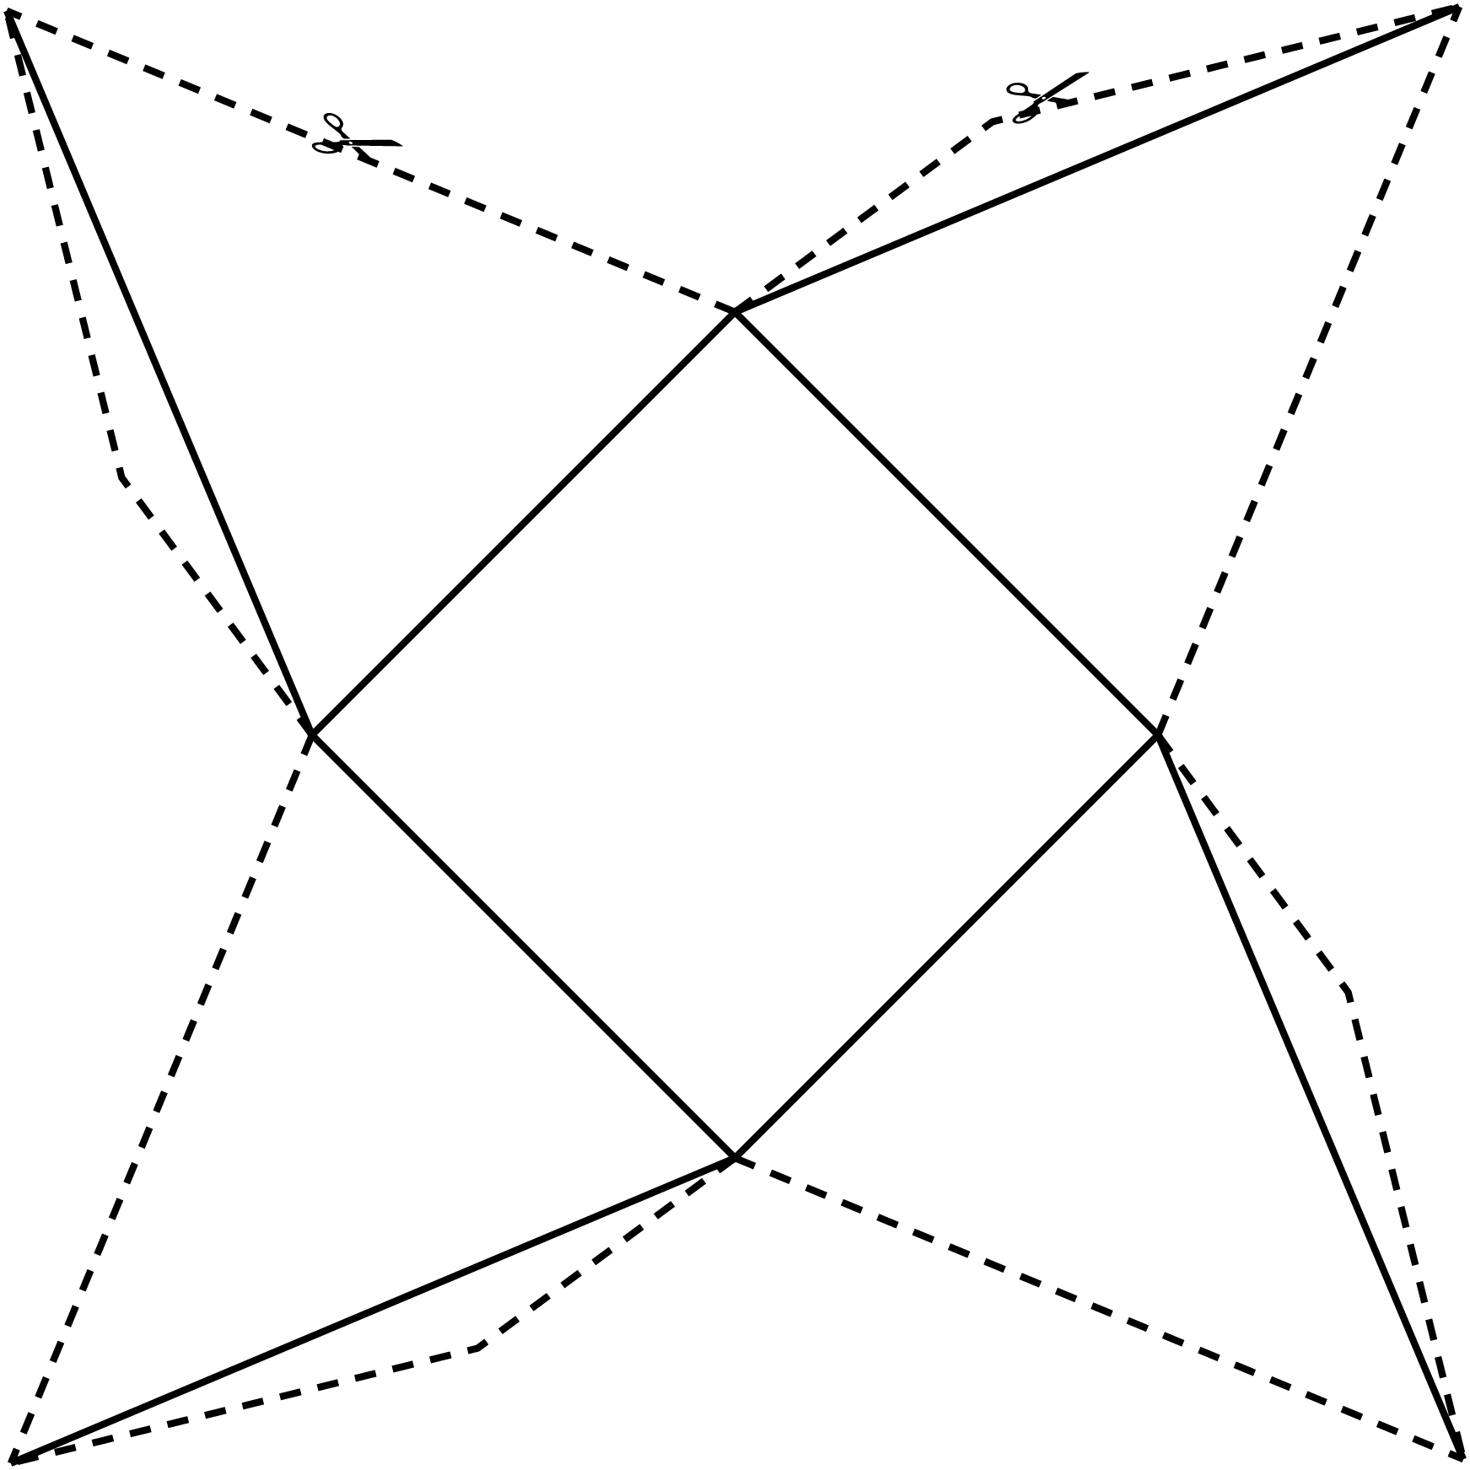

Nets Line Master 6–6

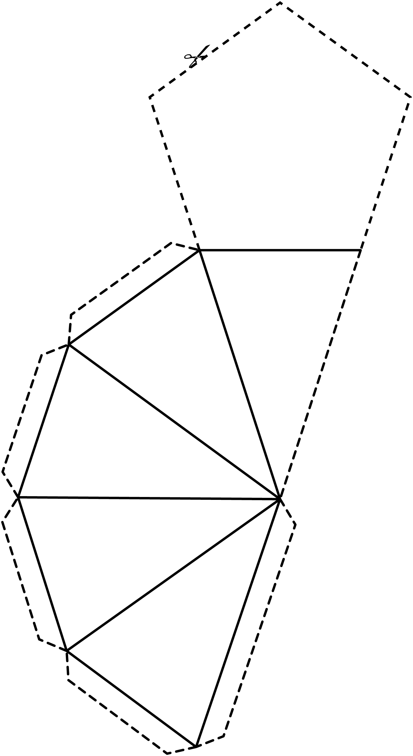

Nets Line Master 6–7

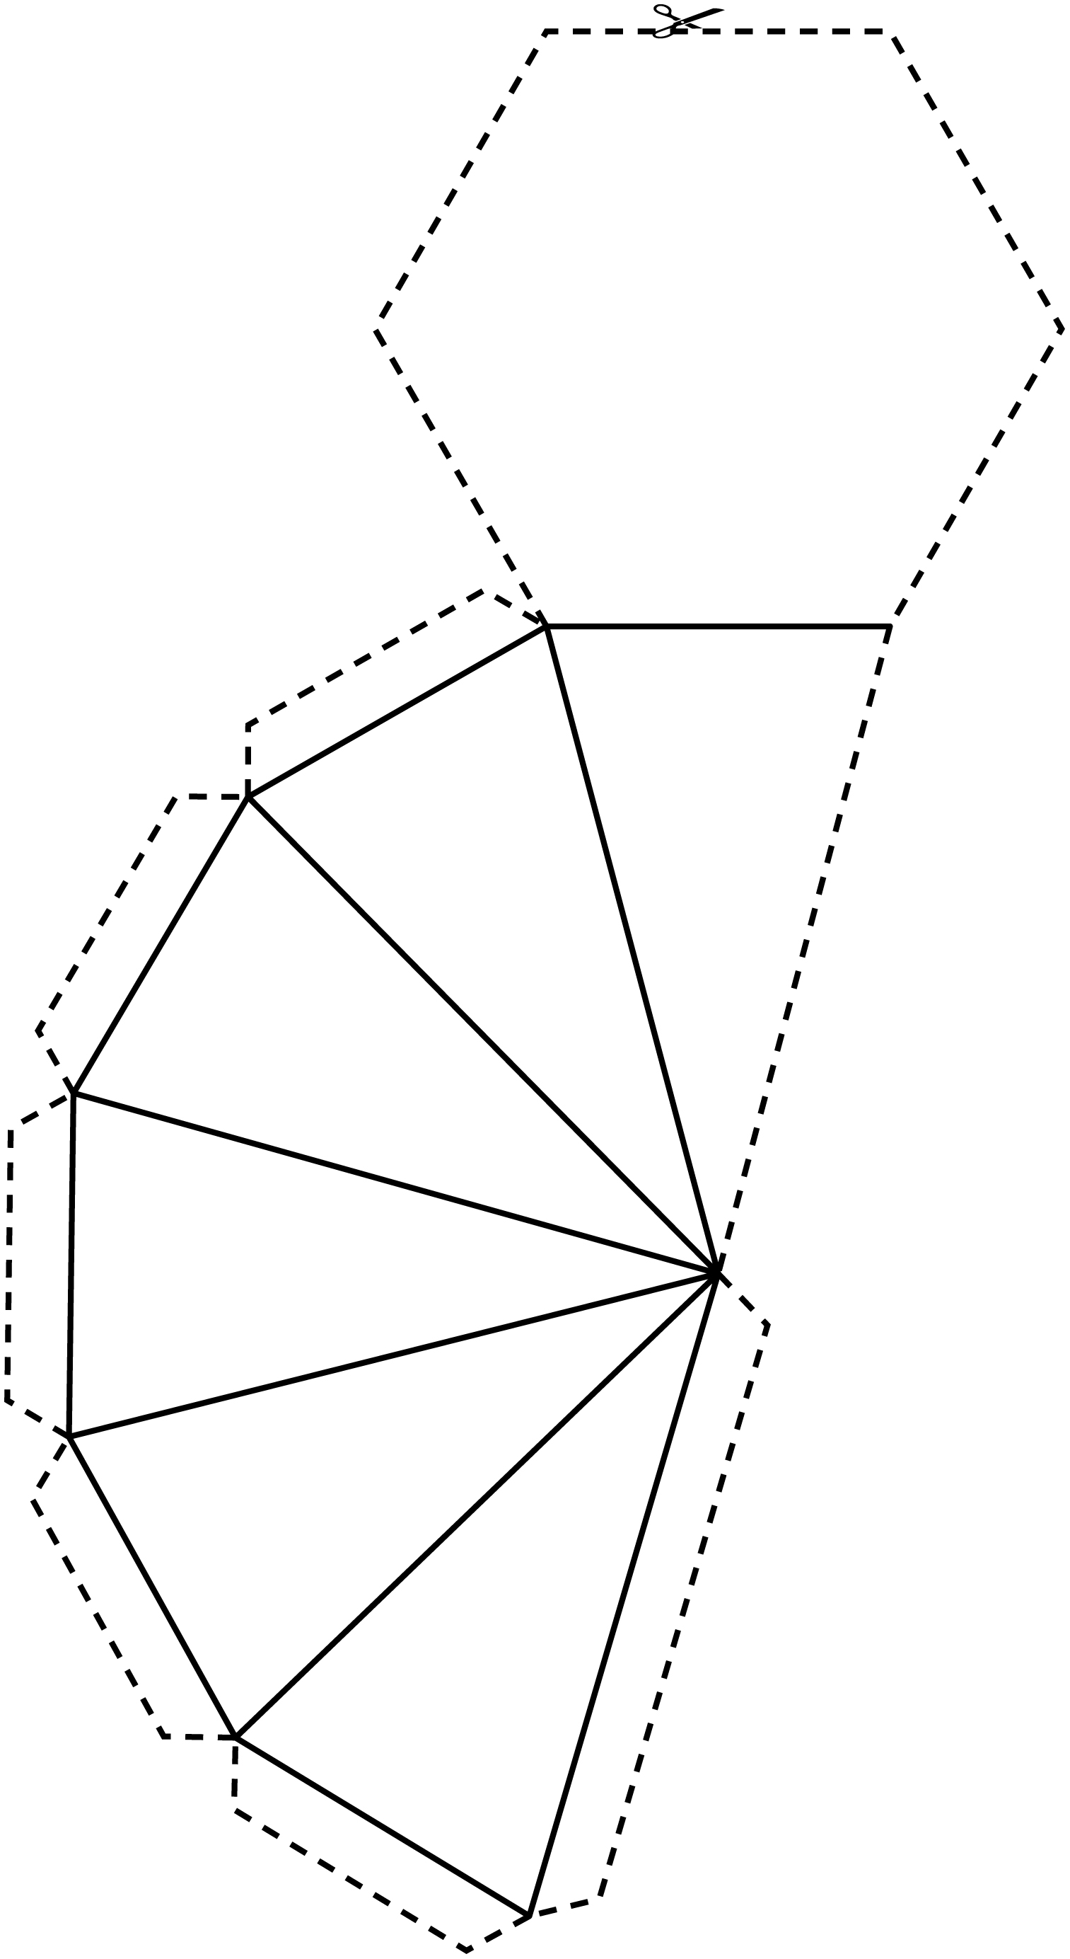

Nets Line Master 6–8

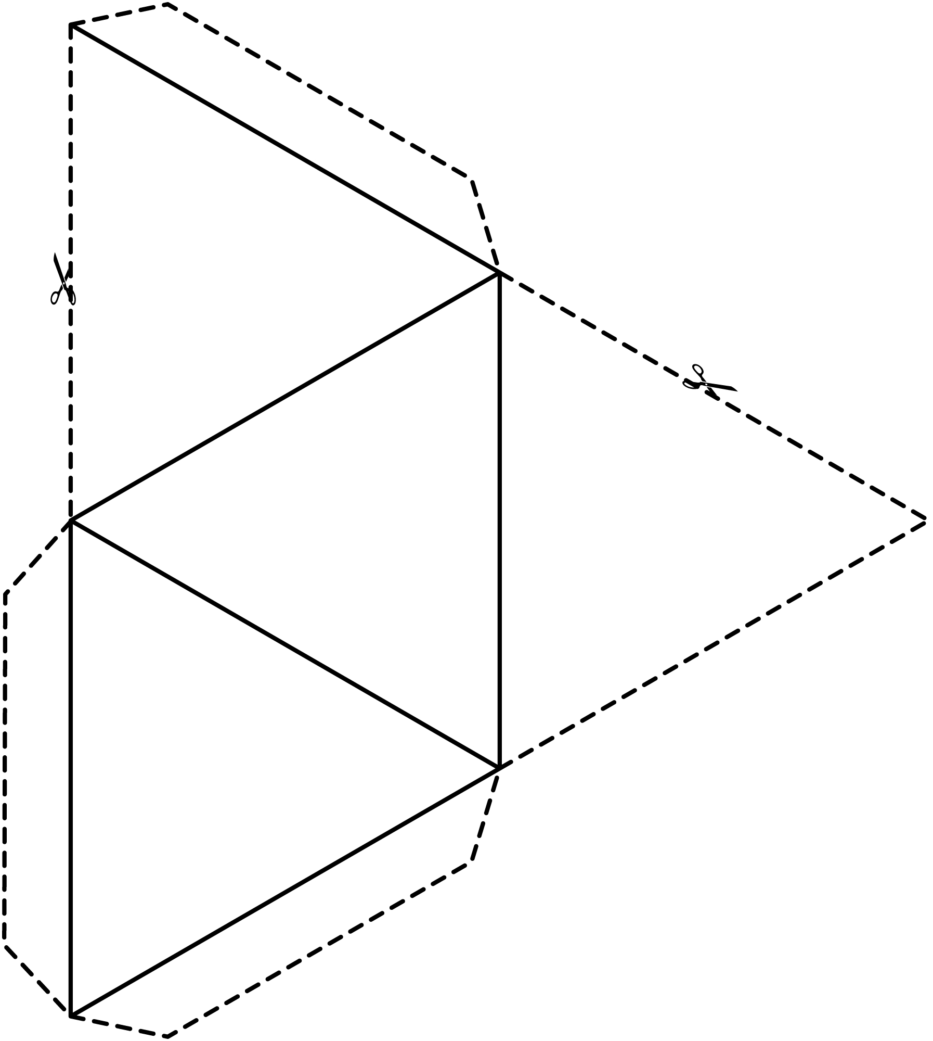

Nets Line Master 6–9

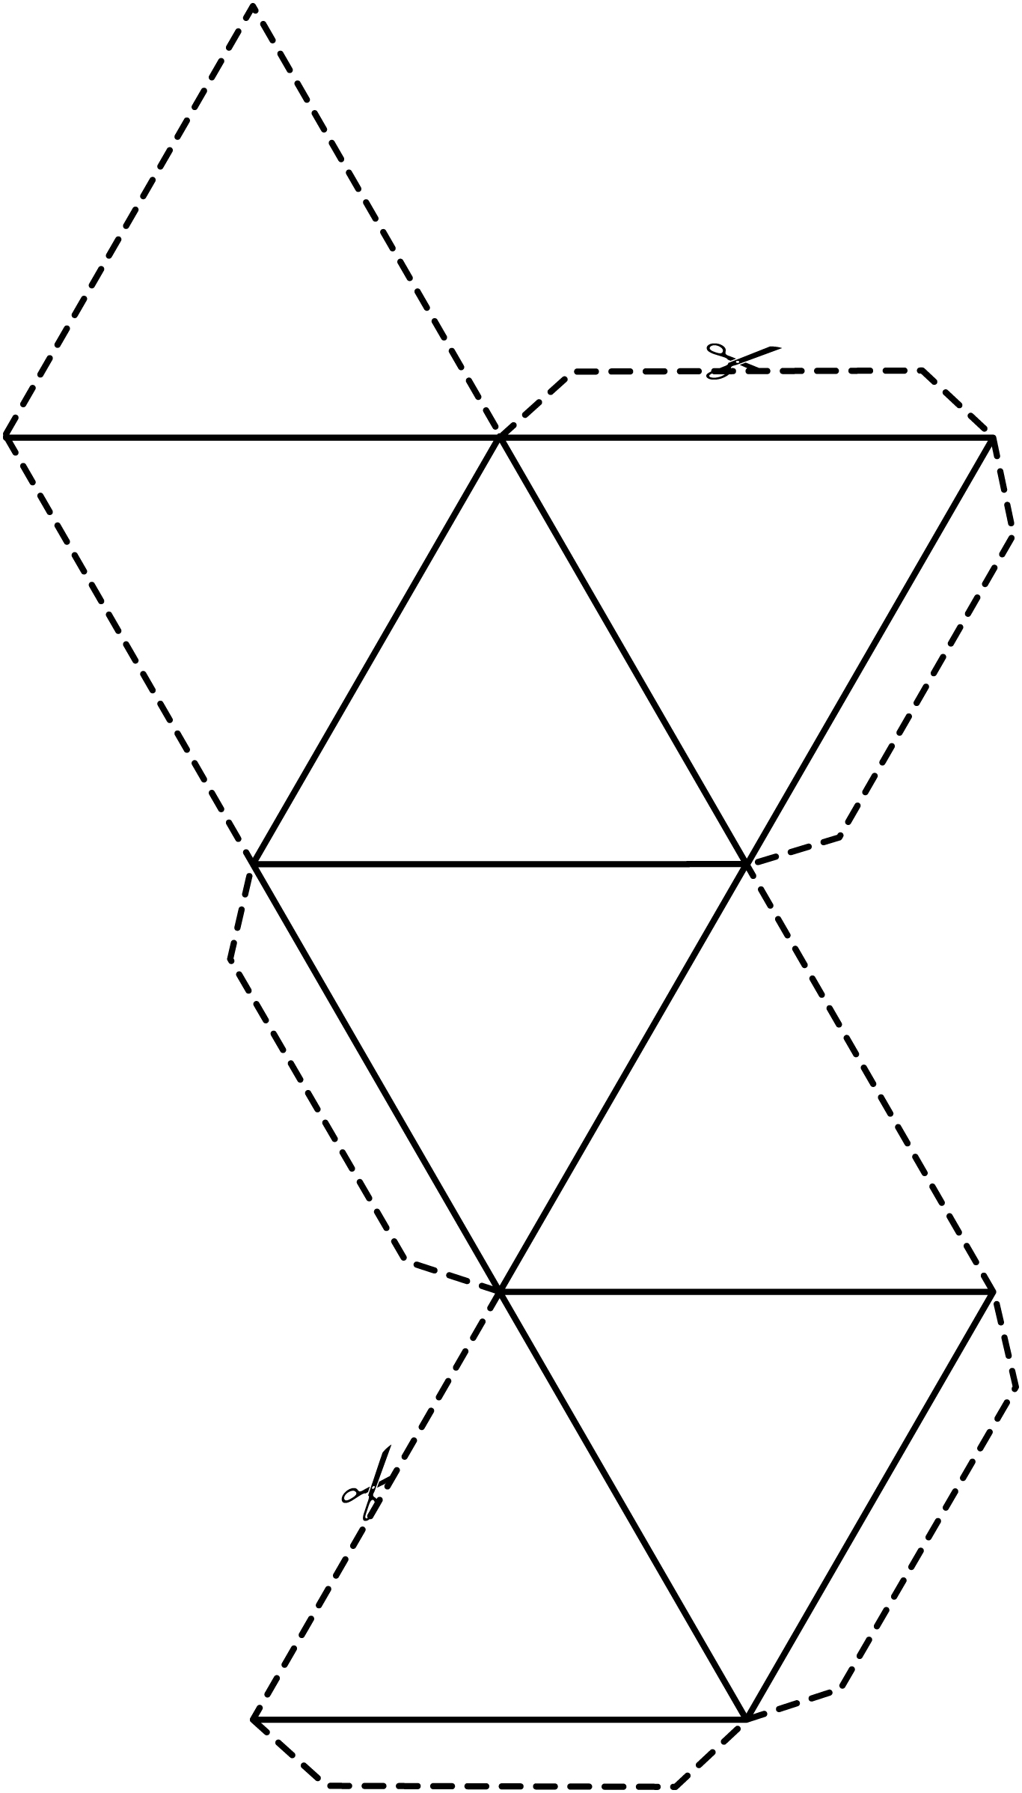

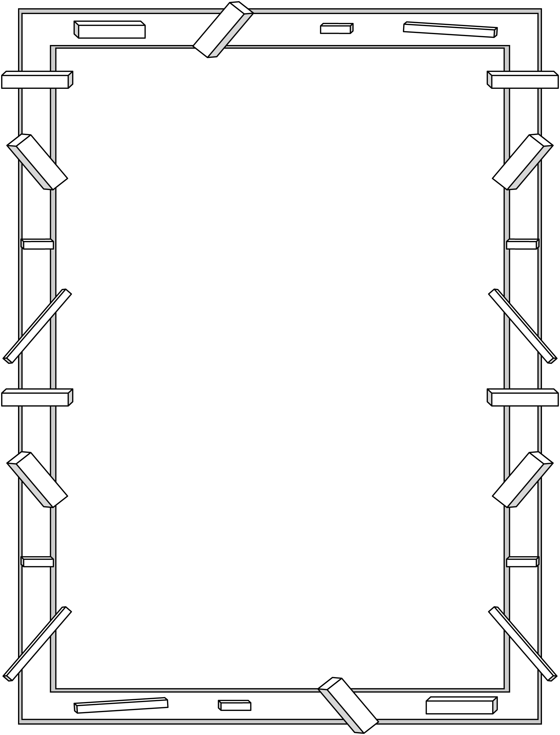
Solids and Nets Line Master 7
Name: _____________________________

Draw what you think the box looks like when open flat.
Label shapes and include fold lines.

Is It a Net? Line Master 8–1

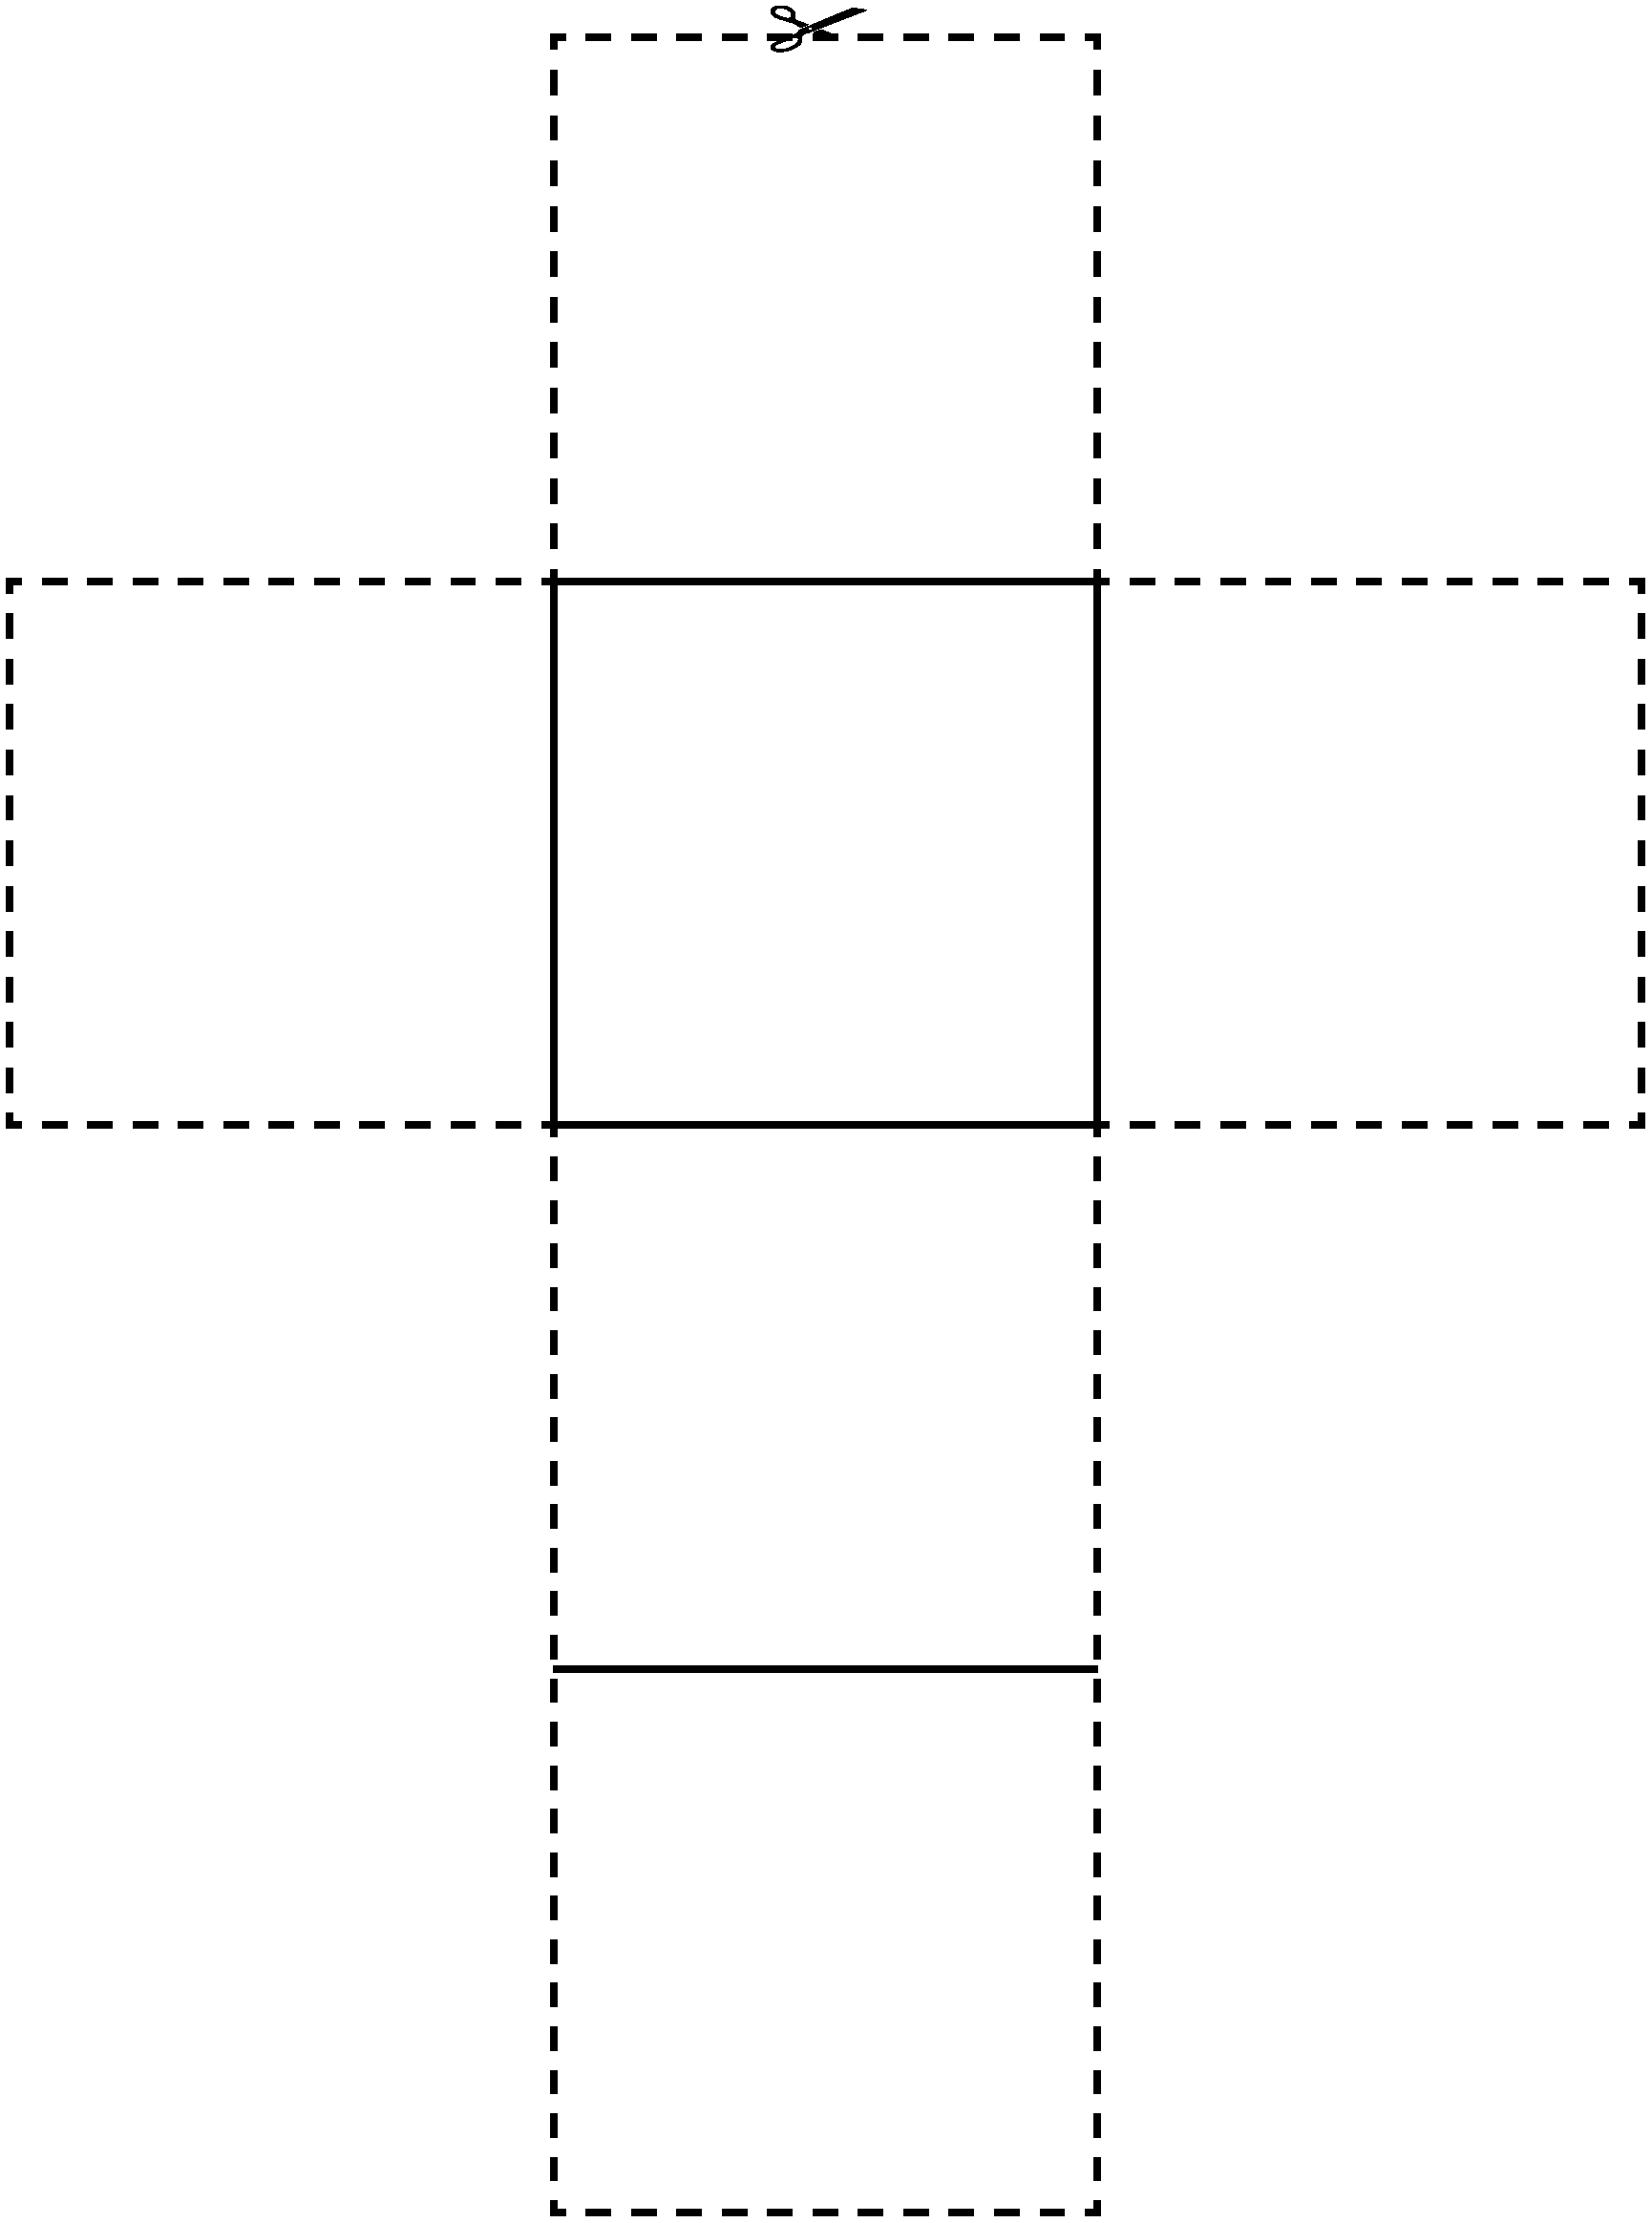

Is It a Net? Line Master 8–2

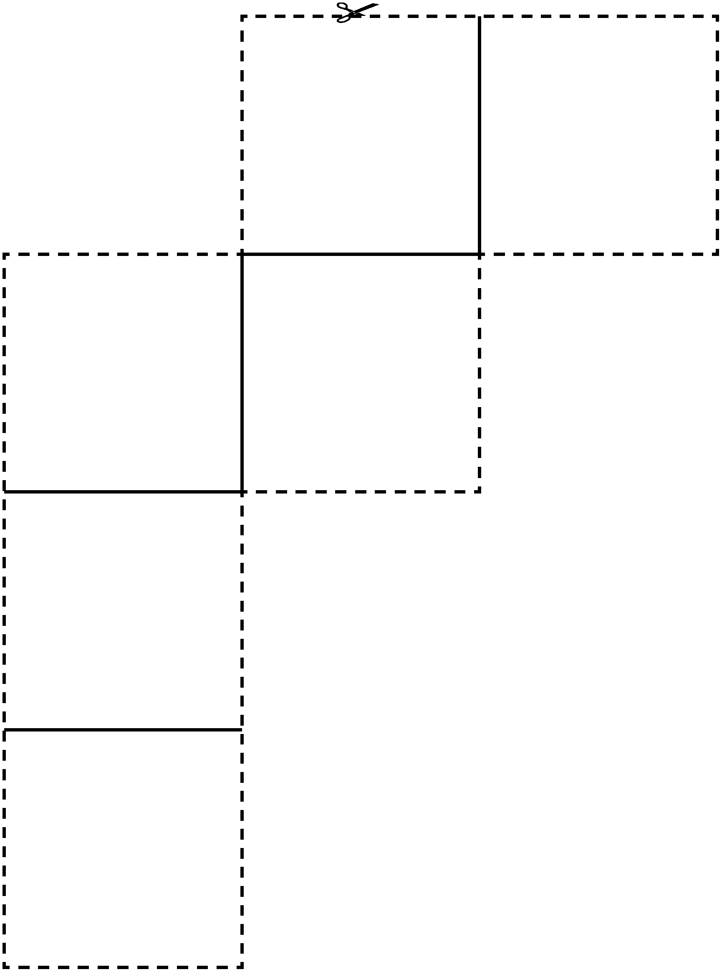

Grid Paper Line Master 9

Dot Paper Line Master 10

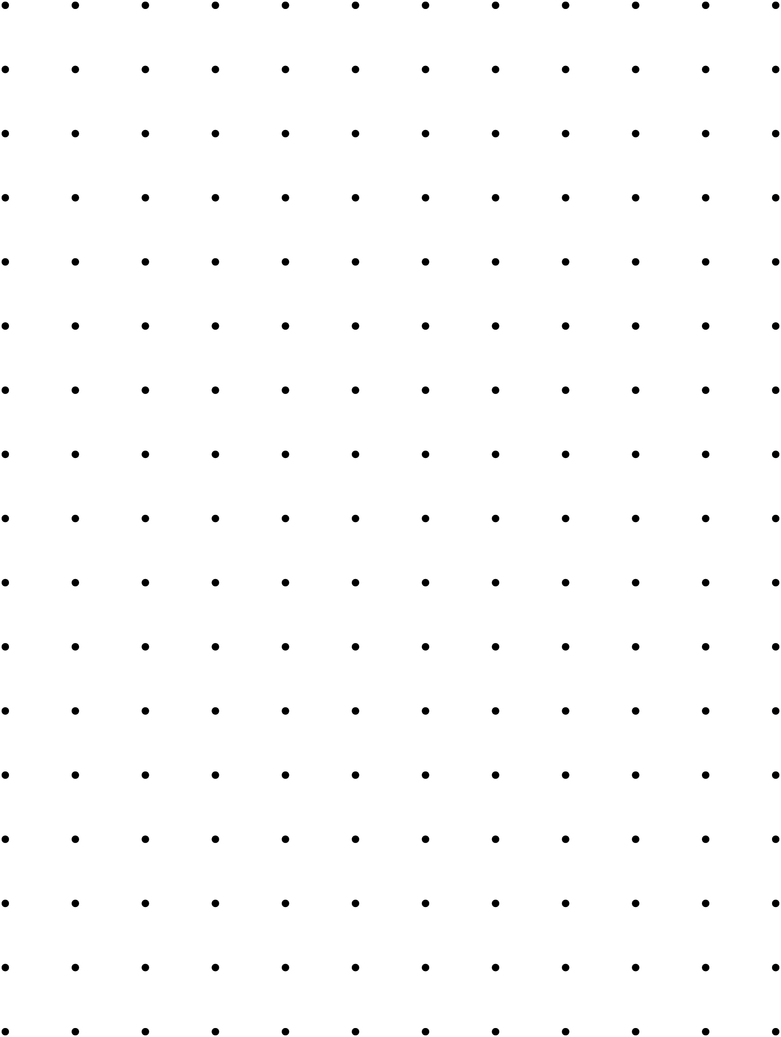

Drawing Shapes Line Master 11

Goal of the Game:
To draw shapes that are worth the greatest number of points
What You Need:
- dot paper to share
- 1 pencil each
How to Play:
1. Decide who goes first.
2. On your turn, draw a line between any two dots. Your line can go in any direction: vertically, horizontally, or diagonally.
3. If you draw a line that completes a shape, write your initials in the shape and then take another turn. Lines and shapes must not overlap.
4. Keep playing until there is no space left to draw shapes.
5. Calculate your score.
Scoring:
1. For each shape you completed, count and record the number of vertices. You get 1 point for each vertex.
2. For each shape that has dots in the middle, add 1 extra point to your score.
Examples:

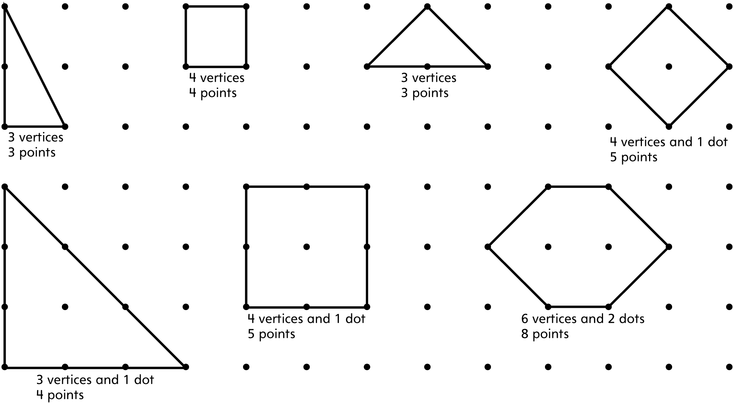

Shape Challenges Line Master 12–1

Build IT!  This model has:  4 vertices  4 triangular faces  6 edges | Build IT!  This model has:  8 vertices  6 square faces  12 edges
Build IT!  This model has:  6 vertices  3 rectangular faces and  2 triangular faces  9 edges | Build IT!  My model has:  __________ vertices  __________ square faces  __________ edges

Shape Challenges Line Master 12–2

Draw IT!  This shape has:  4 sides  all sides the same length  Label your shape. | Draw IT!  This shape has:  3 sides  2 sides the same length  Label your shape.
Draw IT!  This shape has:  6 sides  no sides the same length  Label your shape. | Draw IT!  This shape has:  __________ sides  __________ _______________________  Label your shape.

Shape Challenges Line Master 12–3

What can you make with these?  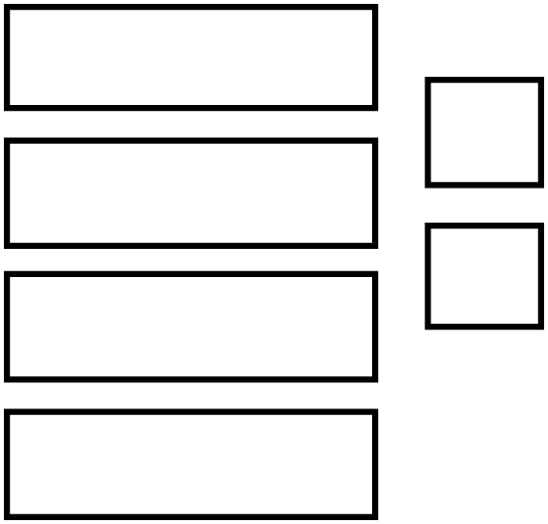  Sketch and label your answer. | What can you make with these?  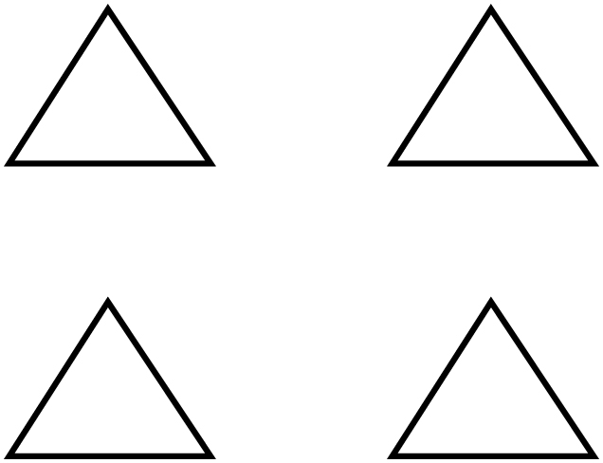  Sketch and label your answer.
What can you make with these?  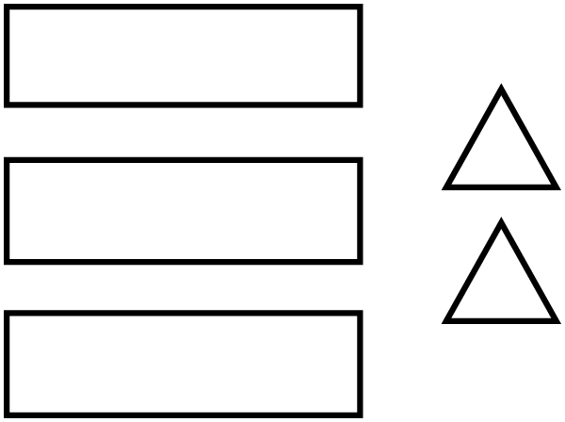  Sketch and label your answer. | What can you make with these?  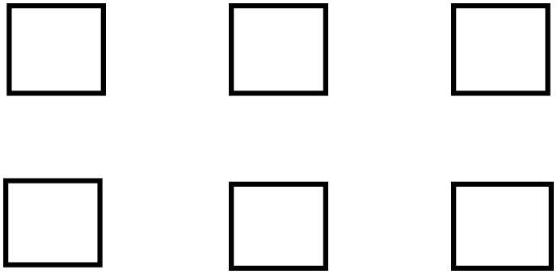  Sketch and label your answer.

