Applying and Visualizing Rotations on a Grid
Identifies rotated 2-D shapes on a grid with a point of rotation on  the shape.  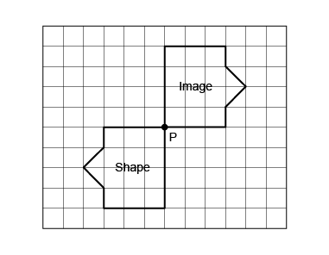  “This grid shows a rotation of a $\frac{1}{2}$ tun about vertex P.” | Identifies rotated 2-D shapes on a grid with a point of rotation outside the shape.  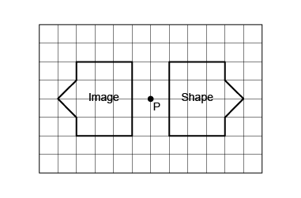  “The shape has been rotated a $\frac{1}{2}$ turn around the point of rotation P, located outside the shape.” | Describes and performs rotations/turns, both clockwise and counterclockwise.  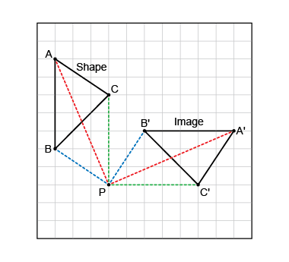  “The shape was rotated by a $\frac{3}{4}$ turn counterclockwise about P. The matching vertices on the shape and its image are the same distance from the point of rotation.” | Visualizes, predicts, and describes where the image of a shape will be after a rotation.  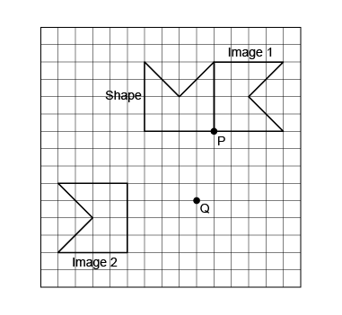  “I visualized and predicted where the images of the pentagon would be after a rotation of a $\frac{1}{4}$ turn clockwise about P (on the shape) and after a rotation of a $\frac{1}{4}$ turn counterclockwise about Q (off the shape). I rotated the shape to check. I know each image is correct because corresponding points are the same distance from the point of rotation.”
Observations/Documentation

