Conceptual Meaning of Addition and Subtraction of Decimals
Recognizes addition and subtraction situations and models concretely to add or subtract to hundredths  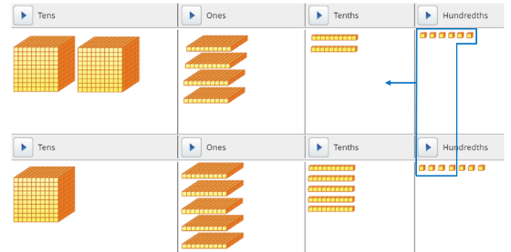  24.26 + 15.57 = 39.83 | Models and symbolizes ways to solve problems using an open number line.  24.26 + 15.57 = ?  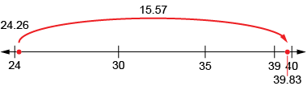 | Uses an understanding of place value to add or subtract decimals with hundredths (decomposes both numbers).  24.26 + 15.57 = ?  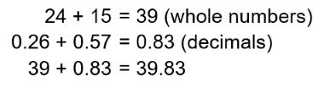  “I decomposed both numbers, added the whole numbers, then added the hundredths.”
Observations/Documentation

Conceptual Meaning of Addition and Subtraction of Decimals (cont’d)
Uses an understanding of place value to decompose one number.  24.26 + 15.57 = ?  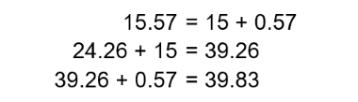  “I used place value to add on the second number.” | Uses estimation and mental math strategies to check reasonableness of solutions.  4.497 + 7.299 + 3.512 =?  “I used compatible numbers to estimate. 4.497 is close to 5, 7.299 is close to 7, and 3.512 is close to 3; 7 + 3 + 5 = 15. I calculated 15.308, so my answer is reasonable.” | Solves addition and subtraction problems flexibly, using a variety of strategies.  36.462 − 25.108 = ?  36.462 – 25 = 11.462  11.462 – 0.108 = 11.354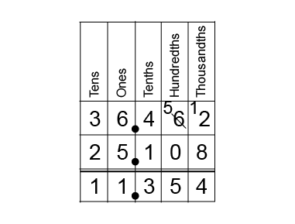
Observations/Documentation

