Listing All Possible Outcomes of an Experiment
Uses a tree diagram to determine all possible outcomes of an experiment.  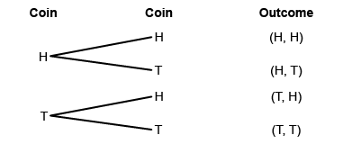  “There are 3 possible outcomes:  2 heads, 2 tails,  and 1 head and 1 tail.” | Uses a table or organized list to determine all possible outcomes of an experiment.  The principal can choose from  2 colours of pants (purple or red) and 3 colours of shirts (green, orange, or pink).  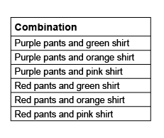  “I chose one pant colour, then matched it with each shirt colour.” | Determines the theoretical probability using a tree diagram, table, or organized list.  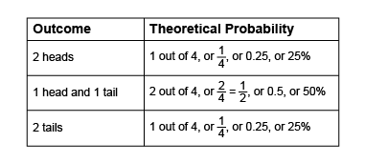  “I divided the number of favourable outcomes by the total number of outcomes to find the theoretical probabilities.” | Flexibly determines theoretical probability and knows that the sum of probabilities is 1 or 100%.  “It is certain that one of the possible outcomes will occur, and the probability of a certain event is 1. So, the sum of the probabilities of all possible outcomes must be  1 or 100%.
Observations/Documentation

