Comparing Theoretical and Experimental Probabilities
Conducts single-outcome experiment and calculates experimental probabilities.  “I tossed the coins 20 times and got 8H and 12T.  The experimental probabilities are: H: $\frac{2}{5}$, T: $\frac{3}{5}$.” | Conducts experiment involving 2 events and calculates experimental probabilities.  “I tossed the coins 20 times and got 3HH, 6TT, 11HT.  The experimental probabilities are: HH: $\frac{3}{20}$, TT: $\frac{3}{10}$, HT: $\frac{11}{20}$.” | Determines and compares the theoretical and experimental probabilities.  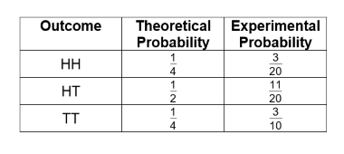  “The actual result was different than the theoretical probability,  but that is to be expected.” | Determines and compares probabilities after a greater number of trials.  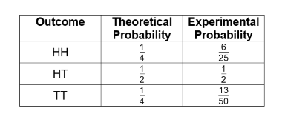  “I used the Pearson Probability Tool to toss the coins 500 times. The results got closer to the theoretical probabilities.”
Observations/Documentation

