Measuring and Constructing Angles
Identifies and compares different types of angles using the benchmark of 90°.  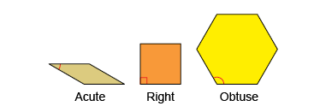  “This is an acute angle because it is less than 90$°.$ This is an obtuse angle because it is  greater than 90°.” | Compares and measures angles using appropriate non-standard units.  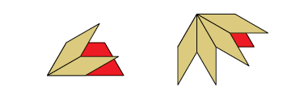  “The acute angle in the trapezoid equals 2 acute angles in the tan parallelogram, or 60°; the obtuse angle equals 4 of the acute angles,  or 120°.” | Compares and measures angles using a protractor.  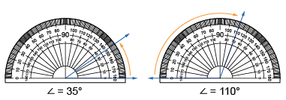  “I can use the protractor to compare and measure angles. The two scales on the protractor make it easier to measure acute and obtuse angles.”
Observations/Documentation

Measuring and Constructing Angles (cont’d)
Flexibly estimates, compares and measures angles using standard units and benchmarks.  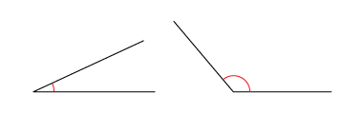  “The first angle is about halfway between 0° and 45°, so it is about 25°. The second angle is less than halfway between 90° and 180°,  so it’s about 130°.” | Measures angles using a 360° protractor and states the relationships between angles.  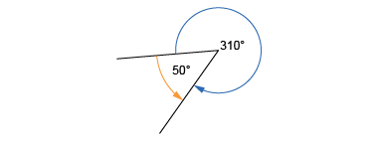  “I measured the angle clockwise and got 310°. I measured it counterclockwise and got 50°. The sum of the angles is 360° because they form a complete circle.” | Flexibly estimates, compares, measures, and constructs angles using various tools.  Draw a 135° angle.  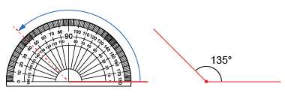  “I drew a horizontal line, aligned the protractor, then followed the outer scale around to 135° and made a mark. I joined the mark to the end  of the line.”
Observations/Documentation

