Angle Properties and Relationships
Understands that smaller angles can be added together to determine a larger angle.  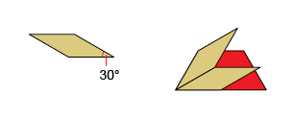  “The tan parallelogram angle is 30°,  and 30° + 30° = 60°, which is the measure of the smaller angle in the red trapezoid.” | Understands and uses the properties of interior angles to solve for unknown angle measures.  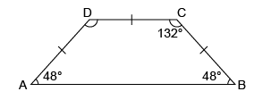  “I know the sum of the interior angles of a quadrilateral is 360°. I add the known angle measures: 48° + 48° + 132° = 228°, then subtract: 360° − 228° = 132°, which is the measure of angle D.” | Understands and uses the properties of supplementary and complementary angles to solve for unknown angle measures.  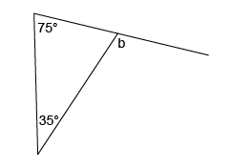  “I know that the interior angles of a triangle add to 180°, so the supplementary angle to b is  180° − 75° − 35° = 70°.  Pairs of supplementary angles have a sum of 180°, so b is 180° − 70° = 110°.”
Observations/Documentation

Angle Properties and Relationships (cont’d)
Understands and uses the properties of exterior angles to solve for unknown angle measures.  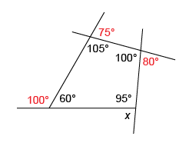  “The sum of exterior angles is 360°:  75° + 80° + 100° = 255° and 360° − 255° = 85°, which is measure of the unknown angle.” | Understands and uses properties of opposite angles to solve for unknown angle measures.  “I know that pairs of supplementary angles have a sum of 180° and opposite angles are equal. So, d is 40° because it’s opposite the 40° angle. To determine the angle measure of opposite angles c and e, I subtract: 180° − 40° = 140°, which is the measure of angles c and e.” | Flexibly applies the properties of various angles to solve for unknown measures.  “I used supplementary angles,  ∠C = 180° − 50° = 130°.  Then, I used the sum of the angles in a quadrilateral, ∠D = 360° − 90° − 130° − 65° = 75°. The unknown angle measure is 75°.”
Observations/Documentation

