Properties of Quadrilaterals
Recognizes that quadrilaterals have 4 sides and angles that sum to 360°.  “I recognize the shapes by name. From left to right: square, rectangle, parallelogram, rhombus, isosceles trapezoid, trapezoid, convex kite (dart), and concave kite.” | Understands that quadrilaterals can be classified using  geometric properties.  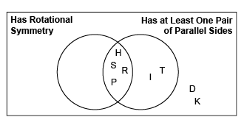  “I sorted the quadrilaterals using the properties of rotational symmetry and at least one pair of  parallel sides.” | Sketches and identifies quadrilaterals when given  specific properties.  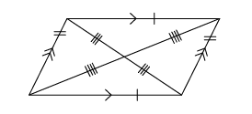  “I drew a parallelogram that has opposite sides equal and parallel; opposite angles equal; and rotational symmetry of order 2.” | Sketches, defines, and analyzes quadrilaterals using common geometric properties.  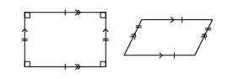  “A rectangle is a parallelogram because it has opposite sides equal and parallel. A parallelogram is not a rectangle because it does not have 4 right angles.”
Observations/Documentation

