Measuring and Comparing Angles
Identifies and compares different types of angles using benchmarks of 90° and 180°.  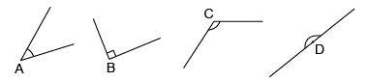  “A is an acute angle because it looks less than 90°. B is a 90° right angle because it looks like a square corner. C is an obtuse angle because it looks like it is between 90° and 180°. D is a 180° straight angle because it is a straight line.” | Compares/measures angles clockwise &counterclockwise using a 180° protractor.  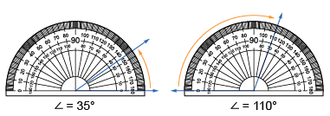  “I can use a protractor to compare and measure angles. The first angle opens right, so I used the inside scale. It measures 35°. The second angle opens left, so I used the outer scale. It measures 110°.” | Constructs angles using a 360° protractor and states the relationships between angles.  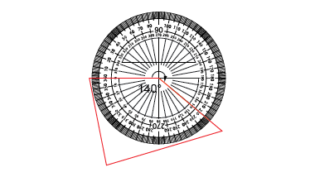  “I used the circle protractor to measure the reflex angle: 220°. I then subtracted the angle from 360° to determine the unknown interior angle: 360° – 220° = 140°. The sum of the reflex angle and the interior angle must be 360°.” | Flexibly measures & constructs angles and matches angles using the additive principle.  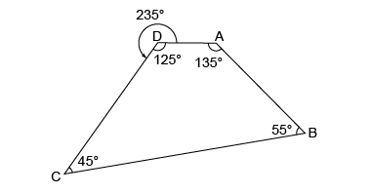  “The angle measures are 135°, 45°, 55°, and 125°, and the sum: 135° + 45 + 55° + 125° = 360°. The 235° reflex angle and 125° matching angle add to 360°.
Observations/Documentation

Properties of Quadrilaterals
Recognizes that quadrilaterals have 4 sides and angles that sum to 360°.  “I recognize the shapes by name. From left to right: square, rectangle, parallelogram, rhombus, isosceles trapezoid, trapezoid, convex kite (dart), and concave kite.” | Understands that quadrilaterals can be classified using  geometric properties.  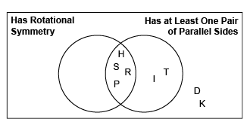  “I sorted the quadrilaterals using the properties of rotational symmetry and at least one pair of  parallel sides.” | Sketches and identifies quadrilaterals when given  specific properties.  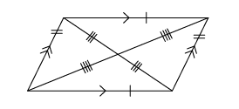  “I drew a parallelogram that has opposite sides equal and parallel; opposite angles equal; and rotational symmetry of order 2.” | Sketches, defines, and analyzes quadrilaterals using common geometric properties.  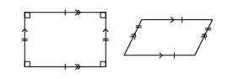  “A rectangle is a parallelogram because it has opposite sides equal and parallel. A parallelogram is not a rectangle because it does not have 4 right angles.”
Observations/Documentation

