Locating and Mapping Shapes in 1st Quadrant of the Cartesian Plane
Describes the location of 2-D shape/objects on the grid.  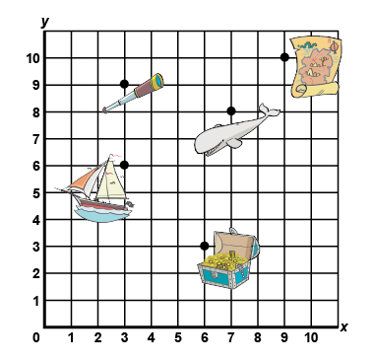  “The treasure chest is located at (6,3).” | Describes translations of points by describing distance, direction, and coordinates.  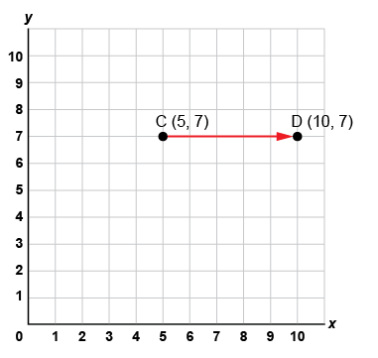  “I plotted the point C(5, 7), then translated it  right 5 squares to C’(10, 5).  The x-coordinate increased by 5.” | Plots and locates points on a grid using various scales and labels the coordinates.  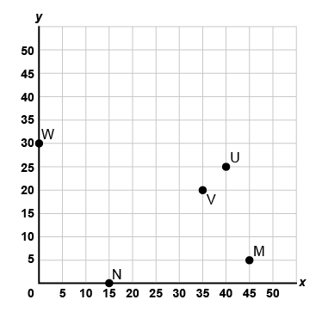  “To plot each point, I counted by 5s along each axis and labelled the coordinates: W(0,30),  N(15,0), V(35,20), U(40,25), M(45,5).”
Observations/Documentation

Locating and Mapping Shapes in 1st Quadrant of the Cartesian Plane (cont’d)
Translates or reflects shapes and labels coordinates of the image.  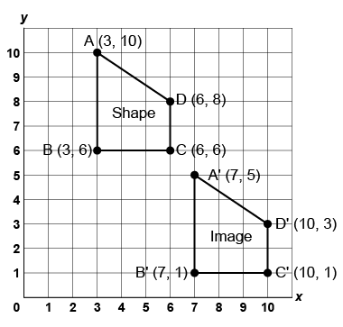  “I translated the quadrilateral right 4 squares, then down 5 squares. The x-coordinate of each vertex of the image increased by 4 and each  y-coordinate decreased by 5.” | Analyzes and locates the vertices of 2-D shapes before and after rotations.  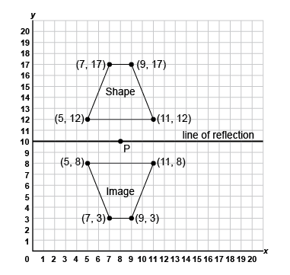  “I rotated the shape 180° about P(8, 10). I chose point P because it is on the line of symmetry of the trapezoid, so when I rotate it 180°, the image is also a reflection.” | Visualizes and predicts the location of 2-D shapes after transformations using various scales.  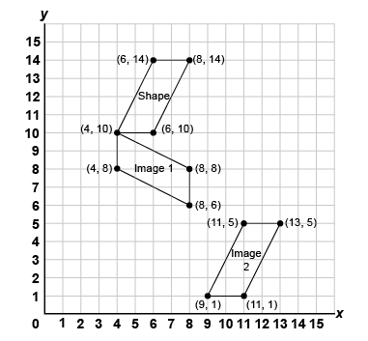  “I visualized and predicted the location of the image after different transformations and identified the coordinates. Image 1 is a rotation 90° clockwise, and Image 2 is a translation right 5 squares, down 9 squares.”
Observations/Documentation

