Applying and Visualizing Transformations on a Grid
Identifies and describes transformations on a grid.  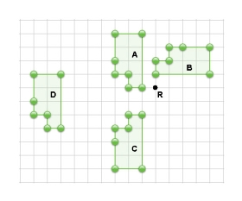  “Shape A to Shape D is a translation. Shape A is reflected in the horizontal line halfway between Shapes A and C to get Shape C. Shape A is rotated 90° clockwise about point R to get Shape B.” | Describes and performs single transformations on a grid.  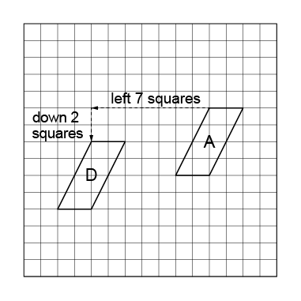  “I translated Shape A left 7 squares and down 2 squares to Image D.” | Describes and performs combinations of transformations.  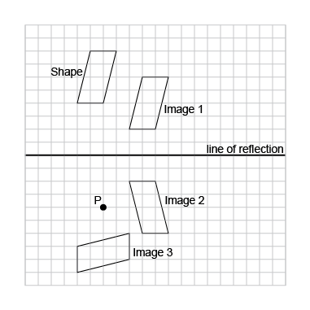  “I used a combination of transformations. I translated the Shape right 4 squares, down 2 squares to Image 1; I reflected Image 1 in the line of reflection shown to get Image 2; I rotated Image 2 90° clockwise about point P to get Image 3.” | Visualizes, describes, and flexibly performs combinations of transformations.  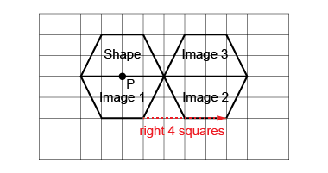  “I visualized the transformations and predicted where the images would be. I performed the transformations to check. I rotated the shape 180° about point P to get Image 1; then translated Image 1 right 4 squares to get Image 2; then reflected Image 2 in the common side to get Image 3.  My predictions were correct.”
Observations/Documentation

Locating and Mapping Shapes in 1st Quadrant of the Cartesian Plane
Describes the location of 2-D shape/objects on the grid.  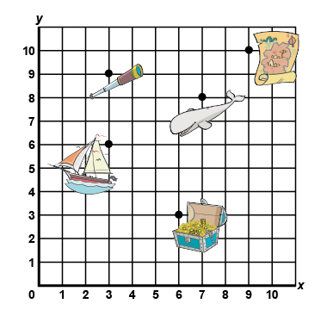  “The treasure chest is located at (6,3).” | Describes translations of points by describing distance, direction, and coordinates.  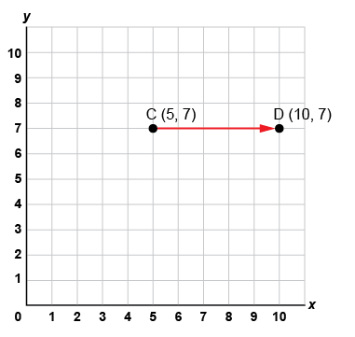  “I plotted the point C(5, 7), then translated it  right 5 squares to C’(10, 5).  The x-coordinate increased by 5.” | Plots and locates points on a grid using various scales and labels the coordinates.  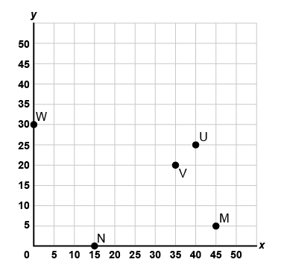  “To plot each point, I counted by 5s along each axis and labelled the coordinates: W(0,30),  N(15,0), V(35,20), U(40,25), M(45,5).”
Observations/Documentation

Locating and Mapping Shapes in 1st Quadrant of the Cartesian Plane (cont’d)
Translates or reflects shapes and labels coordinates of the image.  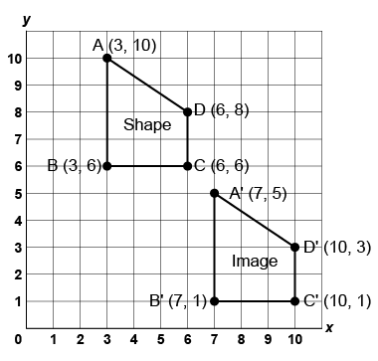  “I translated the quadrilateral right 4 squares, then down 5 squares. The x-coordinate of each vertex of the image increased by 4 and each  y-coordinate decreased by 5.” | Analyzes and locates the vertices of 2-D shapes before and after rotations.  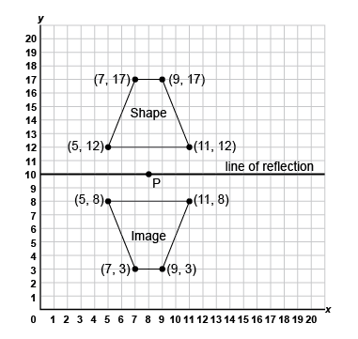  “I rotated the shape 180° about P(8, 10). I chose point P because it is on the line of symmetry of the trapezoid, so when I rotate it 180°, the image is also a reflection.” | Visualizes and predicts the location of 2-D shapes after transformations using various scales.  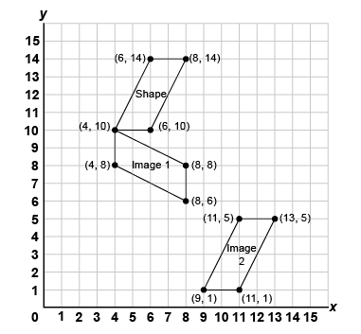  “I visualized and predicted the location of the image after different transformations and identified the coordinates. Image 1 is a rotation 90° clockwise, and Image 2 is a translation right 5 squares, down 9 squares.”
Observations/Documentation

