Applying and Visualizing Transformations on a Grid
Identifies and describes transformations on a grid.  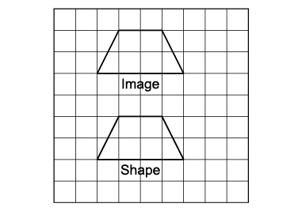  “This shows a translation because the shape and the image face the same way.” | Describes and performs single transformations on a grid.  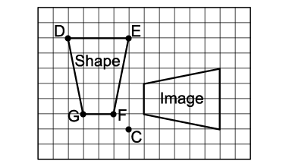  “The shape was rotated 90° about the point of rotation C to get  the Image.” | Describes and performs combinations of transformations.  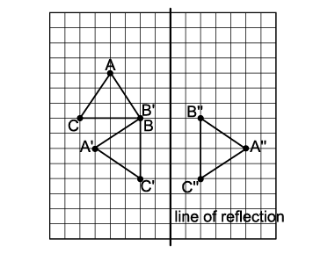  “The triangle is rotated 270° clockwise about vertex B, then reflected in the vertical line.” | Visualizes, describes, and flexibly performs a combination of transformations.  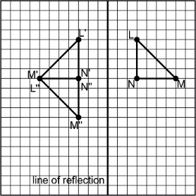  “I visualize reflecting triangle LMN in the vertical line of reflection, then rotating the image 90° counterclockwise about N’ to get triangle L”M”N”.”
Observations/Documentation

