Using Formulas to Determine Perimeter of Polygons
Uses standard units to measure the perimeter of irregular polygons by adding side lengths.  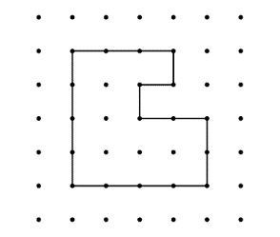  ”The polygon is on 1-cm dot paper.  I added the lengths of the sides:  3 cm + 4 cm + 4 cm + 2 cm + 2 cm + 1 cm + 1 cm + 1 cm = 18 cm;  The perimeter of the shape  is 18 cm.” | Uses P = # of equal sides × length of a side to calculate the perimeter of regular polygons.  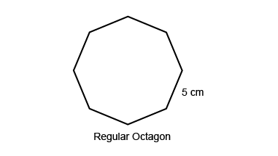  “In a regular octagon, all sides are the same length. I multiply the length of a side by the number of sides: P = 8 × 5 cm = 40 cm. The perimeter is 40 cm.” | Identifies the appropriate formula to determine the perimeter of  different polygons.  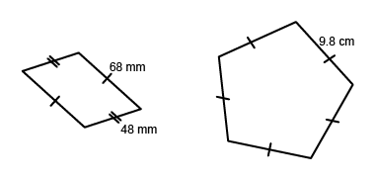  “The irregular polygon is a parallelogram, so I can use the formula: P = 2(a + b): 2(48 mm + 68 mm) = 2(116 mm) = 232 mm.  The pentagon is a regular pentagon, so I can use the formula P = 5s:  5 × 9.8 cm = 49.0 cm.” | Fluently applies formulas for determining perimeter of polygons to solve problems.  A soccer field is 125 m by 85 m. A football field is about 92 m by 49 m.  Which field has the greater perimeter?  “Both fields are rectangular, so I will use the formula for the perimeter of a rectangle: P = 2(l + w).  Soccer field:  P = 2(125 m + 88 m) = 426 m.  Football field:  P = 2(92 m + 49 m) = 282 m  The soccer field has the greater perimeter.”
Observations/Documentation

