Determining the Volume of Right Rectangular Prisms
Understands that volume is a measure of how much space an object fills.  “The rectangular prism has a base that is a rectangle. It is made of 24 cubes, so its volume is 24 cubic units. | Uses benchmarks to estimate volume using metric units.  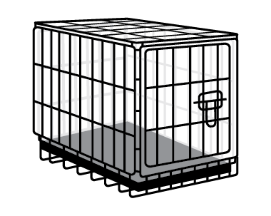  “I would use a large dog crate as a benchmark for 1 m² to measure the volume of storage room.” | Use a formula to calculate the volume of a rectangular prism.  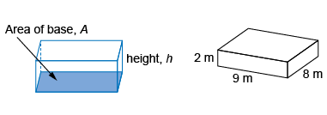  “I determined the area of the base:  9 m × 8 m = 72 m². Then I multiplied the area  of the base by the height: 72 m² × 2 m = 144 m³. The volume of the box is 144 m³.”
Observations/Documentation

Determining the Volume of Right Rectangular Prisms (cont’d)
Constructs different rectangular prisms for a given volume.  Make as many different rectangular prisms as you can with a volume of 30 cm³.  “I made 5 different prisms. The dimensions are:  1 cm by 1 cm by 30 cm; 1 cm by 2 cm by 15 cm;  1 cm by 3 cm by 10 cm; 1 cm by 5 cm by 6 cm;  2 cm by 3 cm by 5 cm.” | Sketches rectangular prisms and calculates volume using formula V = base area × height.  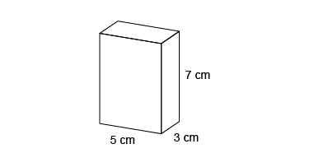  “The base area is: 3 cm × 5 cm = 15 cm².  The height is 7 cm.  Volume = 15 cm² × 7 cm = 105 cm³.” | Flexibly solves problems in various contexts that involve the volume of rectangular prisms.  A box has volume 4500 cm³.  The box has length 30 cm and width 15 cm.  What is the height of the box?  “The area of the base of the box is  30 cm × 15 cm = 450 cm².  V = base area × h  4500 cm³ = 450 cm² × h  h = 10 cm  The box has height 10 cm.”
Observations/Documentation

