Using Formulas to Determine Perimeter of Polygons
Uses standard units to measure the perimeter of irregular polygons by adding side lengths.  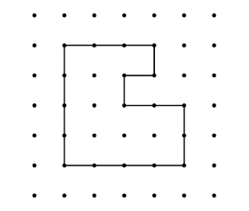  ”The polygon is on 1-cm dot paper.  I added the lengths of the sides:  3 cm + 4 cm + 4 cm + 2 cm + 2 cm + 1 cm + 1 cm + 1 cm = 18 cm;  The perimeter of the shape  is 18 cm.” | Uses P = # of equal sides × length of a side to calculate the perimeter of regular polygons.  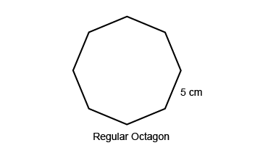  “In a regular octagon, all sides are the same length. I multiply the length of a side by the number of sides: P = 8 × 5 cm = 40 cm. The perimeter is 40 cm.” | Identifies the appropriate formula to determine the perimeter of  different polygons.  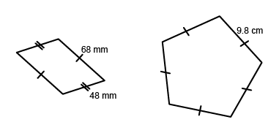  “The irregular polygon is a parallelogram, so I can use the formula: P = 2(a + b): 2(48 mm + 68 mm) = 2(116 mm) = 232 mm.  The pentagon is a regular pentagon, so I can use the formula P = 5s:  5 × 9.8 cm = 49.0 cm.” | Fluently applies formulas for determining perimeter of polygons to solve problems.  A soccer field is 125 m by 85 m. A football field is about 92 m by 49 m.  Which field has the greater perimeter?  “Both fields are rectangular, so I will use the formula for the perimeter of a rectangle: P = 2(l + w).  Soccer field:  P = 2(125 m + 88 m) = 426 m.  Football field:  P = 2(92 m + 49 m) = 282 m  The soccer field has the greater perimeter.”
Observations/Documentation

Measuring Area of Parallelograms, Triangles, and Trapezoids
Determines the area of a rectangle.  “A rectangle is an array of squares. To find the area, I multiply the number of rows by the number of columns or use the formula A = b × h. This rectangle has area 5 cm × 3 cm = 15 cm².”  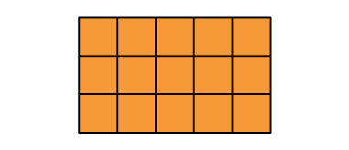 | Partitions and rearranges a parallelogram to form a rectangle with the same base and height  (same area).  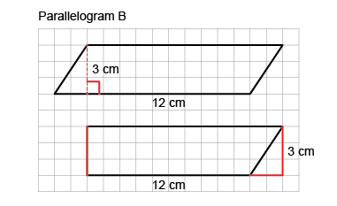  “I partitioned the parallelogram and moved the triangle to create a rectangle.  I then found the area of the rectangle:  A = b × h = 12 cm × 3 cm= 36 cm².  The area of the parallelogram is also 36 cm².” | Doubles and rotates a triangle to create a parallelogram and understands that the area of the triangle is one-half the area of the parallelogram.  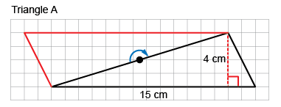  “I rotated the triangle to make a parallelogram with the same base and height. The area of the triangle is one-half the area of the parallelogram.  Area of parallelogram: 15 cm × 4 cm = 60 cm²  Area of triangle: 60 cm² ÷ 2 = 30 cm²  So, the formula for the area of  a triangle is: A = b × h ÷ 2.”
Observations/Documentation

Measuring Area of Parallelograms, Triangles, and Trapezoids (cont’d)
Determines the area of a trapezoid by partitioning it into triangles and rectangles, then uses formulas to determine area.  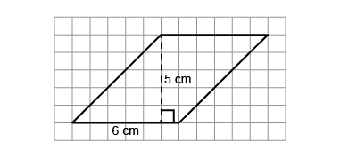  “I divided the trapezoid into 2 triangles  and a rectangle.  Triangle A: A = (1 cm × 4 cm) ÷ 2 = 2 cm²  Rectangle B: A = 5 cm × 4 cm = 20 cm²  Triangle C: A = (3 cm × 4 cm) ÷ 2 = 6 cm²  Area of trapezoid:  2 cm² + 20 cm² + 6 cm² = 28 cm².” | Constructs a parallelogram or triangle with a given area using known formulas and explains strategies used.  Construct a parallelogram with area 30 cm².  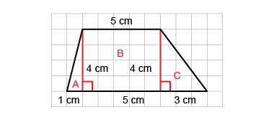  “A parallelogram has the same area formula as a rectangle: A = b × h. Since 5 × 6 = 30, I drew a horizontal line of length 6 cm for the base.  I drew a vertical line of length 5 cm for the height, then drew another horizontal line segment 6 cm long. I joined each end of the line segment  to the base.” | Flexibly solves problems involving the area relationships among rectangles, parallelograms, and triangles and the related formulas.  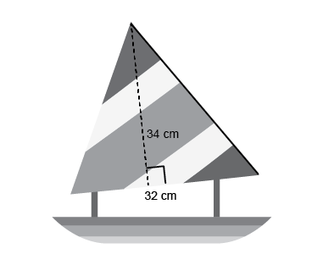  What is the area of the sail on the toy boat?  “I doubled the triangular sail to make a parallelogram with the same base and height. I found the area of the parallelogram:  34 cm × 32 cm = 1088 cm², then divided the area in half to find the area of the triangle:  1088 cm² ÷ 2 = 544 cm².”
Observations/Documentation

