Representing Equivalent Ratios and Rates
Represents and records ratios and rates symbolically.  10 glue sticks cost $4.  How much will 60 glue sticks cost?  For example, using rates:  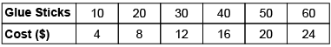  “I skip-counted by 10s and 4s.” | Represents and creates equivalent ratios and rates.  10 glue sticks cost $4.  How much will 60 glue sticks cost?  For example, using ratios:  “The ratio of glue sticks to cost is 10:4. To find the cost of 60 glue sticks, I multiply each term by 6.” | Represents and creates in-between ratios and rates.  A crafter sells 2 hand-painted pots for $18. How much will the crafter make if 7 pots are sold?  For example, using rates:  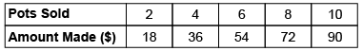  “7 is halfway between 6 and 8, so I find the number halfway between 54 and 72, which is $63.00.” | Flexibly solves problems involving ratios, including percents, and rates.  The ratio of dogs to cats in the animal shelter is 8:12. Show the comparison using percents.  “The whole is 8 + 12 = 20.  Since percent is “out of 100”,  I multiply each term in the ratio by 5 because 5 × 20 = 100.  8 × 5:12 × 5, or 40:60  40% of the animals are dogs and 60% are cats.”
Observations/Documentation

