Multiplication and Division with Proper Fractions
Models multiplication and division situations concretely and pictorially.  4 × $\frac{3}{5}$ = ?  “I modelled the multiplication with fraction strips, then counted fifths:  4 × $\frac{3}{5}$ = $\frac{12}{5}$, or 2$\frac{2}{5}$” | Uses models and think-addition strategies, to solve multiplication problems.  5 × $\frac{2}{5}$ = ?  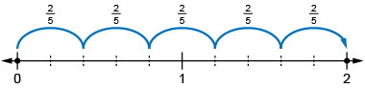  “I know that multiplication is like repeated addition, so I used a number with each whole partitioned into fifths, then took  5 jumps of two-fifths: 5 × $\frac{2}{5}$ = 2” | Uses models and think-addition strategies without leftovers, to solve division problems.  4 ÷ $\frac{2}{5}$ = ?  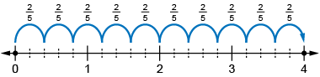  “I used a number line from 0 to 4 and partitioned each whole into fifths. I took jumps of two-fifths until I reached 4. I took 10 jumps.  So, 4 $\frac{2}{5}$ = 10.” | Flexibly solves multiplication and division problems (with and  without leftovers).  5 ÷ $\frac{3}{4}$ = ?  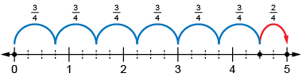  There are 6 groups of $\frac{3}{4}$,  with $\frac{2}{4}$ left over.  $\frac{2}{4}$ is $\frac{2}{3}$ of $\frac{3}{4}$  So, the remainder is $\frac{2}{3}$$.$  5 ÷ $\frac{3}{4}$ = 6$\frac{2}{3}$
Observations/Documentation

