Calculating Percents using Mental Math
Explores number patterns and relationships.  100% of 360 = 360  50% of 360 = 180  25% of 360 = 90  12.5% of 360 = 45  What patterns do you see?  “I see that the percent is halved each time and when this happens, the product is also halved.” | Uses number patterns and relationships to solve problems.  50% of 80 = ?  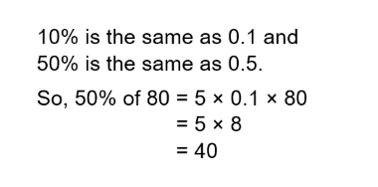 | Uses mental math strategies and checks for reasonableness.  Find 14% of $300  14% = 10% + 5% – 1%  10% of $300 = $30  5% of $300 = $15  1% of $300 = $3  So, 14% of $300 = $30 + $15 – 3  = $42 | Fluently calculates percents using a variety of mental math strategies  8% of 260 = ?  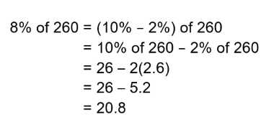
Observations/Documentation

