Multiplying and Dividing Decimals by 1-Digit Numbers
Models multiplication and division situations concretely and pictorially.  1.6 × 3 = ?  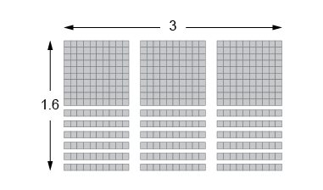  “I used Base Ten Blocks to make an array  with length 3 and width 1.6.  I then counted the blocks to get 4.8”. | Uses models and strategies to solve multiplication and division situations.  4.15 × 5 = ?  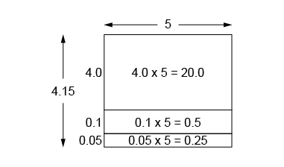  “I used an area model:  4 × 5 = 20;  1 tenth × 5 = 5 tenths, or 0.5;  5 hundredths × 5  = 25 hundredths, or 0.25;  20.0 + 0.5 + 0.25 = 20.75.” | Decomposes numbers to use distributive property and partial products to multiply.  4.15 × 5 = ?  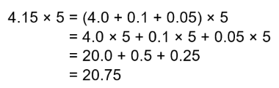
Observations/Documentation

Multiplying and Dividing Decimals by 1-Digit Numbers (cont’d)
Decomposes numbers to use partial quotients  to divide.  21.25 ÷ 5 = ?  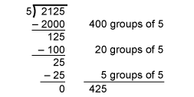  “I used partial quotients to divide as whole numbers, then estimated to place the decimal point. 21.25 is about 20.  20 ÷ 5 = 4  So, I placed the decimal point so 425 is close to 4: 4.25.” | Estimates to determine if answer to multiplication or division problem is reasonable.  38.22 ÷ 3 = 12.74  “I used estimation to check.  38 is close to 39 and 39 ÷ 3 = 13.  Since 12.74 is close to 13,  my answer is reasonable.” | Solves multiplication and division problems flexibly using a variety of strategies.  A bus travelled 446.5 km in 5 h, with no stops.  On average, how far did the bus travel in 1 h?  “I divided as I would whole numbers, then used estimation to place the decimal point.  446.5 is about 450, and 450 ÷ 5 = 90.  I placed the decimal point  so that 893 is close to 90: 89.3.”
Observations/Documentation

Multiplying and Dividing Whole Numbers by Decimal Tenths
Explores and generalizes patterns using place-value relationships.  245 × 1 = 245  245 × 0.1 = 24.5  245 ÷ 0.1 = 2450  “When I multiply by 0.1, the digits shift one place to the right. When I divide by 0.1, the digits shift one place to the left.” | Uses patterns, number relationships, and properties of operations to solve problems.  190 × 0.4 = ?  “I multiplied by 1 tenth first, then multiplied the product by 4.”  190 × 0.1 = 19.0  19.0 × 4 = 76.0  190 × 0.4 = 76.0 | Uses algorithms and checks for reasonableness (e.g., partial products, standard algorithm).  355 × 0.5 = ?  I used partial products to multiply, then estimated to check the reasonableness of my answer.  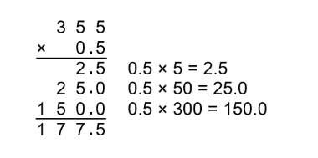  355 is close to 350. 0.5 is the same as one half. One half of 350 is 175.  Since 177.5 is close to 175, my answer is reasonable.” | Flexibly solves multiplication and division problems using a variety of strategies.  428 ÷ 0.4 = ?  “I multiplied both numbers by 10 so I could work with whole numbers, then used an algorithm.”  428 ÷ 0.4 = 4280 ÷ 4
Observations/Documentation

