Comparing Interest Rates and Fees
Identifies factors to consider when choosing an account or loan.  “It is important to compare interest rates and fees.” | Describes the pros and cons of fees and interest rates to borrowing and saving money.  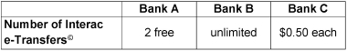  “Each bank offers a different number of e-Transfers. It is important to think about how many a person makes  a month.” | Compares how fees and interest rates support making choices about better deals.  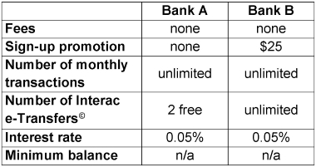  “I choose Bank B because the interest rates are the same, but I get unlimited e-Transfers and $25 for signing up.” | Fluently makes informed financial decisions related to borrowing and saving money.  “When saving money, I look for the higher interest rate, but when borrowing money, I look for the lowest interest rate. It is important to take all factors into account.”
Observations/Documentation

