Comparing Interest Rates and Fees
Identifies factors to consider when choosing an account or loan.  “It is important to compare interest rates and fees.” | Describes the pros and cons of fees and interest rates to borrowing and saving money.  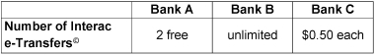  “Each bank offers a different number of e-Transfers. It is important to think about how many a person makes  a month.” | Compares how fees and interest rates support making choices about better deals.  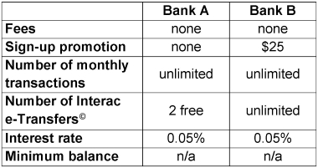  “I choose Bank B because the interest rates are the same, but I get unlimited e-Transfers and $25 for signing up.” | Fluently makes informed financial decisions related to borrowing and saving money.  “When saving money, I look for the higher interest rate, but when borrowing money, I look for the lowest interest rate. It is important to take all factors into account.”
Observations/Documentation

Planning for Financial Goals
Identifies different types of financial goals, including earning and savings goals.  “I want to save $5 for the pizza lunch next Friday. I want to save $50 for new skates next Winter.” | Outlines key steps needed to make a plan to achieve a financial goal.  “I earn $10 a week cutting grass. I will save $5 each week in my  bank account.” | Recognizes and explains various factors that may help or interfere with reaching a financial goal.  “I will have to find another job as I can’t cut grass in the Winter. To save money, I will borrow books from the library.” | Makes informed decisions about planning for a financial goal, considering all possible factors  “If I lose a job or I have an unexpected expense, I need to be able to adjust my plan so that I can still achieve my goal.”
Observations/Documentation

