Generalizing and Representing Patterns
Identifies how a pattern repeats, increases, or decreases and describes the pattern rule.  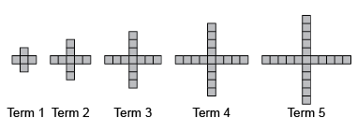  “This is an increasing pattern. The pattern rule is: Start with 5 red tiles and add 4 tiles each time.” | Represents patterns using tables, charts, or graphs and describes the pattern rule.  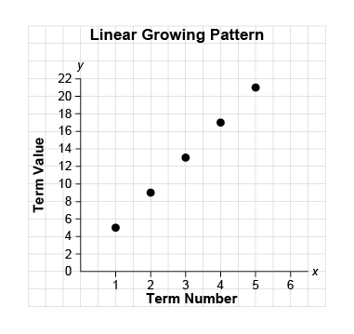  “The graph represents a growing pattern. The pattern rule is: Multiply the term number by 4 and add 1.”  Term Number Number of Blocks  1 8  2 16  3 24 | Represents patterns symbolically, using algebraic expressions and equations.  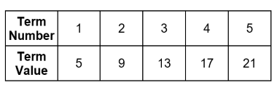  “An algebraic expression for the pattern rule: 4n + 1, where n is the term number. An equation for the pattern: v = 4n + 1, where v is the term value.” | Identifies and describes different representations of patterns as linear or non-linear.  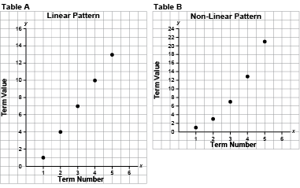  “The first graph represents a linear pattern because the points lie on a straight line. The second graph represents a non-linear pattern because the points do not lie  on a straight line.”
Observations/Documentation

Generalizing and Representing Patterns (cont’d)
Extends patterns using repeated addition and subtraction, multiplication, and division.  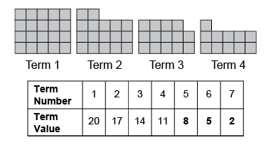  “This is a linear decreasing pattern because the same number (3) is subtracted each time. To extend the pattern, I subtract 3 from the previous term: 11 − 3 = 8, 8 − 3 = 5, 5 − 3 = 2. The term values can be represented with the expression  23 − 3n, where n is the term number.” | Creates and translates linear patterns using various representations.  Kiera has $15 to spend on items that cost $3 each.  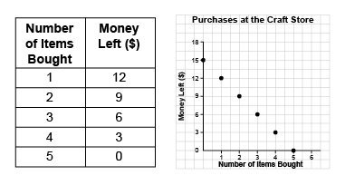  “The table shows that for each additional item bought, the money left decreases by $3. The graph shows the same linear pattern, where the money left decreases by $3 as you move from point to point.” | Uses patterns to represent and solve problems.  How far had the bus travelled after 3 h 30 min?  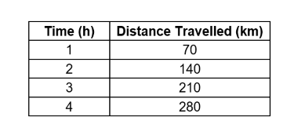  “The bus travels 70 km in 1 h  (60 min). So, in 30 min,  the bus travels 70 km ÷ 2 = 35 km.  In 3 h, the bus travels 210 km.  So, in 3 h 30 min, the bus travels 210 km + 35 km = 245 km.” | Fluently identifies, creates, and extends patterns to solve real-life problems.  How much would a 6-km ride cost?  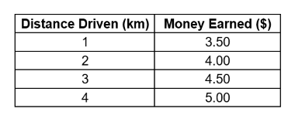  “I added 2 × $0.50 = $1.00 to the cost of a 4-km ride which is $5.00. So, a 6-km ride costs:  $5.00 + $1.00 = $6.00.  Or, I could multiply the number of kilometres by $0.50, then add $3:  6 × $0.50 + $3 = $3 + $3, or $6.”
Observations/Documentation

