Extending Patterns to Solve Problems
Determines the pattern rule.  5, 10, 15, 20, 25, 30, 35, 40  “The term numbers are consecutive multiples of 5.” | Uses pattern rule to determine missing values.  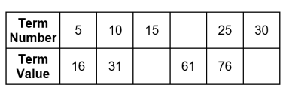  “The pattern rule for the term numbers is: Skip count by 5s.  So, the missing term is 20. The pattern rule for the term values is: Multiply the term number by 3, then add 1. The missing term values are:  15 × 3 + 1 = 46 and 30 × 3 + 1 = 91.” | Extends patterns using mathematical expressions.  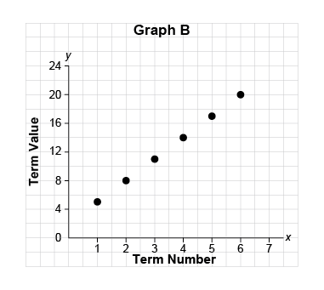  “I can use the expression 3n + 2 to extend the pattern, where n represents the term number.  The seventh and eighth terms would be 3 × 7 + 2 = 23 and  3 × 8 + 2 = 26.” | Flexibly describes and solves problems using mathematical expressions and properties.  Zac earned $504 to buy games for a children’s hospital.  Each game costs $64.  How many games can Zac buy?  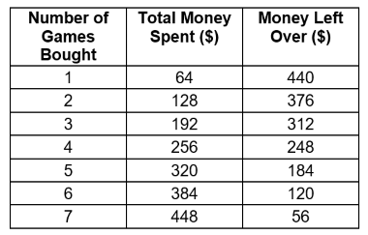  “Expression for money spent ($) is 64v, where v is the number of games bought. The money left over, in dollars, is: 504 – (the money spent) = 504 – 64v. Zac can buy 7 games and have $56 left over.”
Observations/Documentation

Number Pattern Relationships
Recognizes pattern relationships in repeating, increasing, and decreasing patterns.  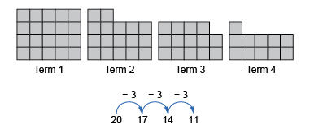  “I see a relationship that shows skip-counting backward by 3. The rule is: Start with 20 tiles and take away 3 tiles each time.” | Identifies and describes linear and non-linear patterns in tables, charts, and graphs.  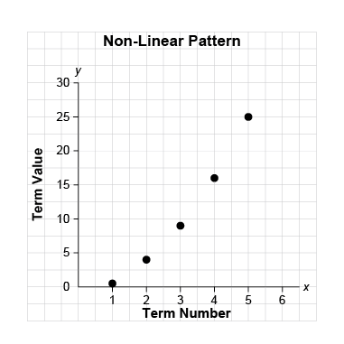  “The graph shows a non-linear increasing pattern. The points do not lie on a straight line, and a different number is added to the term value each time.” | Creates and translates repeating, increasing, and decreasing patterns using various representations.  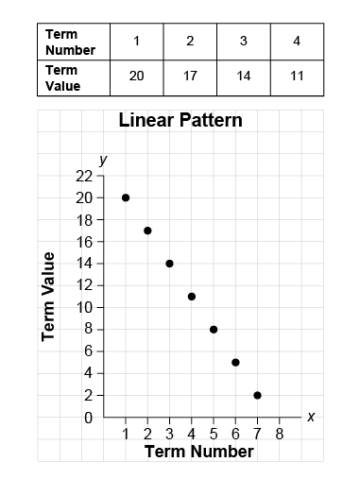  “Each of these representations shows a linear pattern that follows the pattern rule: Start at 20 and subtract 3 each time.”
Observations/Documentation

Number Pattern Relationships (cont’d)
Creates and translates repeating, increasing, and decreasing patterns and describes them using algebraic expressions and equations.  “I created this increasing pattern. An expression for the term values is: 3n + 2, where n is the term number. An equation for this pattern is:  v = 3n + 2, where v is the term value.” | Describes patterns to show relationships among whole numbers and decimals with tenths, hundredths, and thousandths.  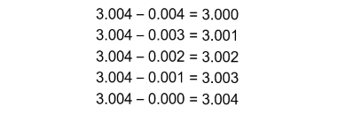  “As the number that is subtracted decreases by 0.001, the difference increases by 0.001.” | Fluently identifies and describes linear and non-linear patterns and justifies choice of representation to show pattern relationships.  Students raised $180 to buy 8 games that cost $26 each. Do they have enough money?  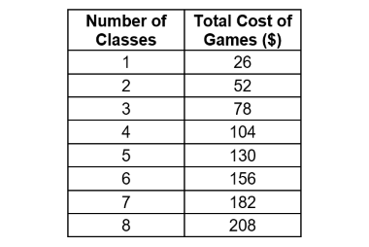  “This is a linear pattern where $26 dollars is added each time. I used the equation c = 26n to determine the cost of n games in dollars, where  n = 8: c = 26 × 8, which is $208. There is not enough money to buy games for 8 classes.  Only 6 classes can have a game.”
Observations/Documentation

