Solving and Graphing Inequalities
Identifies range of numbers in solution to inequalities.  45 + 5n ≥ 100  45 + 5n > 100  “Each time, the unknown can be any number greater than 11. In the second equation, it could also be 11. There are many quantities that would work.” | Represents solutions to simple inequalities by graphing on a number line.  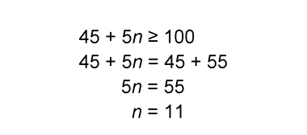  At least 11 cars need to be washed.  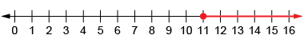  “Since 11 is part of the solution, I drew a closed circle at 11. Since n must be greater than or equal to 11, the arrow goes to the right.” | Verifies the solution to an inequality.  45 + 5n ≥ 100  n ≥ 11  “To check, I substituted a number greater than 11 into the left side.  45 + 5(20) = 145.  Since 145 > 100, the solution is correct.” | Flexibly solves inequalities using various strategies, then verifies and graphs the solutions.  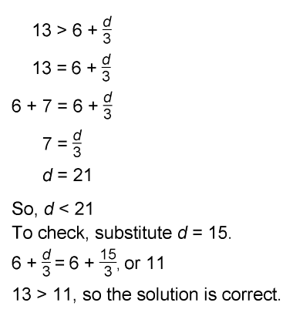  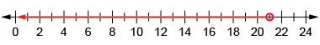
Observations/Documentation

