Geometry
Unit 1B Line Master 1a
Angle Puzzles

Puzzle A
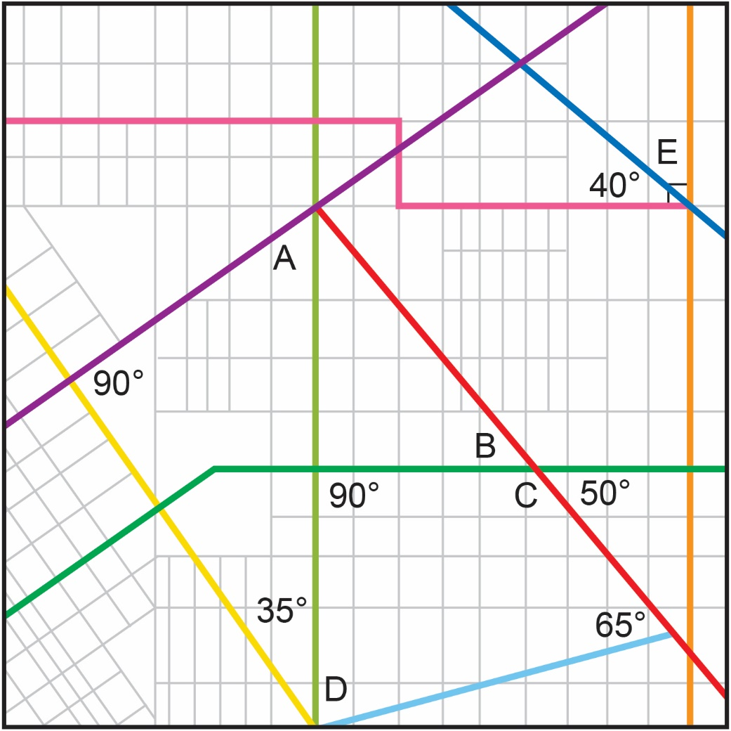

∠A: | ∠B: | ∠C:
∠D: | ∠E:

Sum of angles A to E:

Geometry
Unit 1B Line Master 1b
Angle Puzzles (cont’d)

Puzzle B
Measure the angles in each shape.
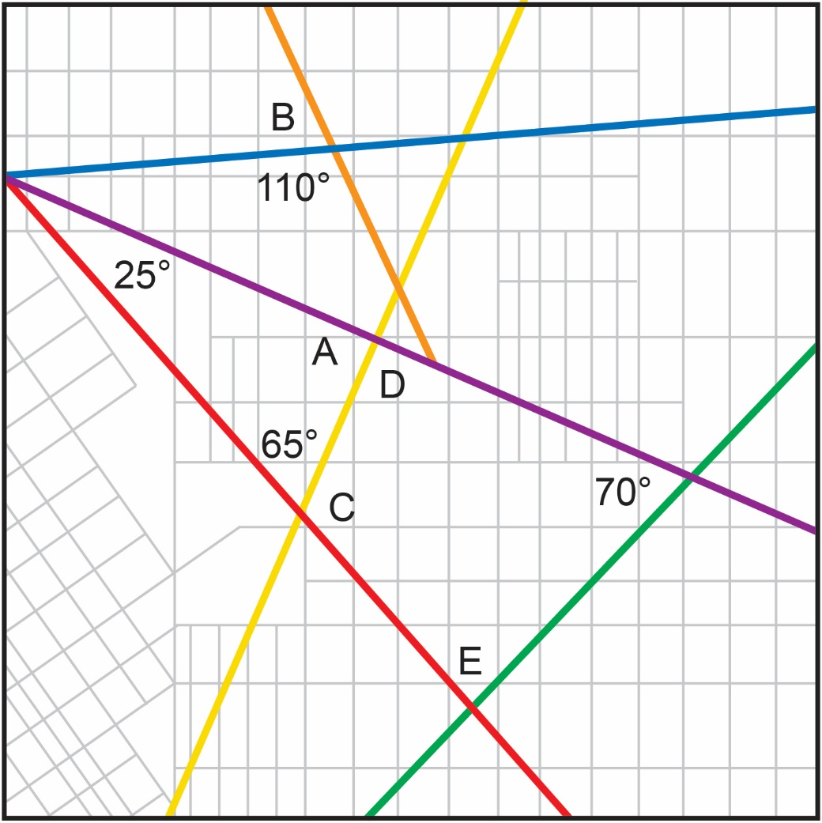

∠A: | ∠B: | ∠C:
∠D: | ∠E:

Sum of angles A to E:

