Who’s the Suspect Shape?
Cards

Geometry
Unit 1B Line Master 2a
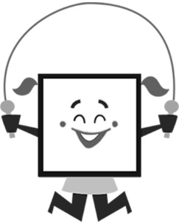  Sayo Square  ● 4 equal sides  ● 4 right angles  ● 2 pairs of opposite  angles equal  ● opposite sides equal  ● opposite sides parallel  ● 2 equal diagonals  ● 4 lines of symmetry  ● rotational symmetry of order 4  ● diagonals that intersect at right angles  ● diagonals bisect each other | 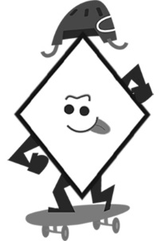  Roger Rhombus  ● 4 equal sides  ● 2 lines of symmetry  ● rotational symmetry  of order 2  ● 2 pairs of parallel sides  ● opposite sides parallel  ● opposite sides equal  ● 2 pairs of opposite  angles equal  ● diagonals that intersect at right angles  ● diagonals bisect each other  ● 2 lines of symmetry  ● rotational symmetry of order 2
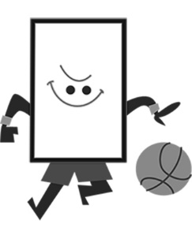  Roscoe Rectangle  ● 4 right angles  ● 2 pairs of opposite  angles equal  ● opposite sides equal  ● opposite sides parallel  ● 2 equal diagonals  ● 2 lines of symmetry  ● rotational symmetry of order 2  ● diagonals bisect each other | Padma Parallelogram  ● 2 pairs of opposite angles equal  ● opposite sides equal  ● opposite sides parallel  ● rotational symmetry of order 2  ● diagonals bisect each other  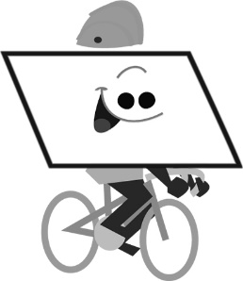

Who’s the Suspect Shape? (cont’d)
Cards

Geometry
Unit 1B Line Master 2b

Curtis Convex Kite  ● diagonals that intersect at right angles  ● 2 pairs of adjacent sides equal  ● 1 line of symmetry  ● 2 equal angles  ● 1 bisected diagonal  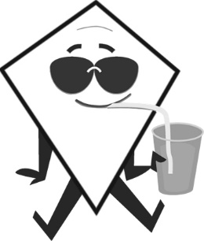 | Cleo Concave Kite  ● 1 reflex angle  ● 2 pairs of adjacent sides equal  ● 1 line of symmetry  ● 2 equal angles  ● 1 bisected diagonal  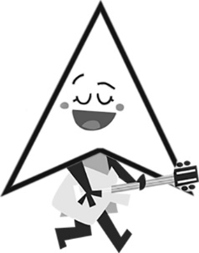
Trina Trapezoid  ● exactly 1 pair of parallel sides  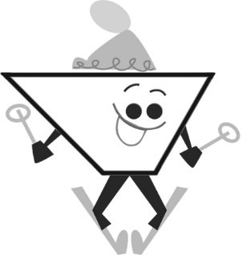 | Imene Isosceles Trapezoid  ● exactly 1 pair of parallel sides  ● exactly 1 pair of opposite sides equal  ● 2 equal diagonals  ● 2 pairs of equal angles  ● 1 line of symmetry

Who’s the Suspect Shape? (cont’d)
Cards

Geometry
Unit 1B Line Master 2c

Sayo Square  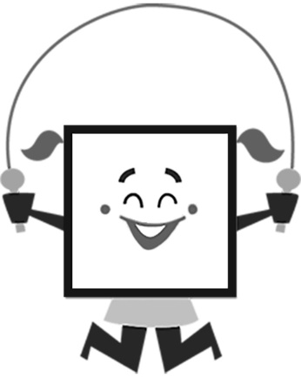 | Roger Rhombus  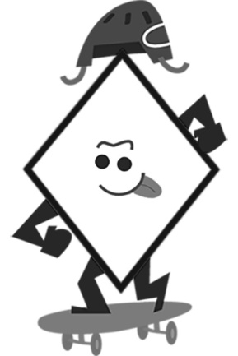 | Roscoe Rectangle  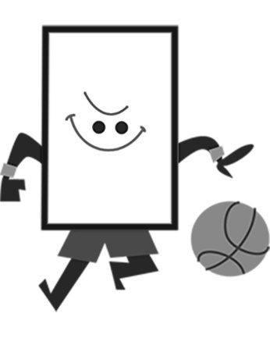
Padma Parallelogram  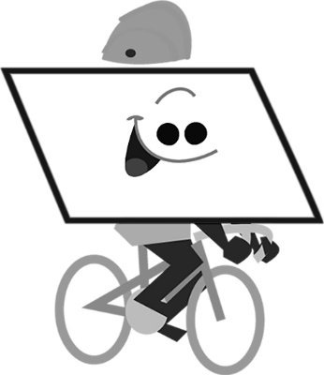 | Curtis Convex Kite  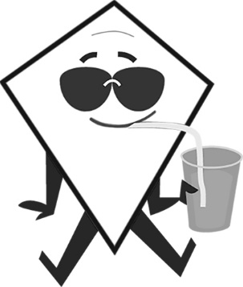 | Cleo Concave Kite  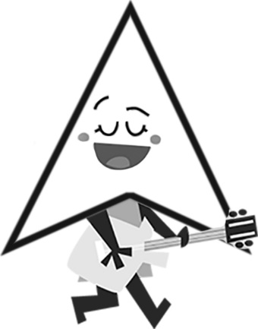
Trina Trapezoid  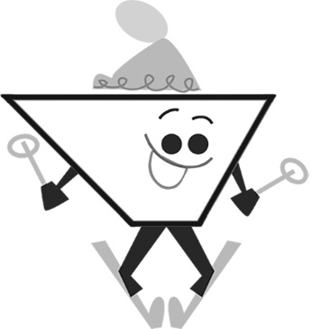 | Imene Isosceles Trapezoid

