Building Objects from Views

Geometry
Unit 1B Line Master 5a

Part A: Given one view
Build an object that has this top view.
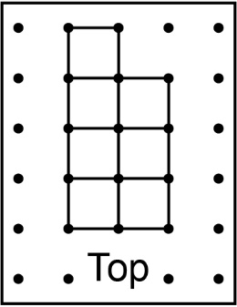

How many different objects can you build?

Part B: Given two views
Build an object that has this top view and front view.
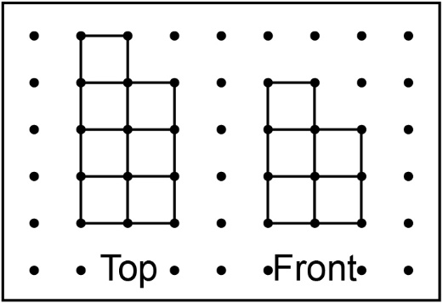

How many different objects can you build now?

Building Objects from Views (cont’d)

Geometry
Unit 1B Line Master 5b

Part C: Given three views
Build an object that has this top view, front view, and right-side view.
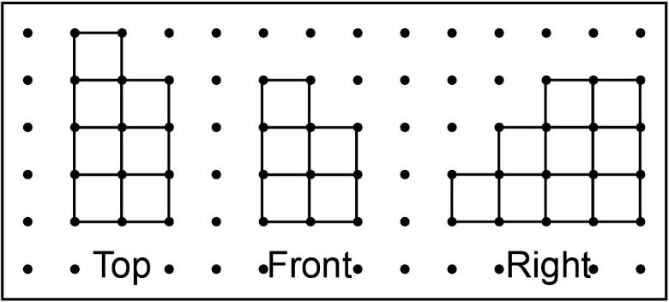

How many different objects can you build now?

Part D: Given four views
Here is the left-side view. Is your object correct?
If not, add or move cubes until it is.
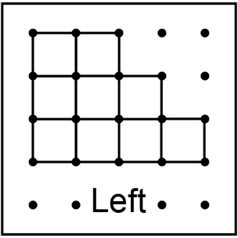

What did you notice as more views were given?

Building Objects from Views (cont’d)

Geometry
Unit 1B Line Master 5c

Part A: Given one view
Build an object that has this top view.
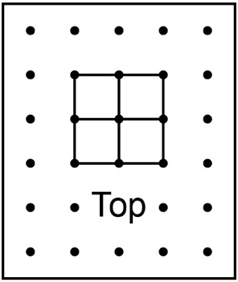

How many different objects can you build?

Part B: Given two views
Build an object that has this top view and front view.
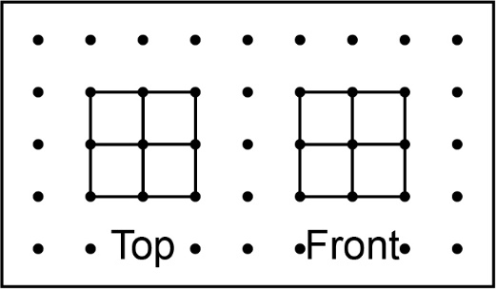

How many different objects can you build now?

Building Objects from Views (cont’d)

Geometry
Unit 1B Line Master 5d

Part C: Given three views
Build an object that has this top view, front view, and right-side view.
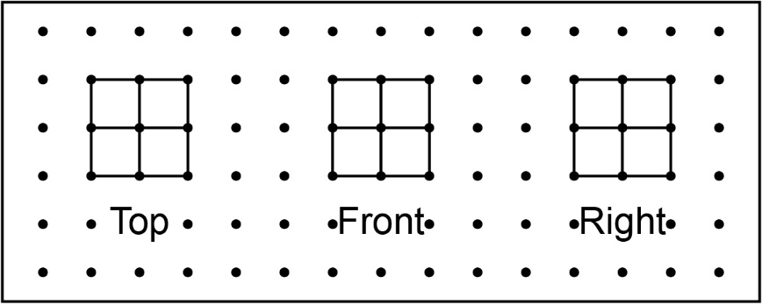

How many different objects can you build now?

Part D: Given four views
Here is the left-side view. Is your object correct?
If not, add or move cubes until it is.
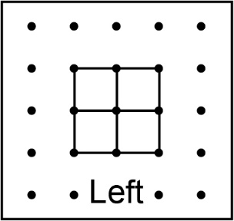

What did you notice as more views were given?

