Centre Tasks

Number
Unit 3 Line Master 12a

Centre A: The Garden
(Representing Fractions)

The residents of an apartment building decided
to make a rectangular community garden.
Their design is shown below.
The walkway is part of the garden.
What fraction of the garden does each type of vegetable cover? Explain.

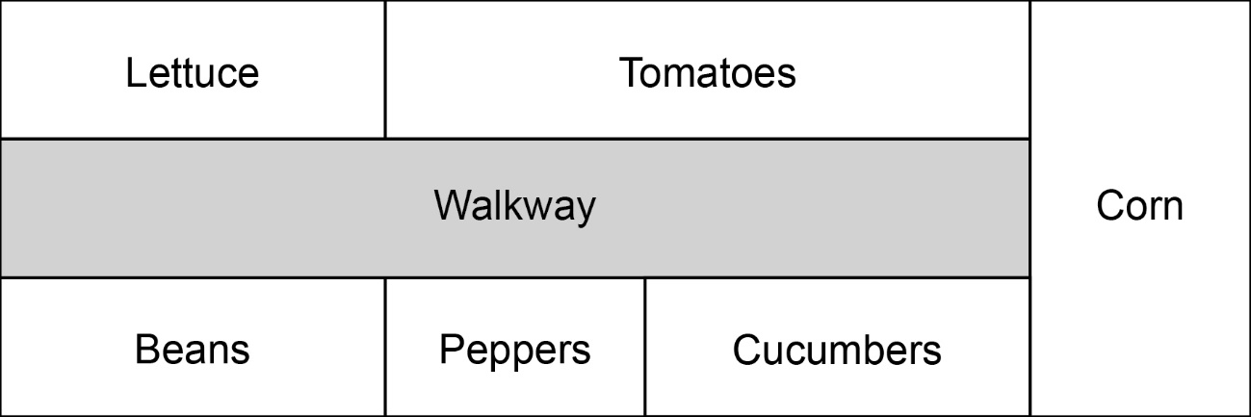

Centre Tasks (cont’d)

Number
Unit 3 Line Master 12b

Centre B: Planting Seeds
(Comparing Fractions)

Seeds come in small packages, with different numbers
of seeds in each, depending on the type of vegetable.

This table shows the fraction of the garden each package
of seeds will cover.

Vegetable | Lettuce | Tomatoes | Corn | Peppers | Cucumbers | Beans
Fraction of garden covered with 1 package of seeds | $\frac{1}{9}$ | $\frac{1}{9}$ | $\frac{1}{6}$ | $\frac{1}{6}$ | $\frac{1}{6}$ | $\frac{1}{3}$

Use the fractions you identified in Centre A.
Determine how many packages of each seed
the gardeners should buy.

Centre Tasks (cont’d)

Number
Unit 3 Line Master 12c

Centre C: Tending to the Garden
(Working with Percents)

These tasks need to be completed daily to maintain the garden.
Task | Time (h)
Watering | 2
Weeding | 4
Fertilizing | 0.5
Pruning | 1
Maintenance of Walkway | 1
Picking/Cleaning Crop | 1.5

The gardeners want to divide up the tasks equally.
To do this, they would like a visual that shows
each time as a percent of the total daily time: 10 h.
Create a visual to help the gardeners.

Centre Tasks (cont’d)

Number
Unit 3 Line Master 12d

Centre D: Harvesting Vegetables
(Fractions of a Set)

One day in mid-August, 24 vegetables were harvested
from the garden.
Here is the harvest:
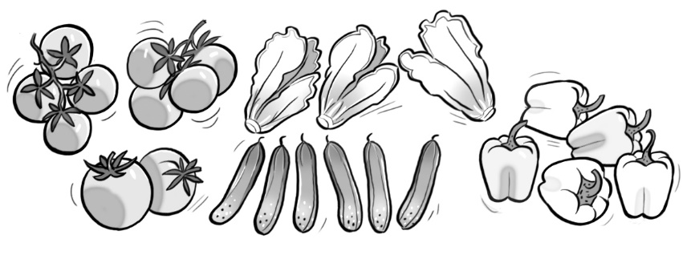
• Show each type of vegetable as a fraction of the whole harvest
for that day.
• Order the fractions from least to greatest.
• Create a visual to show the harvest.
Partition the rectangle to show the harvest
of each type of vegetable.
Today’s Harvest

Centre Tasks (cont’d)

Number
Unit 3 Line Master 12e

Centre E: Recording Temperatures
(Interpreting Integers)

The gardeners recorded the temperatures daily.
This table shows the temperatures for the first 10 days of May.

Date | Daytime High (°C) | Nighttime Low (°C)
May 1 | 15 | −3
May 2 | 12 | −7
May 3 | 23 | 4
May 4 | 24 | 15
May 5 | 23 | 10
May 6 | 29 | 16
May 7 | 28 | 8
May 8 | 15 | −4
May 9 | 19 | 0
May 10 | 17 | −1

• Which day had the coldest daytime temperature?
• Which day had the coldest nighttime temperature?
• Frost is possible any time the nighttime temperature
drops to 4°C or lower.
For which dates was there a risk of frost?
• Order the nighttime temperatures from highest to lowest.

Centre Tasks (cont’d)

Number
Unit 3 Line Master 12f

Centre F: Applying Fertilizer
(Relating Fractions, Decimals, and Percents)

The gardeners want to use an organic fertilizer
that is high in nitrogen and low in potash.
Here are their options.
Natural Nutrients  Fertilizer  Nitrogen: $\frac{1}{5}$  Phosphate: $\frac{1}{10}$  Potash: $\frac{1}{20}$ |  | Greener Growers  Fertilizer  Nitrogen: 0.15  Phosphate: 0.2  Potash: 0.05 |  | Perfect Plants  Fertilizer  Nitrogen: 5%  Phosphate: 10%  Potash: 5%

• Which fertilizer best matches their needs?
• For the chosen fertilizer, express the value of each chemical as:
– a fraction
– a decimal
– a percent
• Identify the fertilizer that has the most phosphate.
Show your thinking.

Centre Tasks (cont’d)
Answers

Number
Unit 3 Line Master 12g

Centre A:
Lettuce: $\frac{2}{18}$ or $\frac{1}{9}$; Tomatoes: $\frac{3}{18}$ or $\frac{1}{6}$; Corn: $\frac{3}{18}$ or $\frac{1}{6}$;
Cucumbers: $\frac{2}{18}$ or $\frac{1}{9}$; Peppers: $\frac{1}{18}$; Beans: $\frac{2}{18}$ or $\frac{1}{9}$

Centre B:
Lettuce: 1 package; Tomatoes: 2 packages; Corn: 1 package;
Cucumbers: 1 package; Peppers: 1 package; Beans: 1 package
Centre C:
Visual to show: Watering: 20%; Weeding: 40%; Fertilizing: 5%; Pruning: 10%; Maintenance of Walkway: 10%;
Picking/Cleaning Crop: 15%
Centre D:
Tomatoes: $\frac{10}{24}$, or $\frac{5}{12}$; Cucumbers: $\frac{6}{24}$, or $\frac{1}{4}$; Lettuce: $\frac{3}{24}$, or $\frac{1}{8}$;
Peppers: $\frac{5}{24}$;
 | Today’s Harvest
 | T | T | T
 | T | T | T
 | T | T | T
 | T | C | C
 | C | C | C
 | C | L | L
 | L | P | P
 | P | P | P
Least to greatest: $\frac{1}{8}$, $\frac{5}{24}$, $\frac{1}{4}$, $\frac{5}{12}$

Centre Tasks (cont’d)
Answers

Number
Unit 3 Line Master 12h

Centre E:
May 2; May 2; May 1, May 2, May 3, May 8, May 9, May 10;
16, 15, 10, 8, 4, 0, −1, −3, −4, −7

Centre F: Natural Nutrients Fertilizer; Nitrogen: $\frac{1}{5}$, 0.2, 20%;
Phosphate: $\frac{1}{10}$, 0.1, 10%; Potash: $\frac{1}{20}$; 0.05, 5%;
Greener Growers Fertilizer; 20%.

