Making Shapes
Using a Block-Coding Program

Patterning and Algebra
Unit 3 Line Master 3a

What to Do
Click the link to access Scratch: Cat and Dinosaur – Making Shapes:
https://scratch.mit.edu/projects/494179883/
● To execute Cat’s code, press 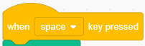.
● To execute Dinosaur’s code, press .
● Alter the code so that Cat makes a triangle and
Dinosaur makes a parallelogram.
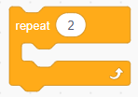
● Try changing some of the numbers.
How do the changes impact the outcome?
● Try to include a Repeat Block to make
the code more efficient.

Tips
● Change one thing at a time. Talk about what you are changing
and why.
● When you press , you will see the code.
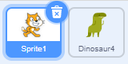
● You can click the values in the code 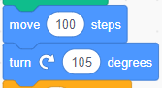
and change them.
● To see the code for Dinosaur,
you need to click the Dinosaur icon.
Making Shapes (cont’d)
Using a Block-Coding Program

Patterning and Algebra
Unit 3 Line Master 3b

● You can move blocks in the code
to different spots to change when that outcome occurs
(Cat or Dinosaur).
● You can click and drag any of the blocks of code out of the code
to remove them or change their order.
● At the start of the code, there are other blocks that help to achieve
the outcome. They are part of what makes the code work.
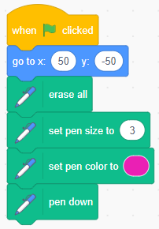

Self-check in
What have you learned about block coding so far?
Did you get stuck? If so, what did you do?
Did you turn to your classmates for help? If so, how did they help?
What are you doing to help the learning of others?
This is “hard fun.” What do you think we mean by “hard fun”?
What other activities do you do that are “hard fun”?

