Creating and Classifying Polygons
Using a Block-Coding Program

Patterning and Algebra
Unit 3 Line Master 5a

Follow the link to access the file: What type of polygon?
https://scratch.mit.edu/projects/546910232/editor

Let’s explore.
Enter 3 for the number of sides. What polygon did you make?
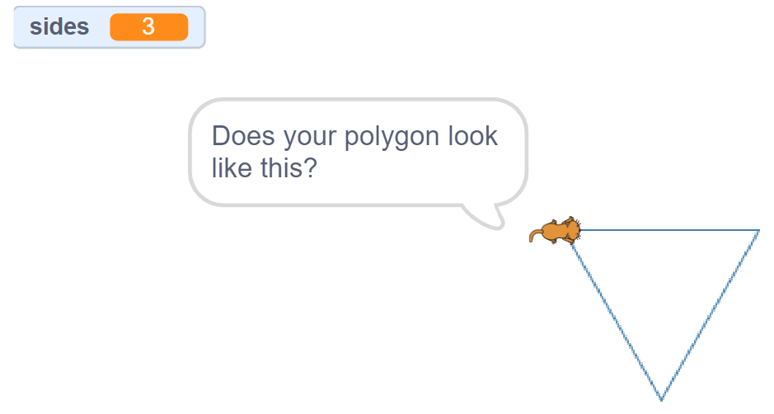
Try again. This time enter 5.
It seems as like the program isn’t quite right.
We need to alter the code so that the words
and drawings are accurate.
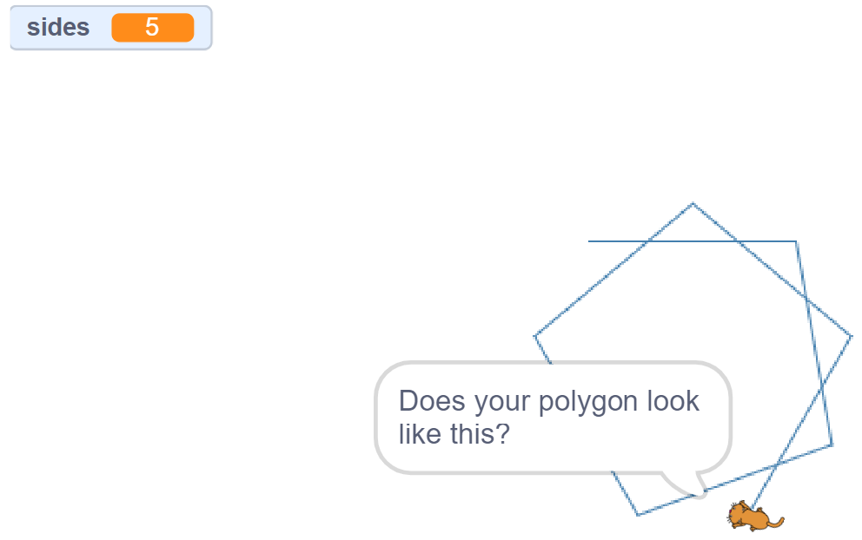
Creating and Classifying Polygons (cont’d)
Using a Block-Coding Program

Patterning and Algebra
Unit 3 Line Master 5b

Try one more time. Enter 8.

Ha! I guess it would take forever to code this for
ALL possible polygons.
But maybe we can code a few more polygons.

Let’s look inside the code.
This program uses a conditional statement where something is either
true or false. We are going to use these to classify different polygons.
It either has 3 sides or it doesn’t.
● If it does, a triangle is named and drawn.
● If it doesn’t, nothing happens.
Notice that the code for 3 sides is working for our program.
You might use this code as you determine how to make the other
polygons work properly.
You will see that some Blocks have already been created and
labelled by their polygon name. These are part of the conditional
statements that this program runs on, but there are mistakes.

Creating and Classifying Polygons (cont’d)
Using a Block-Coding Program

Patterning and Algebra
Unit 3 Line Master 5c

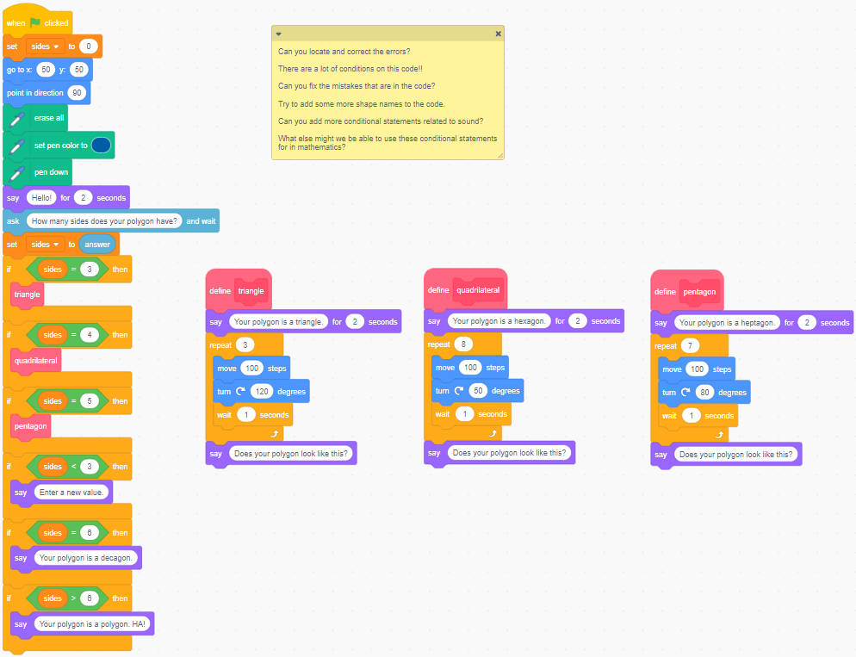
What are some of the blocks you recognize? Any new ones?
Notice for the triangle code, we used a “repeat 3” block. If we wrote this without a repeat block, it would require more blocks. We’d have to use the “move” and “turn” blocks three times! Repeats help our code to be more efficient.
When we are coding, we try to make our code as efficient as possible. The more experience we have with coding, the more efficient we are to make our applications!
Creating and Classifying Polygons (cont’d)
Using a Block-Coding Program

Patterning and Algebra
Unit 3 Line Master 5d

Tips
This code allows the “answer” to be used in the rest of the code,
since the classification is based on the answer that is given.
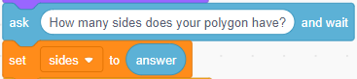
We’ve stored the user’s answer in a variable called “sides.”
You might notice that you can use this variable block (found under
Variables) to make your code even more efficient by incorporating it
in your repeat values. There’s that word again – “efficient”. Variables are another great way to help us make our code more efficient.
This code incorporates a conditional  statement that means:  “If the answer entered by the user is 3,  then the triangle code will be executed.” | 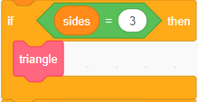
This is the resulting code.
This defines the code to create  a triangle.  When you click the green flag,  the main program begins.  The main program “calls” the triangle  code (or subprogram).  The code for the triangle is executed  if the user typed 3 for number  of sides. | 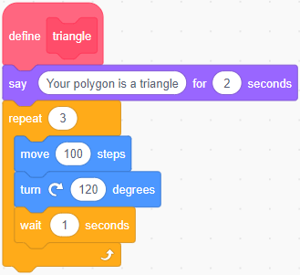
Creating and Classifying Polygons (cont’d)
Using a Block-Coding Program

Patterning and Algebra
Unit 3 Line Master 5e

For this conditional statement,  the user is told to enter a new value  if they enter a number less than 3.  This is because we cannot create  a polygon with fewer than 3 sides!  Why is that? |  | 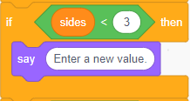
For the other conditional statements,  you will need to ensure the proper  polygon is named and drawn according  to the number of sides.  For example, if the user enters 4 for  number of sides, a quadrilateral should  be named and drawn: |  | 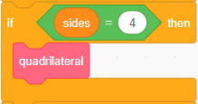
But what happens when the user  types in 4 now?  Look at the quadrilateral code as  it is currently written: | 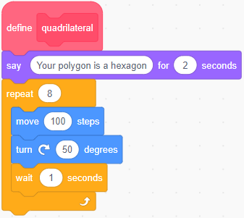
What a mess! We can see several mistakes:
● The polygon is named incorrectly.
● The repeat value is incorrect.
● The angle turn is incorrect.
Make the required changes for the quadrilateral.
Creating and Classifying Polygons (cont’d)
Using a Block-Coding Program

Patterning and Algebra
Unit 3 Line Master 5f

What to Do
Alter all the code so it is accurate.
Remember to change only one value at a time,
so that you can reflect on the impact of your change.
After you fix the broken parts of the code, try to add more
blocks to make this program define and draw more polygons.
You will find these in the My Blocks Tab
You can see that the block for triangle,  quadrilateral and pentagon have already  been created. | 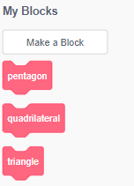
Alter the code for each of the blocks that are there so they are
accurate with naming, classifying, and drawing.
Try to add more blocks (My Blocks, Make a Block) for other polygons,
so that more polygons are included in the classification.

Creating and Classifying Polygons (cont’d)
Using a Block-Coding Program

Patterning and Algebra
Unit 3 Line Master 5g

Self-check in
What have you learned about block coding so far?
What is one way to make your code more efficient?
Did you get stuck? If so, what did you do?
Did you turn to your classmates for help? If so, how did they help?
What are you doing to help the learning of others?
This is “hard fun.” What do you think we mean by “hard fun”?
What other activities do you do that are “hard fun”?
Go on “spy walks” to see what your classmates have done.

