Conceptual Meaning of Addition and Subtraction of Decimals
Recognizes addition and subtraction situations and models concretely or pictorially to add or subtract to hundredths (using hundredths grids or Base Ten Blocks)  25.86 – 17.23 = ?  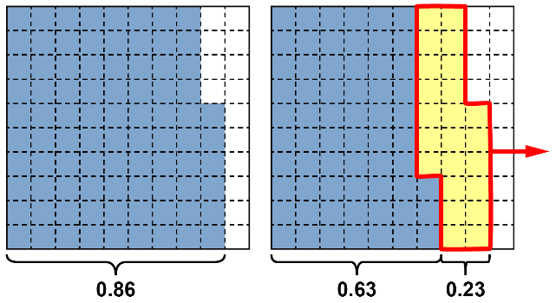  “86 hundredths – 23 hundredths =  63 hundredths  25 – 17 = 8”  25.86 – 17.23 = 8.63 | Uses an understanding of place value to add or subtract decimals with hundredths (using standard algorithm)  25.86 − 17.23 = ?  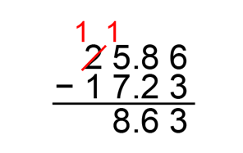  “I used the standard algorithm to subtract the hundredths, then the tenths, and then the whole numbers.” | Models to add or subtract decimals with thousandths (e.g., using thousandths grids or number lines)  43.600 – 1.345 = ?  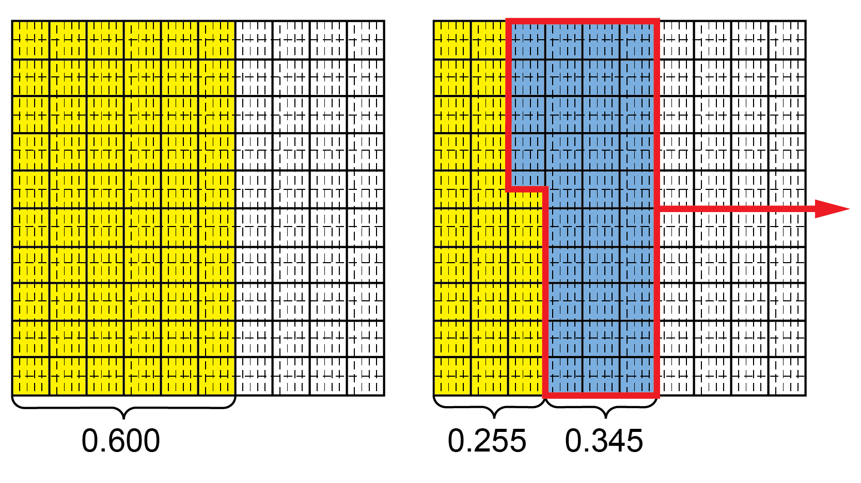  “600 thousandths – 345 thousandths =  255 thousandths  43 – 1 = 42.”  43.6 – 1.345 = 42.255
Observations/Documentation

Conceptual Meaning of Addition and Subtraction of Decimals (cont’d)
Uses an understanding of place value to add or subtract decimals with thousandths (e.g., using standard algorithm)  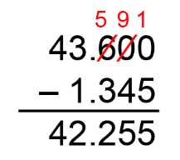  “I used the standard algorithm to subtract the thousandths, then the hundredths, then the tenths, and then the whole numbers.” | Uses estimation and mental math strategies to check reasonableness of solutions  43.6 – 1.345 = 42.255  43.6 is close to 44. 1.345 is close to 1.  44 – 1 = 43  “42.255 is the answer I calculated, and it is close to 43, so my answer is reasonable.” | Solves addition and subtraction problems flexibly, using a variety of strategies  Naomi swam 1.5 km, rode a bicycle for  35.29 km, and ran for 8.375 km. What was  the total distance Naomi travelled?  1.5 km + 35.29 km + 8.375 km = ?  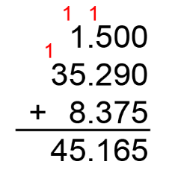  “I wrote each number as a decimal with thousandths.  Naomi travelled 45.165 km in total.”
Observations/Documentation

