Investigating Arithmetic Sequences
Identifies how an arithmetic sequence increases or decreases and describes the initial term and constant change  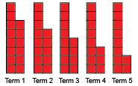  “This is a decreasing sequence.  Initial term: 14 red tiles;  Constant change: take away 1 red tile.” | Represents arithmetic sequences in tables of values and on graphs  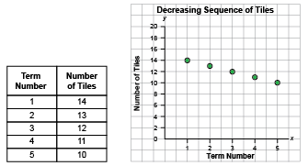  “The table and graph show the number of tiles decreases by 1 each time. The points on the graph lie on a straight line that goes down  to the right.” | Identifies a rule that relates the positions and terms of an arithmetic sequence  Term Number Number of Tiles  1 14  2 13  3 12  4 11  5 10  “By looking at the table, I see that the number of tiles is equal to 15 minus the term number.”
Observations/Documentation

Investigating Arithmetic Sequences (cont’d)
Writes an algebraic expression that relates the positions and terms of an arithmetic sequence  Term Number Number of Tiles  1 14  2 13  3 12  4 11  5 10  “The number of tiles is equal to 15 minus the term number. I can write this rule as 15 − n, where n represents the term number.” | Determines the missing term in an arithmetic sequence (using expression)  Term Number Term Value  1 8  2 16  3 ?  4 32  5 ?  6 48  “Rule: Multiply the term number by 8 to get the term value. I can write this rule as: 8n, where n represents the term number.  Term 3: 8n = 8 $×$ 3, or 24  Term 5: 8n = 8 $×$ 5, or 40.” | Fluently identifies, creates, and extends various arithmetic sequences to solve real-life problems  Box Cost to Ship ($)  1 3.50  2 7.00  3 10.50  How much would it cost to ship 9 boxes?  “To determine the shipping cost, multiply the number of boxes by $3.50. I would use the expression 3.5n, where n is the number of boxes:  3.5n = 3.5 $×$ 9, or 31.5  So, the cost to ship 9 boxes is $31.50.”
Observations/Documentation

