Who is Correct?

Number
Unit 4 Line Master 2

An egg farmer took 10 cartons of eggs to the market.
Each carton had 12 eggs.
How many eggs did the farmer take?

To solve the problem:
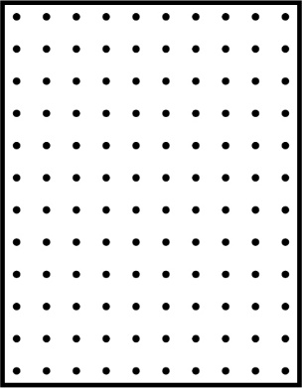
- Ronica outlined an array on dot paper.
- Patrick made an open array.
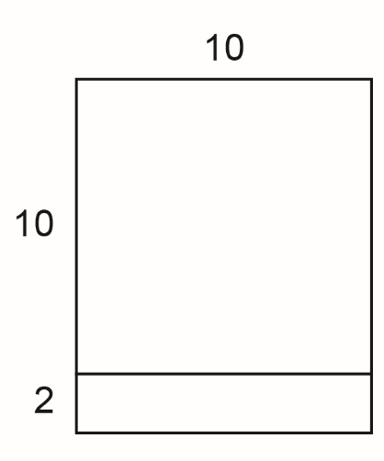
Whose solution is correct? Explain.
How are the solution strategies the same?
How are they different?

