Investigating Relative Frequency through Experiments
Lists all possible outcomes for an experiment with equally likely outcomes.  These counters are in a bag.  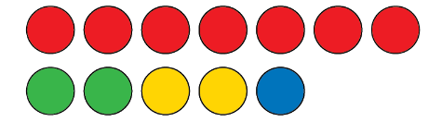  “I could get a red, green, yellow, or blue counter.” | Determines expected likelihood of an event.  “Red: most likely, $\frac{7}{12}$; green: unlikely, $\frac{2}{12}$ or $\frac{1}{6}$; yellow: unlikely,  $\frac{2}{12}$ or $\frac{1}{6}$; blue: least likely: $\frac{1}{12}$” | Uses the possible outcomes of an experiment to predict the likelihood of an event.  “There are 12 counters and  7 are red. 12 × 4 = 48, which is close to 50. So, in 50 trials I think I will get a red counter about 7 × 4,  or 28 times.” | Conducts experiment and organizes collected data.  “I conducted the experiment.  In 50 trials, I got a red counter  35 times.”
Observations/Documentation

Investigating Relative Frequency through Experiments (cont’d)
Uses outcomes of experiment to determine relative frequencies.  “I got a red counter 35 times  in 50 trials. So, the relative frequency of getting red  is $\frac{35}{50}$, or $\frac{70}{100}$, or 0.7, or 70%.” | Realizes that relative frequencies vary among sets of collected data.  “The relative frequency of getting red was different for other pairs  of students. I got $\frac{35}{50}$, but others got $\frac{29}{50}$, $\frac{33}{50}$, and $\frac{37}{50}$.” | Understands that with more trials of an experiment, the closer the actual results may be to expected likelihoods.  “When I conducted more trials,  I noticed that the results got closer to the expected likelihoods,  but they still didn’t match exactly.” | Flexibly performs experiments, analyzes results, and compares and justifies predictions.  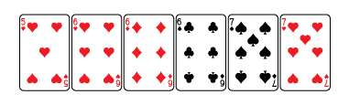  “The likelihood of drawing  a 6 or a 7 is $\frac{5}{6}$. So, when I conduct  the experiment 60 times,  I would expect to get a 6 or 7  about 50 times. I got 6 or 7  forty-four times.  I have to do more trials.”
Observations/Documentation

