Exploring Symmetry and Congruence
Verifies symmetry of two shapes by reflecting or rotating one shape onto another.  “I reflected one trapezoid  in a vertical line of reflection  so that it mapped onto the other trapezoid exactly. So, the two shapes are symmetrical.” | Describes the symmetry between two shapes as reflection symmetry or rotation symmetry, or a combination of two transformations.  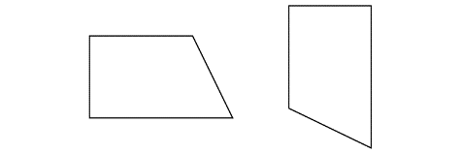  “These two symmetrical shapes  are related by a combination  of transformations. I could reflect  the shape on the left in a vertical line, then rotate the image counterclockwise until it has  the same orientation  as the other shape.” | Demonstrates congruence between two shapes in any orientation by superimposing.  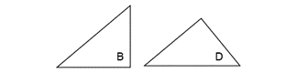  “The two shapes are congruent  even though they have different orientations. I traced Shape B  and placed the tracing on Shape D and they matched exactly. They have the same size and shape.” | Understands that shapes related by symmetry are congruent to each other.  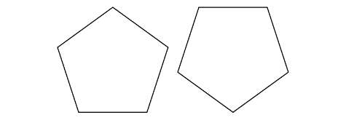  “These two shapes are related  by rotation symmetry. I can map  one shape onto the other through rotation so that they match exactly. This means the shapes  are congruent as they have  the same size and shape.”
Observations/Documentation

