Location and Transformations in the Cartesian Plane
Reads and interprets the Cartesian plane.  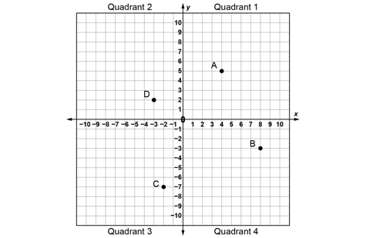  “The x-axis looks like a horizontal number line and the y-axis looks like a vertical number line, and  the two number lines intersect.” | Locates points on a Cartesian plane using ordered pairs.  “Point A is at (4, 5), Point B  is at (8, -3), Point C is at (-2, -7), and Point D is at (-3, 2).” | Uses coordinates to plot points on a Cartesian plane.  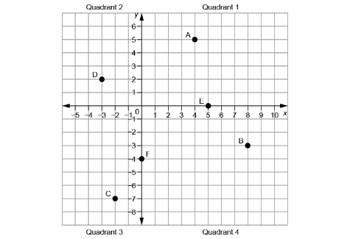  “I plotted Point E(5, 0)  and Point F(0, −4).” | Models and describes the location of the vertices of a polygon in the Cartesian plane using coordinates.  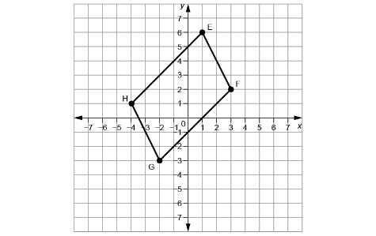  “I drew a parallelogram.  Its vertices are at E(1, 6), F(3, 2), G(−2, −3), and H(−4, 1).”
Observations/Documentation

Location and Transformations in the Cartesian Plane (cont’d)
Describes and performs transformations of polygons on a Cartesian plane.  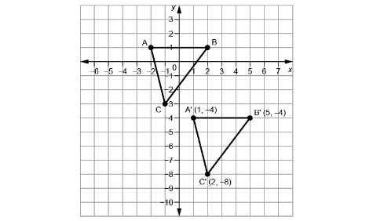  “I translated ABC right 3 squares and down 5 squares  to get A’B’C’.” | Identifies transformation used to move a polygon on a Cartesian plane.  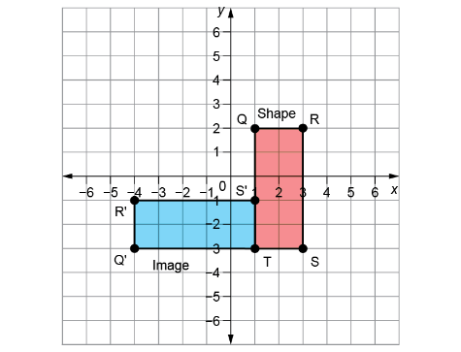  “The shape was rotated  90° counterclockwise about T  to get the image. The shape  and its image are congruent  but have different orientations.” | Relates the coordinates of a polygon and its image after a translation, reflection, or rotation.  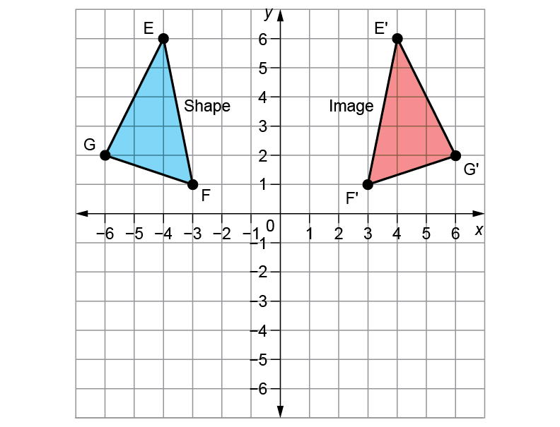  “After a reflection in the y-axis,  the x-coordinates of the vertices change sign, and the y-coordinates stay the same.” | Flexibly visualizes and predicts where the image of a polygon will be after a transformation.  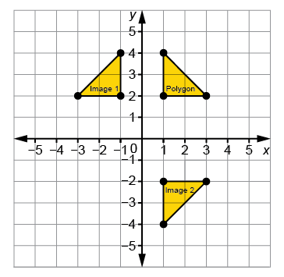  “I can picture the Polygon’s reflection, Image 1, on the other side of the y-axis, and the Polygon’s reflection, Image 2, on the other side of the x-axis. Each time, matching vertices will be the same distance from the line of reflection and the polygon, and its image  will have opposite orientations.”
Observations/Documentation

