Exploring Symmetry and Congruence
Verifies symmetry of two shapes by reflecting or rotating one shape onto another.  “I reflected one trapezoid  in a vertical line of reflection  so that it mapped onto the other trapezoid exactly. So, the two shapes are symmetrical.” | Describes the symmetry between two shapes as reflection symmetry or rotation symmetry, or a combination of two transformations.  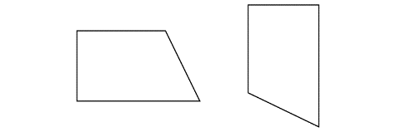  “These two symmetrical shapes  are related by a combination  of transformations. I could reflect  the shape on the left in a vertical line, then rotate the image counterclockwise until it has  the same orientation  as the other shape.” | Demonstrates congruence between two shapes in any orientation by superimposing.  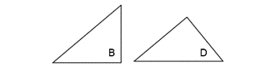  “The two shapes are congruent  even though they have different orientations. I traced Shape B  and placed the tracing on Shape D and they matched exactly. They have the same size and shape.” | Understands that shapes related by symmetry are congruent to each other.  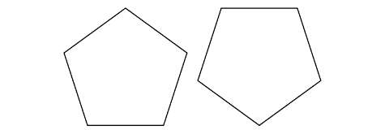  “These two shapes are related  by rotation symmetry. I can map  one shape onto the other through rotation so that they match exactly. This means the shapes  are congruent as they have  the same size and shape.”
Observations/Documentation

Location and Transformations in the Cartesian Plane
Reads and interprets the Cartesian plane.  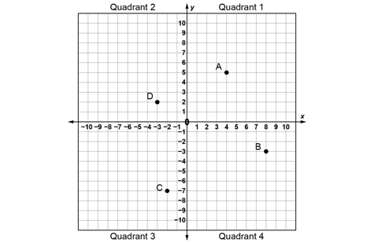  “The x-axis looks like a horizontal number line and the y-axis looks like a vertical number line, and  the two number lines intersect.” | Locates points on a Cartesian plane using ordered pairs.  “Point A is at (4, 5), Point B  is at (8, -3), Point C is at (-2, -7), and Point D is at (-3, 2).” | Uses coordinates to plot points on a Cartesian plane.  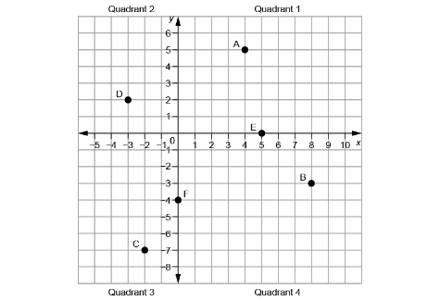  “I plotted Point E(5, 0)  and Point F(0, −4).” | Models and describes the location of the vertices of a polygon in the Cartesian plane using coordinates.  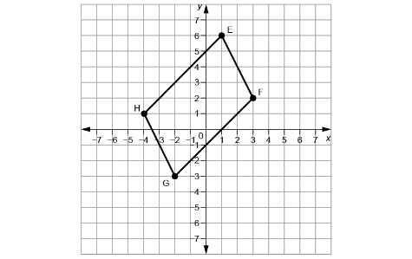  “I drew a parallelogram.  Its vertices are at E(1, 6), F(3, 2), G(−2, −3), and H(−4, 1).”
Observations/Documentation

Location and Transformations in the Cartesian Plane (cont’d)
Describes and performs transformations of polygons on a Cartesian plane.  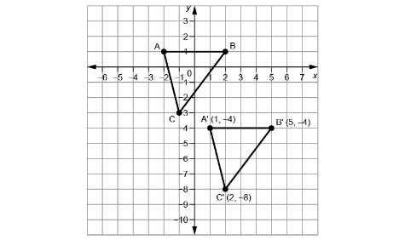  “I translated ABC right 3 squares and down 5 squares  to get A’B’C’.” | Identifies transformation used to move a polygon on a Cartesian plane.  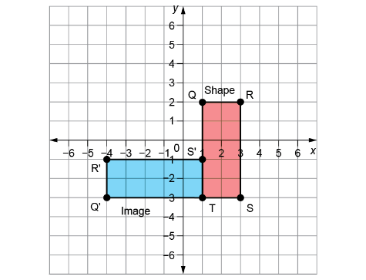  “The shape was rotated  90° counterclockwise about T  to get the image. The shape  and its image are congruent  but have different orientations.” | Relates the coordinates of a polygon and its image after a translation, reflection, or rotation.  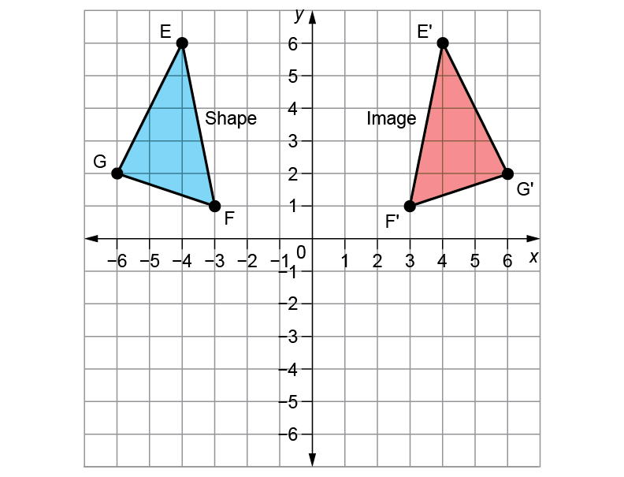  “After a reflection in the y-axis,  the x-coordinates of the vertices change sign, and the y-coordinates stay the same.” | Flexibly visualizes and predicts where the image of a polygon will be after a transformation.  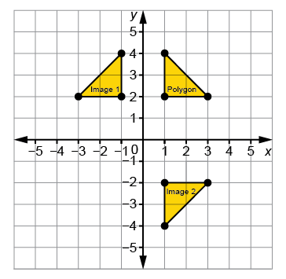  “I can picture the Polygon’s reflection, Image 1, on the other side of the y-axis, and the Polygon’s reflection, Image 2, on the other side of the x-axis. Each time, matching vertices will be the same distance from the line of reflection and the polygon, and its image  will have opposite orientations.”
Observations/Documentation

