Measuring Area of Parallelograms and Triangles
Determines the area of a rectangle.  “A rectangle is an array of squares. To find the area, I multiply the number of rows by the number of columns or use the formula A = b × h.  This rectangle has area  5 cm × 3 cm = 15 cm².”  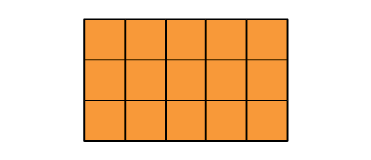 |  | Partitions and rearranges a parallelogram to form a rectangle with the same base and height.  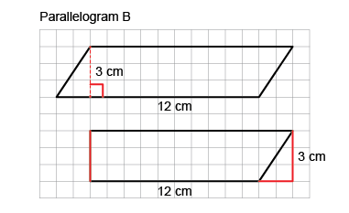  “I partitioned the parallelogram  and moved the triangle to  create a rectangle.  I then found the area of the rectangle:  A = b × h = 12 cm × 3 cm= 36 cm².  The area of the parallelogram is also 36 cm².” | Doubles a triangle to create a parallelogram (area of triangle is one-half that of parallelogram).  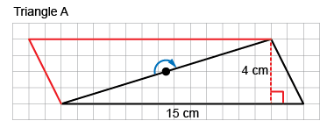  “I rotated the triangle to make a parallelogram  with the same base and height.  The area of the triangle is one-half  the area of the parallelogram.  Area of parallelogram:  15 cm × 4 cm = 60 cm²  Area of triangle: 60 cm² ÷ 2 = 30 cm²  So, the formula for the area of a triangle is:  A = b × h ÷ 2.”
Observations/Documentation

Measuring Area of Parallelograms and Triangles (cont’d)
Determines area by decomposing shapes into smaller shapes (rectangles, triangles, parallelograms), then adding their areas.  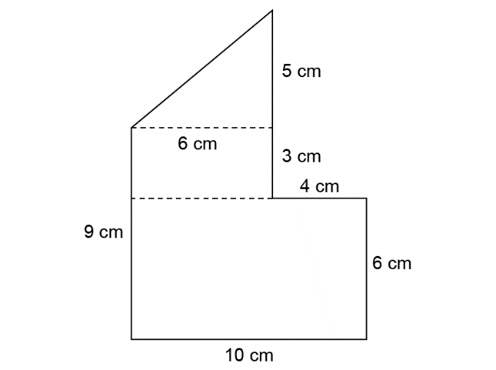  “I decomposed the shape into a triangle  and 2 rectangles.  Area of small rectangle: 3 cm × 6 cm = 18 cm²  Area of large rectangle: 6 cm × 10 cm = 60 cm²  Area of triangle: 6 cm × 5 cm ÷ 2 = 15 cm²  Area of composite shape:  18 cm² + 60 cm² + 15 cm² = 93 cm²” | Decomposes a composite shape in different ways and realizes that its area doesn’t change (conservation of area).  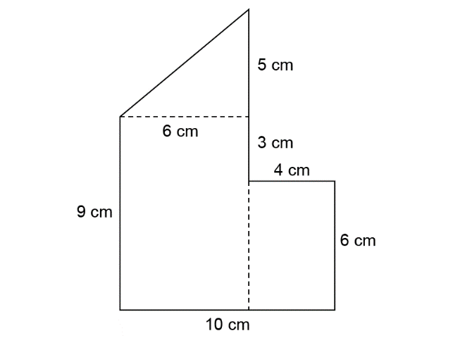  “I decomposed the shape into a triangle  and 2 rectangles.  Area of small rectangle: 4 cm × 6 cm = 24 cm²  Area of large rectangle: 9 cm × 6 cm = 54 cm²  Area of triangle: 6 cm × 5 cm ÷ 2 = 15 cm²  Area of composite shape:  24 cm² + 54 cm² + 15 cm² = 93 cm²  The area is always the same no matter how  I decompose the shape.” | Flexibly solves problems involving the relationships among the areas of rectangles, parallelograms, and triangles.  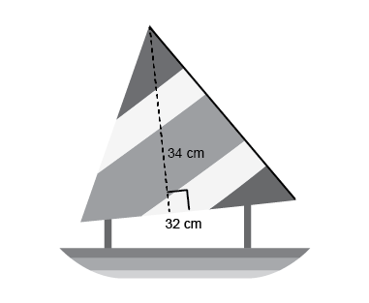  What is the area of the sail on the toy boat?  “I doubled the triangular sail to make  a parallelogram with the same base and height.  I found the area of the parallelogram:  34 cm × 32 cm = 1088 cm², then divided  the area in half to find the area of the triangle: 1088 cm² ÷ 2 = 544 cm².”
Observations/Documentation

