Measuring Area of Parallelograms and Triangles
Determines the area of a rectangle.  “A rectangle is an array of squares. To find the area, I multiply the number of rows by the number of columns or use the formula A = b × h.  This rectangle has area  5 cm × 3 cm = 15 cm².”  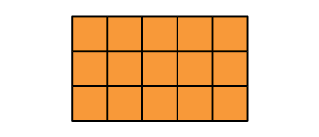 |  | Partitions and rearranges a parallelogram to form a rectangle with the same base and height.  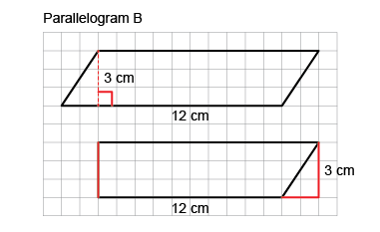  “I partitioned the parallelogram  and moved the triangle to  create a rectangle.  I then found the area of the rectangle:  A = b × h = 12 cm × 3 cm= 36 cm².  The area of the parallelogram is also 36 cm².” | Doubles a triangle to create a parallelogram (area of triangle is one-half that of parallelogram).  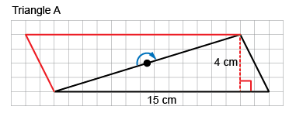  “I rotated the triangle to make a parallelogram  with the same base and height.  The area of the triangle is one-half  the area of the parallelogram.  Area of parallelogram:  15 cm × 4 cm = 60 cm²  Area of triangle: 60 cm² ÷ 2 = 30 cm²  So, the formula for the area of a triangle is:  A = b × h ÷ 2.”
Observations/Documentation

Measuring Area of Parallelograms and Triangles (cont’d)
Determines area by decomposing shapes into smaller shapes (rectangles, triangles, parallelograms), then adding their areas.  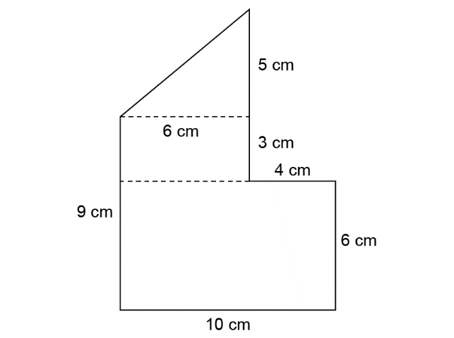  “I decomposed the shape into a triangle  and 2 rectangles.  Area of small rectangle: 3 cm × 6 cm = 18 cm²  Area of large rectangle: 6 cm × 10 cm = 60 cm²  Area of triangle: 6 cm × 5 cm ÷ 2 = 15 cm²  Area of composite shape:  18 cm² + 60 cm² + 15 cm² = 93 cm²” | Decomposes a composite shape in different ways and realizes that its area doesn’t change (conservation of area).  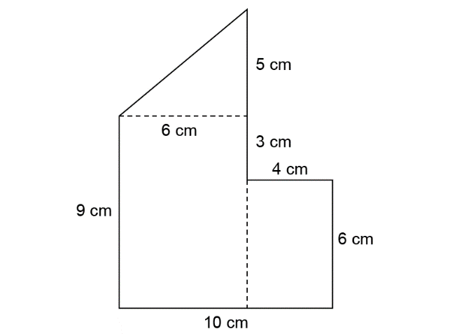  “I decomposed the shape into a triangle  and 2 rectangles.  Area of small rectangle: 4 cm × 6 cm = 24 cm²  Area of large rectangle: 9 cm × 6 cm = 54 cm²  Area of triangle: 6 cm × 5 cm ÷ 2 = 15 cm²  Area of composite shape:  24 cm² + 54 cm² + 15 cm² = 93 cm²  The area is always the same no matter how  I decompose the shape.” | Flexibly solves problems involving the relationships among the areas of rectangles, parallelograms, and triangles.  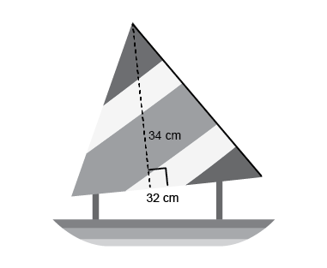  What is the area of the sail on the toy boat?  “I doubled the triangular sail to make  a parallelogram with the same base and height.  I found the area of the parallelogram:  34 cm × 32 cm = 1088 cm², then divided  the area in half to find the area of the triangle: 1088 cm² ÷ 2 = 544 cm².”
Observations/Documentation

Interpreting and Expressing Volume
Explores volume as the amount of space occupied by a 3-D shape.  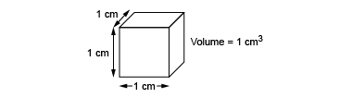  “This cube occupies a space  that can be measured.  Each edge has a length of 1 cm  and it has a volume of 1 cm³.” | Recognizes volume of 3-D shapes in familiar contexts.  “Everyday objects have volume;  for example, a loaf of bread  and a cereal box.” | Models volume using concrete materials (non-standard units).  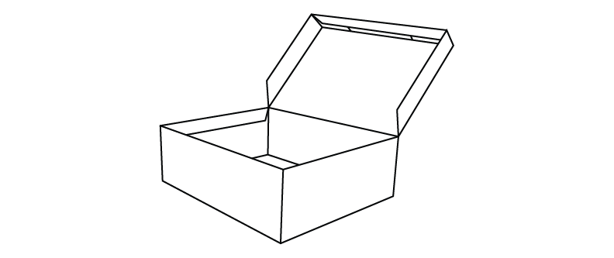  “The volume of the box  is about 12 marbles.  Marbles aren’t the greatest unit because they leave gaps.” | Expresses volume of 3-D shapes using standard units (cubic metres, cubic centimetres).  “I filled the box with centimetre  cubes. The volume of the box  is about 24 cm³.”
Observations/Documentation

Interpreting and Expressing Volume (cont’d)
Models volume of a rectangular prism as a 3-D array of cubic units.  “The prism is a 3-D array of centimetre cubes. There are  12 cubes in each layer and 3 layers: 12 + 12 + 12 = 36.  The prism has volume 36 cm³.” | Recognizes that volume remains the same when decomposed or rearranged.  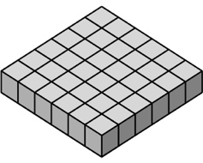  “I rearranged the 36 centimetre cubes to make a different prism.  The number of cubes didn’t change so, the volume is still 36 cm³.” | Determines the volume of a rectangular prism using multiplication.  “The prism has length 4 cm,  width 3 cm and height 3 cm.  The area of the base is  4 cm × 3 cm = 12 cm², and the volume of the prism is:  Area of the base × height  = 12 cm² × 3 cm  = 36 cm³.” | Flexibly solves problems in various contexts that involve the volume of rectangular prisms.  A square prism has height 11 cm and volume 539 cm³. Determine the side length of the square base.  “Volume = area of base × height 539 cm³ = Area of the base × 11 cm  539 ÷ 11 = 49  So, the area of the base is 49 cm².  The base is a square, so all sides are equal: 49 cm² = s × s  Since 7 × 7 = 49, the side length  of the square base is 7 cm.”
Observations/Documentation

