Exploring Integers
Describes integers in terms of a positive or negative distance  from zero.  “−5 is 5 units to the left of 0  on a horizontal number line.  +3 is 3 units to the right of 0.” | Understands that an integer and its opposite are the same distance from zero but on opposite sides of zero.  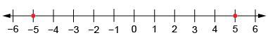  “Negative 5 is the same distance from zero as positive 5.” | Recognizes that the value of negative numbers decreases as the number of digits increases.  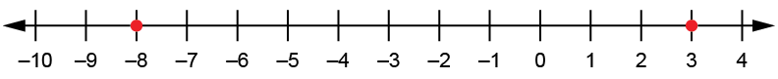  “−8 is less than +3  because it is less than zero:  −8 < 3.” | Compares and orders positive and negative integers.  −5, 0, −2, 5, −1  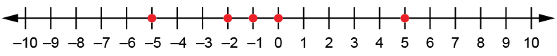  “From least to greatest:  −5, −2, −1, 0, 5”
Observations/Documentation

Exploring Integers (cont’d)
Adds integers with like signs concretely or pictorially (e.g., using counters or number lines).  –3 + (–2) = –5  “The sum of two negative integers  is negative.” | Recognizes that the sum of a number and its additive inverse is 0.  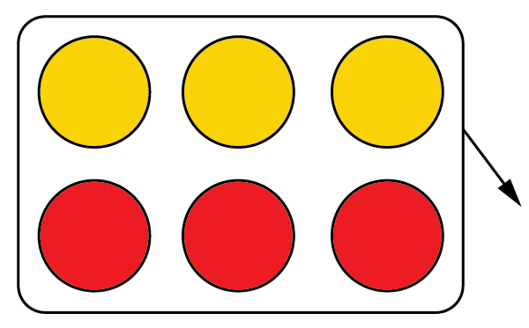  –3 + (+3) = 0  “Adding an integer and its opposite gives 0.” | Adds integers with different signs concretely (e.g., using counters and zero pairs or number lines).  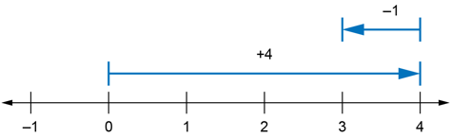  4 + (–1) = 3  “I moved right to model +4, then left to model −1. I ended up at +3.” | Flexibly adds integers and solves addition story problems.  –6 + 2  “I think of it as the sum of 0  and another integer.”  –6 + 2 = (–4 + (–2)) + 2  = –4 + (–2 + 2)  = –4 + 0  = –4
Observations/Documentation

