Relating Fractions, Decimals, Percents, Ratios, and Rates
Describes an equal-sharing situation using a fraction.  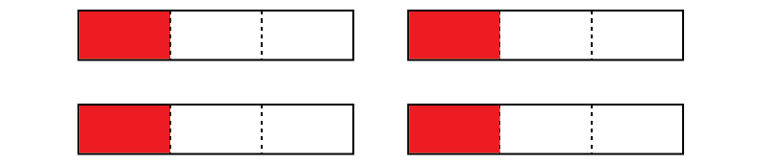  “To share 4 granola bars among  3 friends, I draw a picture that shows 4 wholes each divided into thirds.” | Describes a fraction as a division statement and vice versa.  “To share 4 granola bars among  3 friends, I can write the division statement 4 ÷ 3 or I can write a  fraction $\frac{4}{3}$. The picture shows  4 wholes each divided into thirds. Each person gets 3 thirds  and one more third or 1$\frac{1}{3}$.” | Makes connections between fractions, decimals, and percents.  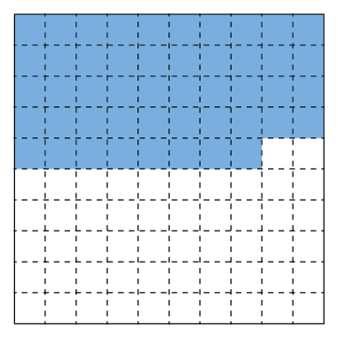  “I see forty-eight hundredths, which is the same as 0.48 or $\frac{48}{100}$. Since percent is ‘out of 100’, it can also be thought of as 48% of something.” | Determines the percent of a number.  “I can determine 12% of 40  by multiplying 40 by 12  and dividing by 100.”  40 × 12 ÷ 100 = 480 ÷ 100  = 4.8
Observations/Documentation

Relating Fractions, Decimals, Percents, Ratios, and Rates (cont’d)
Relates percent of a number to ratios and proportions.  “In the expression 12% of 50,  12% represents $\frac{12}{100}$.  I can use equivalent ratios to determine what 12% is of 50.  $\frac{12}{100}$ = $\frac{6}{50}$  I divide the denominator by 2  to get 50. So, I divide the numerator by 2 to get 6.” | Represents and records ratios and rates symbolically (using ratio table).  10 glue sticks cost $4.  How much will 60 glue sticks cost?  For example, using rates:  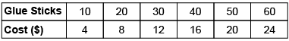  “I skip-counted by 10s and 4s.” | Represents and creates equivalent ratios and rates.  10 glue sticks cost $4.  How much will 60 glue sticks cost?  For example, using ratios:  “The ratio of glue sticks to cost is 10:4. To find the cost of 60 glue sticks, I multiply each term by 6.”  10 × 6:4 × 6  60:24 | Flexibly solves problems involving fractions, decimals, percents, ratios, and rates.  The ratio of dogs to cats in the animal shelter is 8:12. Show the comparison using percents.  “The whole is 8 + 12 = 20.  Since percent is “out of 100”,  I multiply each term in the ratio by 5 because 5 × 20 = 100.  8 × 5:12 × 5, or 40:60  40% of the animals are dogs  and 60% are cats.”
Observations/Documentation

