Variables and Equations
Evaluates a numerical expression using the order of operations.  80 ÷ 5 × (2 + 3) − 23  = 80 ÷ 5 × 5 − 23  = 80 ÷ 5 × 5 − 8  = 16 × 5 − 8  = 80 − 8  = 72  “I have to do the operation  in parentheses first, then the power, then the multiplication and division  in the order they appear,  and then the subtraction.” | Models an algebraic expression and combines like terms.  3q + 2r + 4r + q  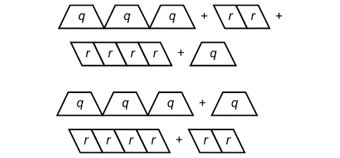  “3q + 2r + 4r + q = 4q + 6r” | Uses algebraic properties to rearrange terms in an algebraic expression.  6(b + 3) + 7b  = 6 × b + 6 × 3 + 7b  = 6b + 18 + 7b  = 6b + 7b + 18  “I used the distributive property to eliminate the parentheses,  then I used the commutative property to rearrange the terms.” | Simplifies algebraic expressions by combining like terms.  6(b + 3) + 7b  = 6 × b + 6 × 3 + 7b  = 6b + 18 + 7b  = 6b + 7b + 18  = 13b + 18  “6b and 7b are like terms  so I can add them.”
Observations/Documentation

Variables and Equations (cont’d)
Simplifies expressions on both sides of an equation.  2(3d + 4) − 1 = 100 ÷ 4  6d + 2 × 4 − 1 = 25  6d + 8 − 1 = 25  6d + 7 = 25  “I used algebraic properties  to simplify the expressions  on both sides of the equation.  Now I have an equation  with two operations.” | Solves equations involving one or two operations using different strategies.  6d + 7 = 25  6d + 7 = 18 + 7  So, 6d = 18  “I used a balance model.  Then, I know 6 × 3 = 18,  so d = 3.” | Verifies the solution to an equation.  2(3d + 4) − 1 = 100 ÷ 4  6d + 7 = 25  To check, substitute d = 3.  Left side = 2(3d + 4) − 1  = 2(3 × 3 + 4) − 1  = 2(13) − 1  = 26 − 1  = 25  Right side = 100 ÷ 4  = 25  “Since the left side equals the right side, my solution is correct.” | Flexibly works with equations to solve problems using a variety of strategies.  Ava rents a bicycle to ride around the city. There is a flat fee of $10, plus $3 per hour. Ava pays a total of $28. For how many hours did Ava rent the bicycle?  10 + 3n = 28, where n is the number of hours that Ava rented the bicycle.  10 – 10 + 3n = 28 – 10  3n = 18  n = 6  “I know 3 × 6 = 18, so n = 6.  Ava rented the bicycle for 6 hours.”
Observations/Documentation

