Fill the Cartesian Plane
Geometry
Unit 1 Line Master 5a

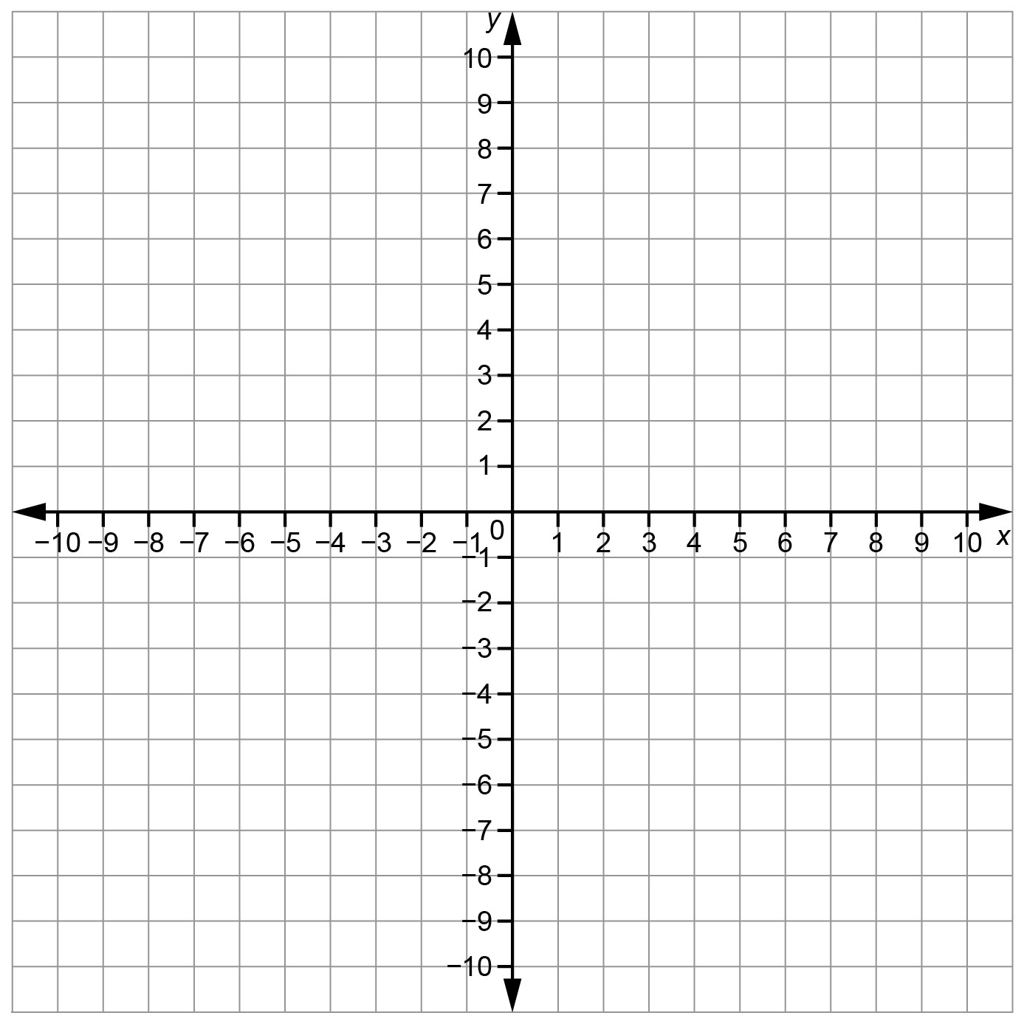

Fill the Cartesian Plane
Geometry
Unit 1 Line Master 5b

Coordinates of the vertices of rectangle ABCD | Translations |  | Coordinates of the vertices of image rectangle
 | Horizontal  Left/right | Vertical  Up/down

Fill the Cartesian Plane
Geometry
Unit 1 Line Master 5c

Coordinates of the vertices of rectangle ABCD | Translations |  | Coordinates of the vertices of image rectangle
 | Horizontal  Left/right | Vertical  Up/down

Geometry
Unit 1 Line Master 5d

Fill the Cartesian Plane

Coordinates of the vertices of rectangle ABCD | Translations |  | Coordinates of the vertices of image rectangle
 | Horizontal  Left/right | Vertical  Up/down

