Rotating a Polygon
Geometry
Unit 1 Line Master 7a

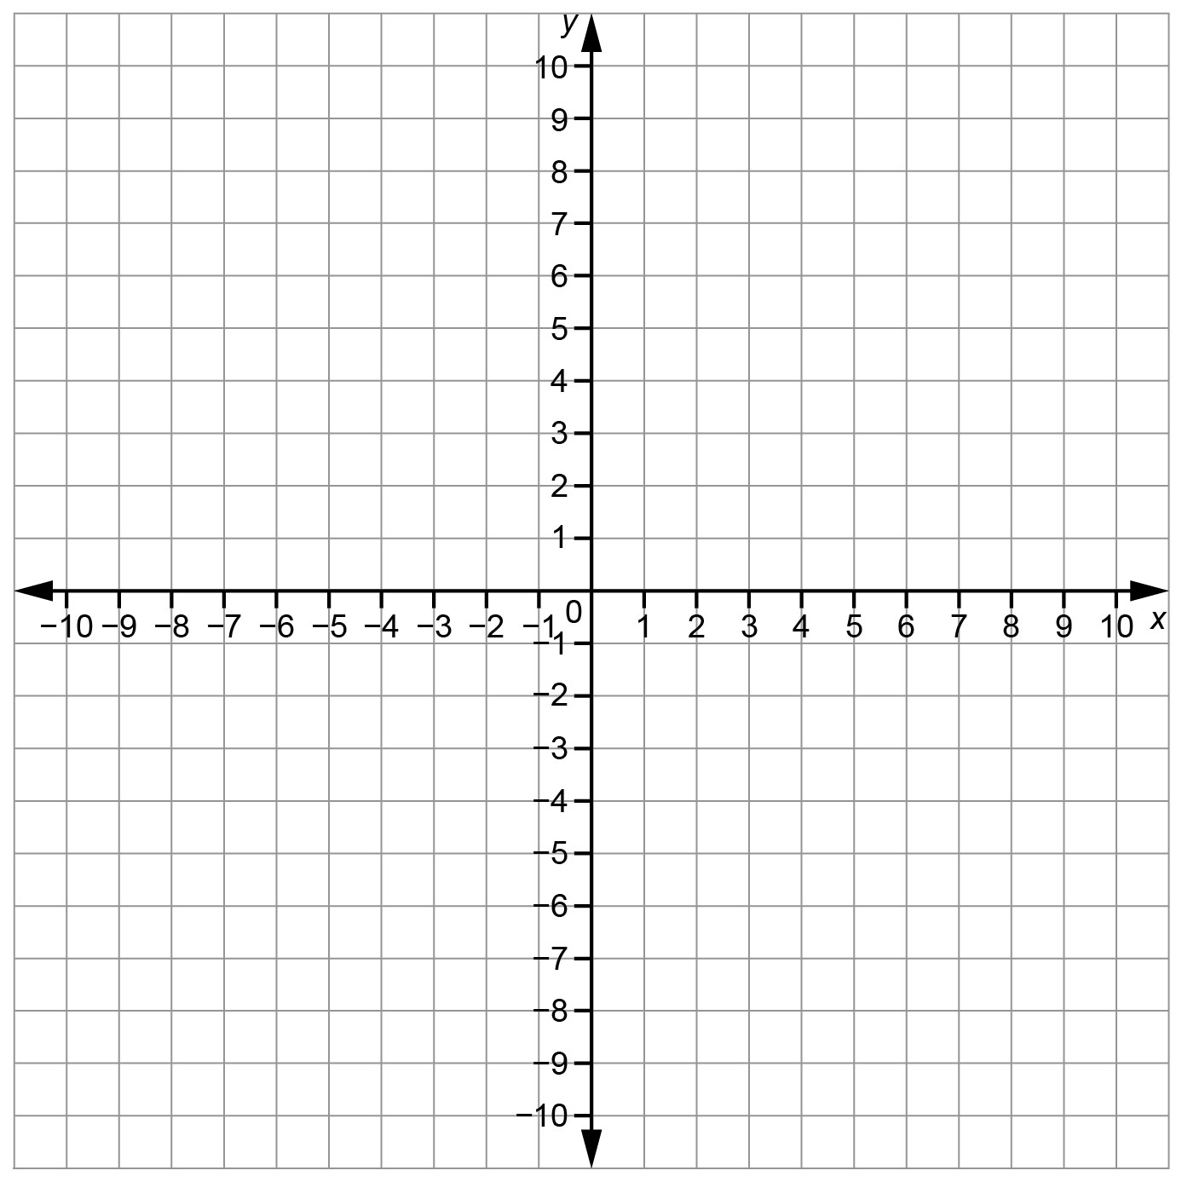

Rotating a Polygon (cont’d)
Geometry
Unit 1 Line Master 7b

Rotation Image 1
Description | Coordinates of Vertices of Polygon | Coordinates of Vertices of Image 1
Rotation Image 2
Description | Coordinates of Vertices of Polygon | Coordinates of Vertices of Image 2
Rotation Image 3
Description | Coordinates of Vertices of Polygon | Coordinates of Vertices of Image 3

