Area of Composite Shapes

**Measurement**

**Unit 1 Line Master 3a**

**Shape A**

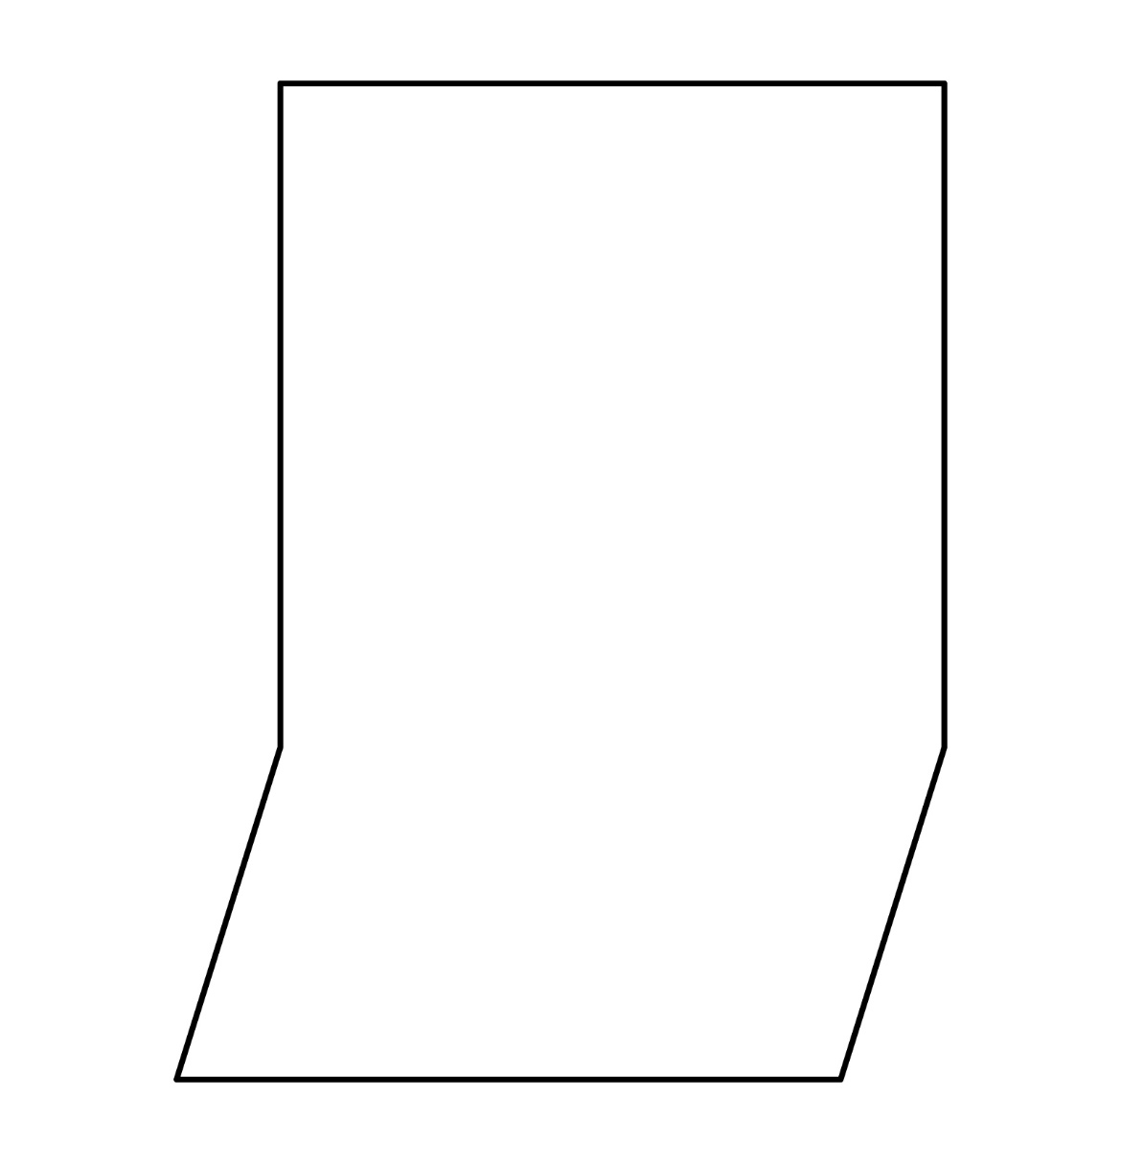

Area of Composite Shapes (cont’d)

**Measurement**

**Unit 1 Line Master 3b**

**Shape B**

