**Number**

**Unit 2 Line Master 4a**

Number Lines 1

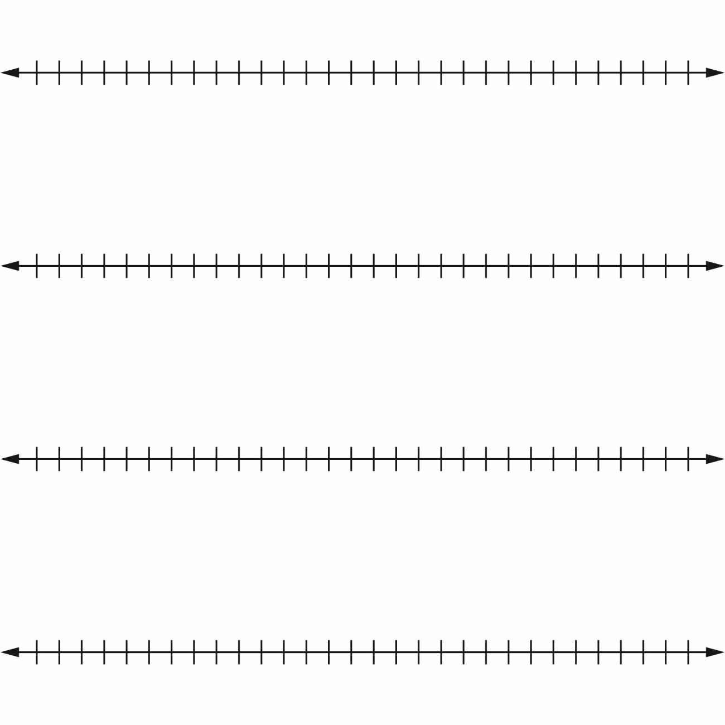

**Number**

**Unit 2 Line Master 4b**

Number Lines 2

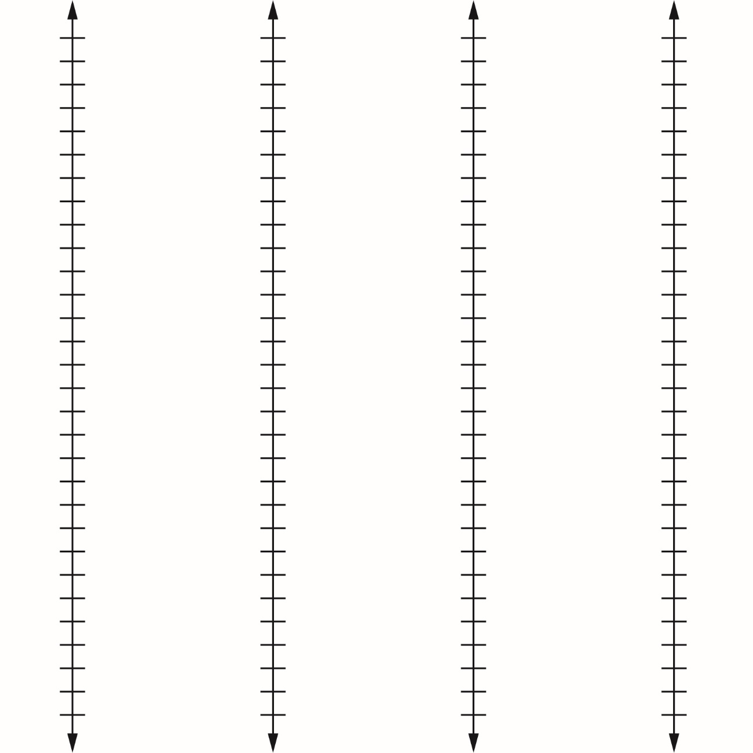

**Number**

**Unit 2 Line Master 4c**

Number Lines 3

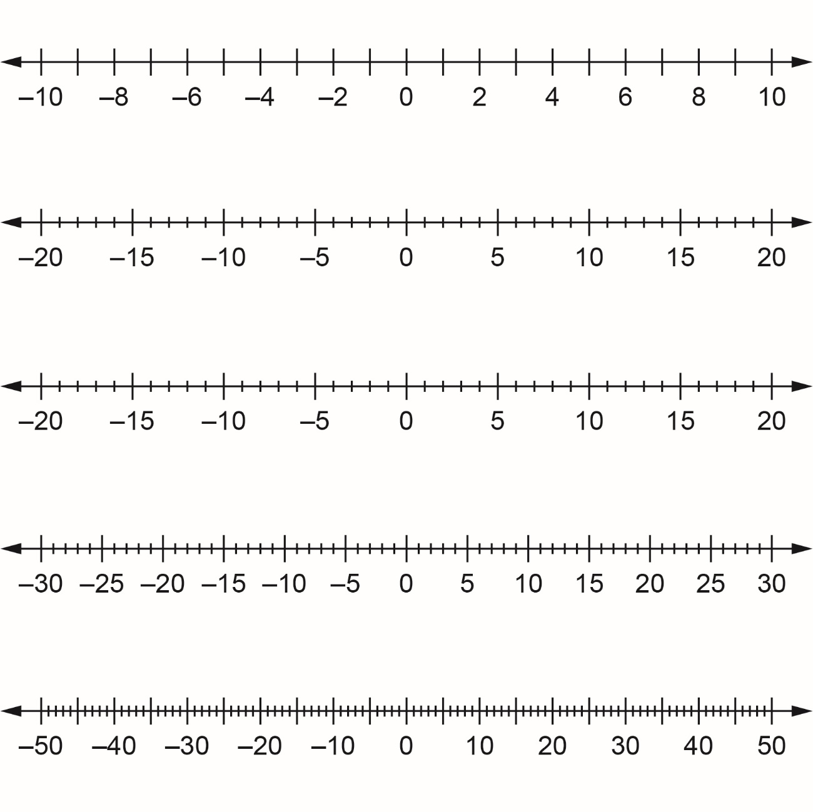

**Number**

**Unit 2 Line Master 4d**

Number Lines 4

