Centre Tasks

Number
Unit 3 Line Master 2a

Centre A: The Garden
(Representing Fractions)

The residents of an apartment building decided
to make a rectangular community garden.
Their design is shown below.
The walkway is part of the garden.
What fraction of the garden does each type of vegetable cover? Explain.

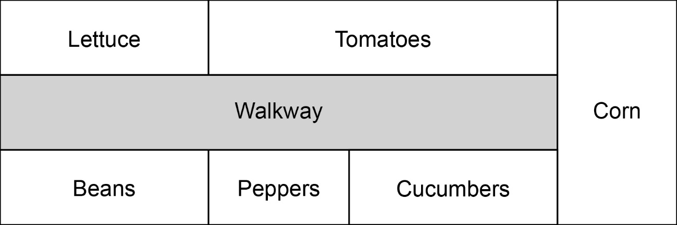

Centre Tasks (cont’d)

Number
Unit 3 Line Master 2b

Centre B: Planting Seeds
(Comparing Fractions)

Seeds come in small packages, with different numbers
of seeds in each, depending on the type of vegetable.

This table shows the fraction of the garden each package
of seeds will cover.

Vegetable | Lettuce | Tomatoes | Corn | Peppers | Cucumbers | Beans
Fraction of garden covered with 1 package of seeds | $\frac{1}{9}$ | $\frac{1}{9}$ | $\frac{1}{6}$ | $\frac{1}{6}$ | $\frac{1}{6}$ | $\frac{1}{3}$

Use the fractions you identified in Centre A.
Determine how many packages of each seed
the gardeners should buy.

Centre Tasks (cont’d)

Number
Unit 3 Line Master 2c

Centre C: Tending to the Garden
(Working with Percents)

These tasks need to be completed daily to maintain the garden.
Task | Time (h)
Watering | 2
Weeding | 4
Fertilizing | 0.5
Pruning | 1
Maintenance of Walkway | 1
Picking/Cleaning Crop | 1.5

The gardeners want to divide up the tasks equally.
To do this, they would like a visual that shows
each time as a percent of the total daily time: 10 h.
Create a visual to help the gardeners.

Centre Tasks (cont’d)

Number
Unit 3 Line Master 2d

Centre D: Harvesting Vegetables
(Fractions of a Set)

One day in mid-August, 24 vegetables were harvested
from the garden.
Here is the harvest:
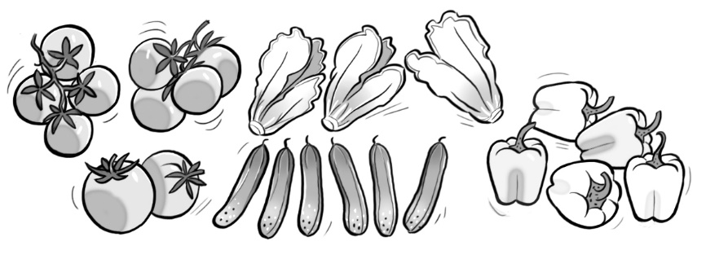
• Show each type of vegetable as a fraction of the whole harvest
for that day.
• Order the fractions from least to greatest.
• Create a visual to show the harvest.
Partition the rectangle to show the harvest
of each type of vegetable.
Today’s Harvest

Centre Tasks (cont’d)

Number
Unit 3 Line Master 2e

Centre E: Applying Fertilizer
(Relating Fractions, Decimals, and Percents)

The gardeners want to use an organic fertilizer
that is high in nitrogen and low in potash.
Here are their options.
Natural Nutrients  Fertilizer  Nitrogen: $\frac{1}{5}$  Phosphate: $\frac{1}{10}$  Potash: $\frac{1}{20}$ |  | Greener Growers  Fertilizer  Nitrogen: 0.15  Phosphate: 0.2  Potash: 0.05 |  | Perfect Plants  Fertilizer  Nitrogen: 5%  Phosphate: 10%  Potash: 5%

• Which fertilizer best matches their needs?
• For the chosen fertilizer, express the value of each chemical as:
– a fraction
– a decimal
– a percent
• Identify the fertilizer that has the most phosphate.
Show your thinking.

Number
Unit 3 Line Master 2f
Centre Tasks (cont’d)

Centre F: Selling the Harvest
(Ratios and Rates)
The gardeners decide to sell some of their harvest at the local farmer’s market.
- One week they harvest 50 tomatoes, and 20 peppers.
What is the ratio of tomatoes to peppers? peppers to tomatoes?
- The second week, their harvest of tomatoes and peppers is double the first week. The third week, the harvest is half the first week.
Write equivalent ratios to represent the numbers of tomatoes and peppers each week.

They package some of their produce into bunches to sell at the market.
- They sell 3 peppers for $3.60. How much does one pepper cost?
- One cucumber costs 75¢. How much does it cost for 5 cucumbers?
- A 2 kg basket of tomatoes sells for $6.00.
What is the cost for a 1 kg basket? A 10 kg basket?

Centre Tasks (cont’d)
Answers

Number
Unit 3 Line Master 2g

Centre A:
Lettuce: $\frac{2}{18}$ or $\frac{1}{9}$; Tomatoes: $\frac{3}{18}$ or $\frac{1}{6}$; Corn: $\frac{3}{18}$ or $\frac{1}{6}$;
Cucumbers: $\frac{2}{18}$ or $\frac{1}{9}$; Peppers: $\frac{1}{18}$; Beans: $\frac{2}{18}$ or $\frac{1}{9}$

Centre B:
Lettuce: 1 package; Tomatoes: 2 packages; Corn: 1 package;
Cucumbers: 1 package; Peppers: 1 package; Beans: 1 package
Centre C:
Visual to show: Watering: 20%; Weeding: 40%; Fertilizing: 5%; Pruning: 10%; Maintenance of Walkway: 10%;
Picking/Cleaning Crop: 15%
Centre D:
Tomatoes: $\frac{10}{24}$, or $\frac{5}{12}$; Cucumbers: $\frac{6}{24}$, or $\frac{1}{4}$; Lettuce: $\frac{3}{24}$, or $\frac{1}{8}$;
Peppers: $\frac{5}{24}$;
 | Today’s Harvest
 | T | T | T
 | T | T | T
 | T | T | T
 | T | C | C
 | C | C | C
 | C | L | L
 | L | P | P
 | P | P | P
Least to greatest: $\frac{1}{8}$, $\frac{5}{24}$, $\frac{1}{4}$, $\frac{5}{12}$

Centre Tasks (cont’d)
Answers

Number
Unit 3 Line Master 2h

Centre E: Natural Nutrients Fertilizer; Nitrogen: $\frac{1}{5}$, 0.2, 20%;
Phosphate: $\frac{1}{10}$, 0.1, 10%; Potash: $\frac{1}{20}$; 0.05, 5%;
Greener Growers Fertilizer; 20%.

Centre F:
Tomatoes: Peppers
50:20 = 5:2
Peppers: Tomatoes
20:50 = 2:5

Week 2:
50:20 = 100:40
They harvest 100 tomatoes and 40 peppers in week 2.
Week 3:
50:20 = 25:10
They harvest 50 tomatoes and 10 peppers in week 3.

$\frac{\$3.60}{3}$ = $\frac{\$1.20}{1}$ Divide numerator and denominator by 3.
One pepper costs $1.20.

80¢ is the same as $0.80
$\frac{\$0.80}{1}$ = $\frac{\$4.00}{5}$ Multiply numerator and denominator by 5.
Five cucumbers cost $4.00.

$\frac{\$6.00}{2}$ = $\frac{\$3.00}{1}$ $\frac{\$3.00}{1}$ = $\frac{\$30.00}{10}$
A 1 kg basket of tomatoes costs $3.00.
A 10 kg basket of tomatoes costs $30.00.

